Variational Bayesian Tracking Approach

Introduction to Variational Bayesian Tracking
The statement captures what I consider the central insight of a Variational Bayesian (VB) tracker. It is also the source of both its computational advantage and its most important approximation.
VB separates the association problem into two interacting operations:
- Spatial assignment: At each scan, determine which measurements are most likely associated with which tracks, enforcing the one-to-one assignment constraints.
- Temporal inference: Across the entire measurement window, estimate each target's most plausible trajectory, using its motion model and the uncertain measurement assignments.
One alternates between these operations, letting the estimated trajectories improve the assignments and the revised assignments improve the trajectories.
The subtlety is that the individual assignment calculations do not directly solve a multi-frame association problem. The temporal information enters through the smoothed target-state distributions.
That's what makes the architecture interesting. Let's work through the actual mathematics and then a crossing example.
1. Two different ways of coupling the tracking problem
Consider two targets observed over five radar scans. Each scan contains two measurements.
A conventional joint multi-frame assignment method asks:
Which complete sequence of assignments across these five scans best explains the measurements and target dynamics?
It reasons about association histories such as
$$\left(A_{1},A_{2},A_{3},A_{4},A_{5}\right).$$
Even with only two possible assignments per scan, there are potentially $2^{5}=32$assignment histories. With more targets, clutter, and missed detections, the combinatorial problem grows rapidly.
The VB approach instead introduces the approximation
$$q\left(A_{1:K}\right)=\prod_{k=1}^{K}{q\left(A_{k}\right)}$$
where $q\left(A_{k}\right)$ is a probability distribution over valid assignments at scan $k.$ But we do something very different with the target states:
$$q\left(X_{1:K}\right)=\prod_{i=1}^{N_{T}}{q\left(x_{i,1:K}\right)}$$
Here, each $q\left(x_{i,1:K}\right)$ is a distribution over the entire trajectory of target i. This is the essential asymmetry:
- Assignment distributions are factorized across time.
- Target-state distributions remain dynamically coupled across time.
Therefore, VB tracking gives up explicit joint association histories
but retains temporally coupled state trajectories.
This is the induced factorization of the method. That distinction is the foundation for everything that follows.
First operation: solve the association problem at one scan
Let's examine scan$k$. Suppose we have two tracks, $T_{1},T_{2}$ and two measurements, $z_{1},z_{2}$.
The two basic complete-assignment hypotheses are:
$$\begin{aligned}H_{1}&:T_{1}→z_{1}, T_{2}→z_{2}, \\ H_{2}&:T_{1}→z_{2}, T_{2}→z_{1.}\end{aligned}$$
Initially, assume the targets are well separated. Their predicted states make $H_{1}$ much more likely than $H_{2}$. At a crossing, both assignments might be nearly equally plausible.
The algorithm evaluates the assignment possibilities using the current estimated state distribution for each track.
For a Gaussian observation model,
$$z_{j,k}=Hx_{i,k}+v_{j,k}, v_{j,k}∼N\left(0,R\right),$$
the association score for assigning measurement j to track i contains
$$l_{ij,k}=E_{q\left(x_{i,k}\right)}\left[\log{N}\left(z_{j,k};Hx_{i,k},R\right)\right].$$
This is an expected log-likelihood, not merely the likelihood evaluated at a predicted point estimate.
If
$$q\left(x_{i,k}\right)=N\left(m_{i,k},P_{i,k}\right),$$
then, apart from terms independent of the assignment.
Two things influence the score:
- Predicted measurement residual: How well does the track's estimated state explain this measurement?
- State uncertainty: How uncertain is the track-state distribution under the measurement model?
The assignment calculation also incorporates detection and clutter probabilities, including information from the track-management meta-state model.
Enforcing assignment competition
We represent each scan's association distribution as
$$q\left(A_{k}\right)∝1\left\{A_{k}\text{ valid}\right\}\exp\left(\sum_{i,j}{A_{ij,k}}w_{ij,k}\right),$$
where $w_{ijk}$combines the expected measurement log-likelihood and relevant assignment-prior terms.
The indicator function enforces the assignment constraints: a measurement cannot belong to two tracks, and a track cannot generate two measurements in the same scan.
The conjugate assignment prior (CAP) gives precisely this structure. The computational challenge is calculating its marginals efficiently, for which the technique introduces a Bethe approximation and loopy belief propagation. The result is a matrix of marginal assignment probabilities,
$$γ_{ijk}= E_{q\left(A_{k}\right)}\left[A_{i,j,k}\right]$$
For example:
Table 1 Illustrative case with both tracks detected and no clutter.
 | Measurement 1 | Measurement 2
Track 1 | 0.55 | 0.45
Track 2 | 0.45 | 0.55

Notice that these are soft probabilities, not hard assignments. And importantly, although the probabilities are fractional, the underlying distribution $q\left(A_{k}\right)$ is defined over valid one-to-one assignments. VB tracking is not simply treating each track-to-measurement probability as an independent Bernoulli variable.
At this point, however, the assignment solver has used information only from the state beliefs supplied to it. It has not explicitly considered competing five-scan assignment histories. That is where the next operation becomes essential.
Second operation: use the soft assignments to estimate each entire trajectory
Here is the most elegant part of the formulation. Ordinarily, a Kalman filter receives a measurement $z_{k}$with measurement covariance $R$. But suppose a track has several possible associated measurements, each with a probability. We derive an equivalent pseudo-measurement using those probabilities.
Define the expected detection indicator
$$d_{i,k}=\sum_{j=1}^{N_{Z}\left(k\right)}{γ_{ij,k}}.$$
For $d_{i,k}>0$, define
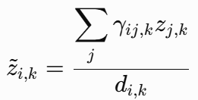and 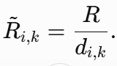
These equations are where the derivation shows the variational state update has the form of a linear Gaussian smoothing problem.
Why is that powerful?
Consider a track with two candidate measurements:
$$z_{1}=98\text{ m}, z_{2}=102\text{ m},$$
with association probabilities
$$γ_{1}=0.7, γ_{2}=0.3.$$
Assume the track was detected, so $d=1$. Then
$$\tilde{z}=\left(0.7\right)\left(98\right)+\left(0.3\right)\left(102\right)=99.2\text{ m}.$$
The Kalman smoother can use 99.2 m as an effective observation for that track.
Now suppose the same track has only a 30% probability of being detected:
$$d=0.3.$$
The effective measurement covariance becomes
$$\tilde{R}=\frac{R}{0.3}≈3.33R.$$
Thus, the information supplied by this scan is weakened. If$d=0$, there is no associated measurement contribution for that track at that scan. This is a remarkable practical simplification: uncertain data association becomes a weighted observation process that can be handled by ordinary state-space smoothing machinery.
There is one important limitation: the pseudo-measurement is a variational device, not a claim that the true measurement distribution is Gaussian with that mean. When candidate measurements are widely separated, their weighted average can lie between two physically plausible alternatives. That is one mechanism by which mean-field tracking can merge or distort competing trajectory hypotheses.
Third operation: smoothing carries information backward and forward through time
Now we have an effective observation sequence for each track:
$${\tilde{z}}_{i,1},{\tilde{z}}_{i,2},…,{\tilde{z}}_{i,K}.$$
We assume a dynamical model, such as
$$x_{i,k}=Fx_{i,k-1}+w_{i,k}, w_{i,k}∼N\left(0,Q\right).$$
The state update is therefore
$$q\left(x_{i,1:K}\right)∝p\left(x_{i,1:K}\right)\prod_{k=1}^{K}{N}\left({\tilde{z}}_{i,k};Hx_{i,k},{\tilde{R}}_{i,k}\right).$$
Notice that the motion model $p\left(x_{i,1:K}\right)$ still couples all time steps. That is the mathematical reason temporal information has not disappeared. A Kalman smoother can solve this complete trajectory estimation problem efficiently.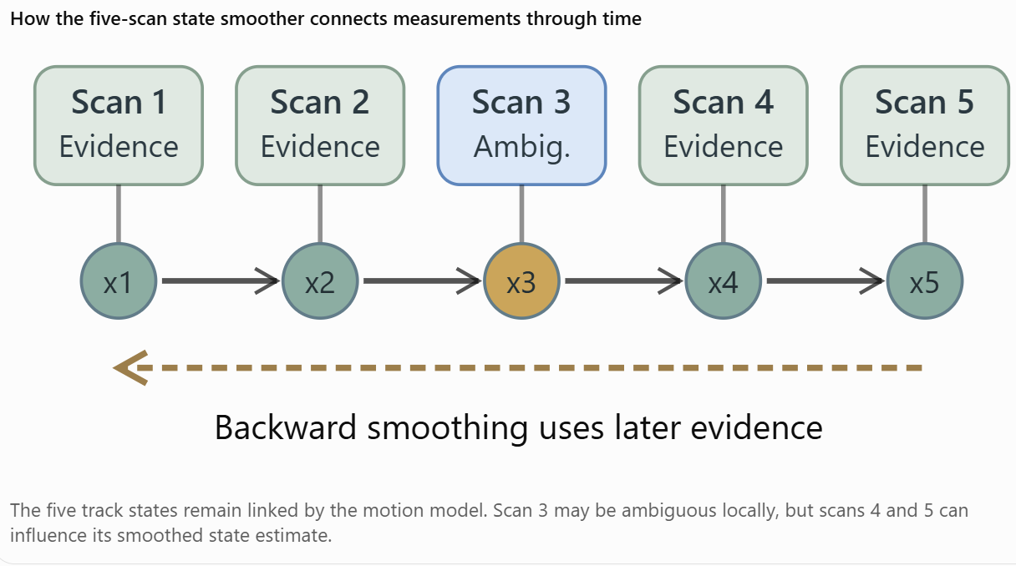
Figure 1 Kalman smoother
In an RTS Kalman smoother, one backward step takes the form
Here:
- ${\hat{x}}_{k|k}$is the forward-filtered state estimate at scan k.
- ${\hat{x}}_{k|K}$ is the smoothed estimate using all K scans.
- $C_{k }$is the smoothing gain.
- The correction involves information from the next smoothed state.
Repeated backward recursion propagates later measurement evidence into earlier state estimates.
Crucially, the smoother itself does not revisit or change the assignment probabilities. It updates the state distributions conditional on the current soft association weights.
To change the assignments, we must return to the first operation.
5. Fourth operation: the revised trajectory changes the earlier assignments
This closes the loop and is the source of the multi-frame benefit. Imagine two targets crossing during scans 1–5.
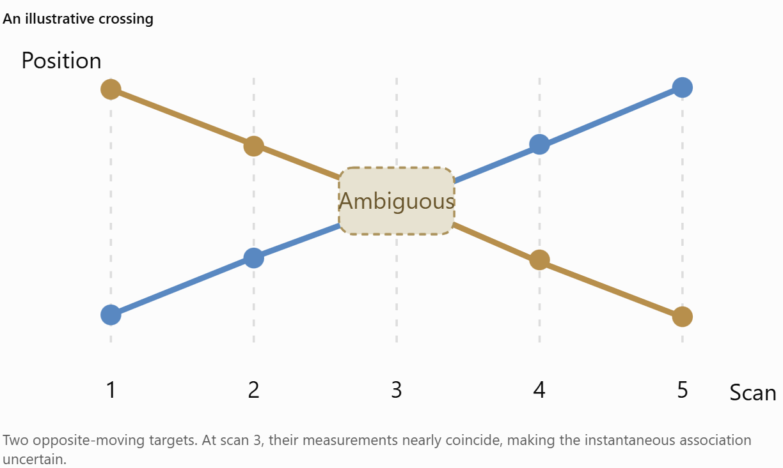
Figure 2 Two opposite moving targets example
Two opposite-moving targets. At scan 3, their measurements nearly coincide, making the instantaneous association uncertain. Initially, the scan-3 association probabilities might be
$$q\left(A_{3}\right): P\left(H_{1}\right)=0.50, P\left(H_{2}\right)=0.50.$$
But the other scans provide information about direction and continuity.
The state smoother considers the motion before and after the crossing. This may produce a revised state estimate showing that Track 1 was moving consistently rightward and Track 2 leftward.
Now we recompute the association probabilities at scan 3 using those revised state beliefs.
For illustration, we might obtain
$$q^{\text{new}}\left(A_{3}\right): P\left(H_{1}\right)=0.85, P\left(H_{2}\right)=0.15.$$
Those numbers are hypothetical, but the mechanism is real. We then use the updated scan-3 association probabilities to reconstruct the pseudo-measurements, smooth the entire trajectory again, and repeat.
In compact notation:
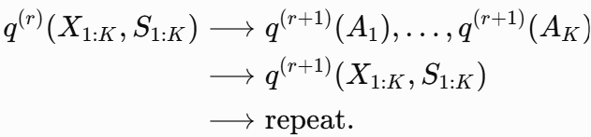
The meta-states S are included because the complete formulation also updates track activity/dormancy probabilities using an HMM forward–backward recursion. This alternating computation is variational coordinate optimization.
The assignment at scan 3 can therefore incorporate evidence from scans 4 and 5—not because the scan-3 assignment algorithm explicitly evaluates future assignments, but because its input state distribution has been smoothed using future measurements.
That's the key distinction.
And we need one qualification: future observations do not guarantee the correct identity will emerge. If the motion histories are genuinely indistinguishable, or the VB updates settle into a poor interpretation, those probabilities may remain ambiguous or become incorrectly concentrated.
6. What happens across one complete outer iteration?
That entire process is one VB outer iteration.
In our earlier experiments, for a ten-scan window and 12 outer iterations, we performed approximately 120 per-scan association calculations and 12 full-window smoothing passes.
All the measurements in the ten-scan window are used repeatedly. We aren't adding observations during the iterations; we're improving the internal consistency of the inferred assignments and trajectories.
7. What makes this fundamentally different from MFA?
This is where we return to the original motivation for the VB method. Suppose an ambiguous crossing admits two coherent complete association histories:
$$H_{1}=\left(A,A,A\right), H_{2}=\left(B,B,B\right),$$
each with posterior probability 0.5. A joint multi-frame representation can retain
$$P\left(H_{1}∣Z\right)=P\left(H_{2}∣Z\right)=0.5.$$
It knows that all three association decisions are correlated.

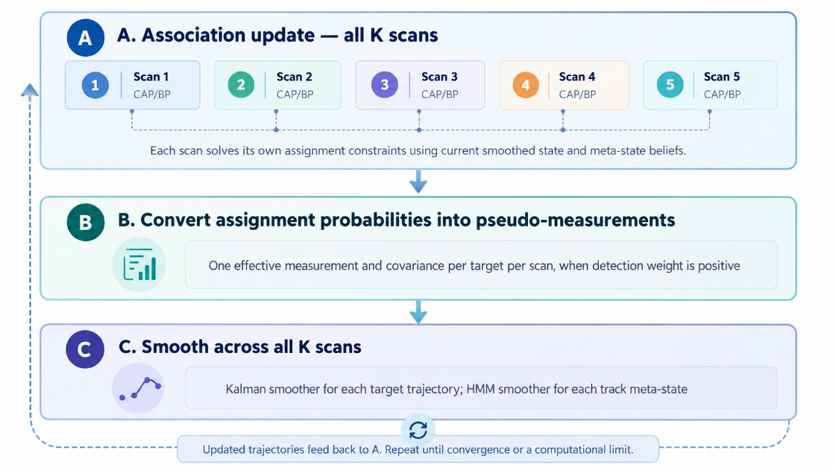
Figure 3 Entire process of one VB outer iteration.
If we instead take the per-scan marginals, each scan has probability 0.5 of choosing A or B.
Their product assigns probability to all eight possible sequences, including six mixed sequences such as $\left(A,B,A\right)$that were absent from our stipulated joint posterior.
In that illustrative case, the product of the exact marginals would place 75% of its mass on incoherent combinations. The optimized variational distributions need not equal the exact marginals; they might instead collapse onto one of the two coherent histories. But the factorized family cannot accurately preserve the original two-mode correlation. That is the statistical information sacrificed. So the distinction is:
Table 2 Distinction between MFA and VB Methods
MFA-style joint history representation | VB architecture
Explicitly represents associations across multiple scans as coupled hypotheses | Represents scan assignments separately under the variational approximation
Preserves selected alternative association histories | Represents one factorized posterior approximation, typically via soft assignment marginals
Motion consistency affects the plausibility of entire histories | Motion consistency affects assignment probabilities through smoothed state beliefs
Multiple competing hypotheses may be retained explicitly | Competing global modes may be lost or collapsed
Hypothesis growth requires pruning or more sophisticated optimization | Work scales approximately linearly in window length under bounded per-scan cost and iteration counts

Notice the distinction between retaining temporal information and retaining temporal association correlations. VB retains the former through the motion model and smoother. VB sacrifices much of the latter through the variational factorization. That is the entire tradeoff.
Why I think this matters for our REACTOR tracking objectives
In a dense multi-target environment, many scans can be individually ambiguous even when the complete target trajectories are relatively easy to distinguish. Imagine two aircraft following stable, opposite-direction trajectories. They approach, their measurements overlap, and they separate. Their instantaneous positions at the crossing are poor indicators of identity, but their multi-scan kinematics contain valuable information about which aircraft is which.
The VB architecture seeks to extract that information without explicitly solving a large joint combinatorial problem. That is precisely the type of situation where one expects it to have value.
By contrast, if two targets have nearly identical kinematics over the full window, then there may be insufficient information to distinguish them. The smoother cannot create nonexistent information, and the factorized approximation may obscure the remaining ambiguity.
One additional point matters: the state-space smoother is a linear-time operation in window length for fixed state dimension, and the association calculations factorize over time. With bounded iteration counts and a scalable per-scan solver, this is what makes the computational argument work. It does not mean the algorithm is linear in the number of targets or measurements, nor that convergence iterations are always bounded by a small constant.
9. The deepest insight
I would characterize the architecture as a deliberate exchange:
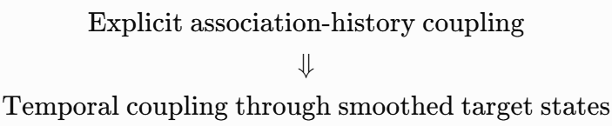
VB doesn't eliminate the multi-frame nature of tracking; VB changes where the temporal coupling lives.
Instead of carrying a combinatorial set of assignment histories through time, the algorithm carries temporally coupled probabilistic state estimates. Those state estimates repeatedly inform the individual assignment problems.
There is one caveat to make explicit: a smoothed Gaussian trajectory is not a lossless encoding of all possible assignment histories. This is an approximation, not a mathematical equivalence to full multi-frame association. But it is a principled approximation that can preserve much of the useful temporal evidence at much lower computational cost.
This is why the VB approach is compelling. Its central innovation is not belief propagation, nor even variational inference in isolation. It is using continuous-time-history state inference as the mechanism for coordinating otherwise separate measurement-assignment problems across scans.
The question our V&V must ultimately answer is how often that mechanism delivers the correct association decisions—and how much critical identity information is lost when the history contains genuinely competing trajectory interpretations.

Three distinct dimensions of the VB tracking algorithm: window length, scans and temporal history.

Window length K
Window length is the number of consecutive measurement scans considered together during an inference operation.
Suppose a radar updates once per second and we want to determine measurement-to-track assignments at scan 20.
Table 3 Window Length Example
Window length | Scans considered | Temporal history
K = 1 | 20 | Current scan only
K = 3 | 18–20 | Current + 2 previous
K = 5 | 16–20 | Current + 4 previous
K = 10 | 11–20 | Current + 9 previous
K = 20 | 1–20 | Current + 19 previous
The advantage VB is pursuing is the ability to use a longer window to resolve ambiguous associations by leveraging target motion before and during a crossing.
In the experiments we conducted today, increasing K from 1 to 20 substantially improved association accuracy in several scenarios.

Per-scan association
Per-scan association is the calculation of measurement-to-track assignment probabilities for one particular scan. Suppose at scan 20 we have three tracks and four radar measurements. The association algorithm calculates probabilities such as:
$$P\left(A_{20,j}=i\right)$$where $A_{20,j}$ represents the track assigned to measurement$j$ at scan 20, with an additional possibility for clutter.
The matlab source file, asgMatBP.m, approximates these probabilities using belief propagation while enforcing the competition constraints among tracks and measurements.
The key distinction is that although assignment probabilities are calculated one scan at a time, they can depend on information from the entire window through the temporally smoothed track-state distributions. That is central to the VB architecture.

Outer iterations $I_{VB}$
Outer iterations are repeated cycles of updating the association probabilities and target-state distributions until they become mutually consistent. One complete outer iteration consists conceptually of:
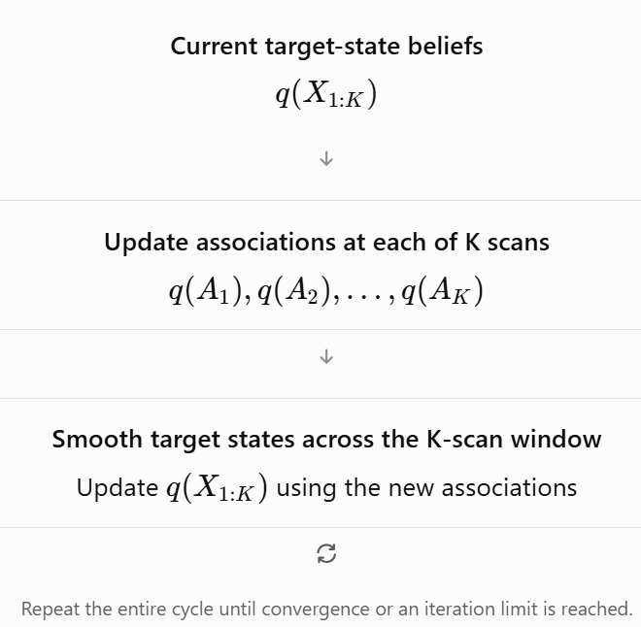
Figure 4 One complete outer iteration
For example, in our initial multi-frame experiment we used 12 outer iterations. Later, we extended this to 80 outer iterations to examine convergence and identity reversals.
More outer iterations do not mean more measurements or a longer history. They simply mean repeatedly refining the posterior approximation using the same measurement window.

How the three concepts interact
Consider a ten-scan window with 12 outer iterations.
Each outer iteration:
- Calculates association probabilities independently for each of the 10 scans, conditional on the current smoothed state beliefs.
- Updates the target-state distributions using temporal smoothing across all 10 scans.
Thus, the full operation performs approximately 120 per-scan association updates and 12 ten-scan smoothing passes.
There's also a fourth parameter worth distinguishing: inner BP iterations. The original asgMatBP.m runs 100 message-passing iterations within each individual per-scan association calculation. Those are not VB outer iterations. For fixed problem size and iteration counts, a useful approximate cost expression is
$$C_{VB}∝K I_{VB}\left(C_{association}+C_{state}\right).$$
This helps explain the linear-in-window-length argument: if all other computational costs stay bounded, doubling the number of scans approximately doubles the work. But if difficult problems demand more outer iterations or more BP iterations, actual runtime may grow faster.

The key distinction
The particularly important idea is that VB tracking does not solve one gigantic combinatorial association problem involving all $K$ scans simultaneously.
Instead, he solves tractable single-scan association subproblems, then uses temporal state smoothing to communicate information across scans, repeating those operations. That is how he seeks to capture much of the benefit of multiple-frame association without explicitly enumerating all possible measurement-assignment histories.
And it's the main reason to still find this architecture compelling: the window provides temporal information; the per-scan solver handles assignment competition; and the outer VB iterations allow those two sources of information to inform each other.

Variational Bayesian Tracking Architecture Key Definitions and Insights
This document explains the technical message of each slide, including the progression from explicit probabilistic graphical models to hard association, and then variational association coupled to track-state inference.
Selected transcription in this window
Here are several foundational expressions from the notebook, normalized for readability. These are working transcriptions; unclear notation still needs confirmation against the handwritten originals.

Page 1 — Mean-field posterior approximation
$$p\left(Z,a∣X\right)≈q\left(Z,a\right)$$
with factorization of the form
$$q\left(Z,a\right)=\prod_{i}{q}\left(a_{i}\right)\prod_{i,j}{q}\left(z_{ij}\right).$$
The central idea is to approximate a difficult joint posterior over data associations and latent track states by a product of simpler distributions.

Pages 2–3 — Variational association update
The notes develop an association update with the general structure
$$\log{q}\left(a_{i}\right)\overset{c}{=}\log{p}\left(a_{i}\right)+\sum_{j}{E_{q\left(Z\right)}}\left[\log{p}\left(X_{j}∣Z_{a_{i}\left(j\right)}\right)\right].$$
The notation $\overset{c}{=}$ denotes equality up to an additive normalization constant.
This is an important distinction from using a likelihood evaluated at a single estimated track state. The association update uses an expected log likelihood, integrating over uncertainty in the latent state.

Pages 10–12 — Variational Bayesian HMM
The notebook moves into exponential-family formulations of a hidden Markov model. Its complete-data log probability includes initial-state, transition, and emission contributions:
$$\begin{aligned}\log{p}\left(s_{1:T},y_{1:T}∣θ\right)=&s_{1}^{⊤}\log{π} \\ &+\sum_{t=2}^{T}{s_{t-1}^{⊤}}\left(\log{A}\right)s_{t} \\ &+\sum_{t=1}^{T}{s_{t}^{⊤}}\left(\log{C}\right)y_{t}.\end{aligned}$$

Pages 29–31 — Assignment partition function
A later part of the notebook investigates a constrained probability distribution over association matrices:
$$p\left(A∣χ\right)=\frac{1\left\{A∈A\right\}\exp\left(\sum_{i,j}{χ_{ij}}A_{ij}\right)}{K\left(χ\right)}$$
where
$$K\left(χ\right)=\sum_{A∈A}{\exp\left(\sum_{i,j}{χ_{ij}}A_{ij}\right)}.$$
For that parameterization, the familiar exponential-family identity is
$$\frac{∂\log{K}}{∂χ_{ij}}=E\left[A_{ij}\right].$$
This is a potentially important connection between marginal assignment probabilities and the gradient of a log-partition function.

What the PowerPoint contributes
Slides 1–2: Generative models
Target states, observations, association variables, and an optional discrete latent variable are represented within a temporal graphical model.
Slide 3: Conventional hard association
A maximum-probability association is selected, then measurements are passed into individual track filters. This illustrates how a single assignment decision can determine later filtering behavior.
Slide 4: Variational inference
Data-association distributions and track-specific forward–backward inference exchange information iteratively. This is the central conceptual departure from committing to a single association.
Slides 5–6: Graphical structure
The figures contrast dense dependencies with a structured representation that introduces explicit association variables.

5. My assessment of where we stand
The materials contain considerably more than a conventional tracking-algorithm sketch. They address the association probability distribution itself, constrained assignment matrices, variational lower bounds, forward–backward inference, and message passing.
For reconstructing the implementation, I expect the most important notebook material will be pages 1–9 for the original variational formulation and pages 28–37 for the assignment distribution and message-passing derivations.
The remaining transcription work is primarily mathematical verification: resolving ambiguous indices, precisely capturing the equations, and separatingThe exploratory alternatives from the formulation eventually implemented.
I have also kept his 2011 Cambridge thesis separate. Its treatment of Bayesian filtering, Gaussian processes, and state-space models may provide useful mathematical context, but the handwritten notebook is the direct source for this project.

Assessment of Matlab Implementation of VB Tracker
The repository contains 23 MATLAB files, but it is missing a shared utility package named tracker.util. There are five distinct unresolved functions in that package, not just one.
The most consequential missing function is tracker.util.logSumExp, which is used throughout the variational inference machinery. Another, tracker.util.numAss, is directly involved in verifying the enumeration of valid track-to-measurement assignments.

Repository inventory
The archive contains 23 .m files organized functionally as follows.
Subsystem MATLAB files
Main VB algorithms VBtracker.m, VBtracker2.m
Variational lower bounds VBLB.m, VBLB2.m, MCVBLB.m, MCVBLB2.m
Data association asgMatBP.m, getAsgMat.m, getOneOfK.m
Markov inference:softForwardBackward.m, markovCond2Joint.m, markovJoint2Cond.m, markovJoint2Marg.m
Probability and entropy MMrnd.m, MMEntrop.m, discreteEntrop.m, getLogPOE.m, getLogPOE2.m
Simulation and tests generate.m, testGenerate.m, testFW.m, testMarkov.m, testAsgMatBP.m
The encouraging news is that the principal VB routines, Markov inference code, Monte Carlo validation code, assignment machinery, and simulation harness are present. In addition, functions such as makeCandList, makeChi0, updateLogqA, and updateLogqX are implemented as local functions within the main tracker files. They are not missing merely because they lack separate filenames.

Missing functions
Missing function | Purpose | Impact
tracker.util.logSumExp | Stable log-domain summation and normalization | Critical
tracker.util.catrnd | Sampling from categorical distributions | High for simulation and validation
tracker.util.numAss | Counting feasible assignments | High for VBtracker2
tracker.util.vertLine | Drawing a vertical reference line | Low; diagnostic plotting
tracker.util.horizLine | Drawing a horizontal reference line | Low; diagnostic plotting
The syntax tracker.util.logSumExp(...) indicates a MATLAB package function that would conventionally reside at +tracker/+util/logSumExp.m.
None of these five functions appears in the supplied archive.

The particularly important one: logSumExp
The VB Matlab implementation repeatedly performs calculations on log probabilities, avoiding direct multiplication of potentially tiny probabilities.
The fundamental operation is
$$\operatorname{LSE}\left(x_{1},…,x_{n}\right)=\log\left(\sum_{i}{e^{x_{i}}}\right).$$
Its numerically stable implementation is
$$m+\log\left(\sum_{i}{e^{x_{i}-m}}\right), m=\max_{i}{x_{i}}.$$
It is frequently calls it using two outputs:
[~, logqX{ii}] = tracker.util.logSumExp(logqX{ii}, 1);
This tells us that the utility is expected to return both a log normalization constant and a normalized log-probability array. We cannot simply replace it with MATLAB's ordinary log(sum(exp(x))) expression everywhere. Its exact two-output contract matters to the tracker.

The second particularly interesting one: numAss
In VBtracker2.m, module writes:
candList = makeCandListR(zeros(1, nMeas), nMeas, nTracks);
assert(size(candList, 1) == tracker.util.numAss(nMeas, nTracks));
The recursive candidate generator exists.
What's missing is the helper that calculates how many valid association hypotheses should exist.
Assuming each track generates at most one measurement and each measurement can belong to at most one track, with unassigned measurements treated as clutter, the count should be
$$N_{ass}\left(M,T\right)=\sum_{k=0}^{\min\left(M,T\right)}{\left({T \atop k}\right)}\frac{M!}{\left(M-k\right)!}.$$
This follows from selecting $k$ detected tracks and injectively assigning them to $M$ measurements.
That gives us a strong basis for reconstructing numAss independently of the implementation.

Additional dependencies and potential execution problems
The linker pass also uncovered several issues that are not missing repository functions but will matter when we try to execute the code.
Table 4 Potential Matlab code conflicts
Finding | Location | Assessment
poissrnd | generate.m | MATLAB Statistics and Machine Learning Toolbox dependency
ttest | MCVBLB.m, MCVBLB2.m, testFW.m | Statistics and Machine Learning Toolbox dependency
hmmdecode | testFW.m | Statistics and Machine Learning Toolbox dependency
keyboard | testAsgMatBP.m | Deliberate interactive debugging breakpoint
One-step sequences | softForwardBackward.m and related functions | Need to verify behavior when only one observation exists
Zero-valued probabilities | makeChi0 and log-domain calculations | Potential numerical edge cases

These are separate from the missing tracker.util functions. They do not all prevent use of the core tracker, but some prevent running the supplied test suite without the required MATLAB toolboxes.
I also found a possible test-harness inconsistency worth investigating. testGenerate.m constructs separate emission matrices for each track, but its active call to VBtracker2 supplies only emissionLogP{1}. That is consistent with VBtracker2 expecting a shared emission matrix, but it means the simulation and inference models need not match.
That is not a linker failure, but it could complicate interpreting validation results.

Which version of the tracker should we restore?
The archive contains two related implementations.
VBtracker.m is the earlier implementation. It supports track-specific emission models and performs variational updates using explicit track-state distributions.
VBtracker2.m uses softForwardBackward and the pairwise Markov-state distributions. It also includes a revised variational lower-bound calculation and associated Monte Carlo validation.
The second implementation appears to represent a more developed approach to temporal inference, although I would not yet call it a validated successor. That requires actually executing and comparing both versions.
There is another significant observation: asgMatBP.m implements a separate belief-propagation approach to the assignment-matrix problem. It is not an unresolved dependency of the primary VB tracker. It appears to be an alternative inference method that was being explored.
This distinction matters because the number of association candidates can grow combinatorially. The belief-propagation formulation may have been intended to address that computational limitation.
- 5. My proposed reconstruction sequence
I would approach restoration in this order:
- Reconstruct logSumExp first. Establish its input/output conventions, dimensional behavior, normalization, and handling of -Inf.
- Reconstruct catrnd and numAss. Both have straightforward mathematical specifications that we can test independently.
- Restore the plotting utilities. These should require little effort and are not algorithmically significant.
- Execute the original unit tests. Begin with testMarkov.m and testFW.m, then move to assignment tests and end-to-end simulation.
- Investigate discrepancies between the two VB implementations. In particular, verify agreement of computed lower bounds, association marginals, and state posteriors under comparable models.
I have not executed MATLAB or validated the numerical results. This is a source-level dependency and call-resolution audit, not a runtime certification.
6. Bottom line
- MATLAB files, 5 Missing package functions, 3 Toolbox functions identified
The most encouraging result is that I did not find evidence of a missing major algorithmic module. The identified unresolved calls are concentrated in a shared utility library, and the primary mathematical machinery is present.
I think we have a strong foundation for restoring the original implementation without rewriting the algorithm prematurely. My recommendation is to reconstruct the five missing utility functions in MATLAB first, preserve the original 2014 source as a baseline, and then use the existing tests to establish numerical correctness before considering a Python translation. That will give us a defensible reference implementation against which any subsequent Python version can be compared.
What We Reconstructed
Utility | Implementation
logSumExp.m | Numerically stable log-sum-exp with two outputs: log-normalizer and normalized log probabilities
catrnd.m | Categorical random sampling, returning MATLAB's 1-based indices
numAss.m | Combinatorial count of feasible partial one-to-one associations
vertLine.m | Vertical diagnostic plotting reference
horizLine.m | Horizontal diagnostic plotting reference

We're ready to begin validating The original Variational Bayesian inference algorithms.
I'd like to start with the forward–backward algorithm, followed by the Markov probability routines, before attempting the complete multi-target tracker.

Next test: Forward–backward inference
This exercises VB algorithm softForwardBackward.m implementation, which is important because the VB tracker needs to infer target-state distributions across time.
In the MATLAB Command Window, run:
dbstop if error
testFW
If MATLAB stops in the debugger, run:
Dbstack
The VB Matlab test compares two estimates of the entropy of a Markov state sequence:
- Analytical entropy, calculated by MMEntrop(logPSS).
- Empirical entropy, estimated by drawing 1,000 state sequences using MMrnd and averaging their negative log probabilities.
The test then uses MATLAB's ttest to determine whether the Monte Carlo estimate is statistically consistent with the analytical entropy.
The results were:
Quantity | Value
Analytical entropy \(H\) | 0.0114
Monte Carlo 95% confidence interval | [0.0011, 0.0011]
Reported p-value | 0
Trial | 1132 of 2500
That's a substantial disagreement, roughly a factor of ten. But here's the subtle issue. A small entropy can indicate an almost deterministic Markov chain in which very rare transitions carry a disproportionate contribution to the true entropy. With only 1,000 samples, the Monte Carlo simulation might never observe those rare transitions. In that case, all sampled sequences can have very similar negative log probabilities, generating an extremely narrow confidence interval that excludes the true expected entropy. Moreover, the Student's t-test can be unreliable when the sampled negative log probabilities have a highly skewed distribution. This is a plausible explanation, not yet a confirmed diagnosis.
2. Let's diagnose the actual failing case
In the MATLAB debugger at the failing assertion, you should have access to the variables involved in this test. At the K>> prompt, enter:
fprintf('Trial: %d\n', ii);
fprintf('States: %d, Observations: %d, Steps: %d\n', ...
nStates, nObs, nSteps);
fprintf('Analytical entropy: %.12g\n', H);
sampleNLL = -sum(logPX, 1);
fprintf('MC entropy estimate: %.12g\n', mean(sampleNLL));
fprintf('MC standard deviation: %.12g\n', std(sampleNLL));
fprintf('Min/Max NLL: %.12g / %.12g\n', ...
min(sampleNLL), max(sampleNLL));
fprintf('Distinct sampled NLL values: %d\n', ...
numel(unique(round(sampleNLL, 10))));
This will tell us whether your 1,000 samples are concentrated on one or a few highly probable sequences.

Then increase the Monte Carlo sample count
Without changing the original test script, run the following in the debugger:
[Xbig, logPXbig] = MMrnd(logPSS, 20000);
nllBig = -sum(logPXbig, 1);
fprintf('Analytical H: %.12g\n', H);
fprintf('Original MC H: %.12g\n', mean(sampleNLL));
fprintf('20,000-sample H: %.12g\n', mean(nllBig));
fprintf('20,000-sample SE: %.12g\n', ...
std(nllBig) / sqrt(numel(nllBig)));
If the expanded sample estimate moves toward 0.0114, that supports the rare-event explanation.
If it remains near 0.0011, we'll investigate the sampler and entropy formula more closely.

Why I'm interested in this particular failure
The test has already passed several other checks before reaching line 54.
In particular, it verifies the consistency of adjacent pairwise Markov marginals and the single-state posterior distributions:
$$\sum_{j}{P}\left(X_{t}=i,X_{t+1}=j\right)=P\left(X_{t}=i\right).$$
That is an important mathematical invariant of forward–backward inference. Those tests apparently succeeded for the failing trial. The failure occurred specifically when comparing analytical and Monte Carlo entropy. That narrows the immediate investigation to the entropy calculation, categorical sampling, and statistical validation methodology.

My recommendation
For the moment, do not change the original code or our reconstructed utilities. I'd like to see the diagnostic output for this exact trial before making any alterations. If this is caused by rare-event sampling, we should replace the fragile statistical assertion with a more deterministic validation technique. Because The test uses at most five states and ten time steps, we can also enumerate sequences for appropriately small cases and calculate entropy independently.
That would provide a stronger mathematical verification than relying exclusively on Monte Carlo sampling. This is precisely the kind of issue we want to distinguish during restoration: an incorrect tracking algorithm, an incorrectly reconstructed utility, or a valid algorithm paired with a statistically unreliable test.
It strongly supports the hypothesis that we're encountering a rare-event Monte Carlo sampling problem, rather than necessarily a defect in The forward–backward algorithm.
Look at the results:
Measurement | Result
Analytical entropy | 0.0113511245782
Monte Carlo entropy | 0.00114071338863
Monte Carlo standard deviation | \(3.9\times10^{-18}\)
Distinct sampled negative log-likelihoods | 1
Every one of the 1,000 sampled sequences produced essentially the same negative log probability.
That strongly suggests the Markov chain is almost deterministic. Your samples may all have followed the overwhelmingly probable state sequence, while the analytical entropy includes contributions from rare alternatives that were never sampled.
Why this matters
Suppose a rare state transition occurs with probability ${10}^{-4}$. Even in 1,000 independently sampled trajectories, there is approximately a 90.5% chance of never observing it. Yet that rare event contributes to the expected entropy. Consequently, the Monte Carlo variance can be effectively zero, making the t-test report an extremely significant difference despite the analytical calculation potentially being correct.
But there is still one alternative: our reconstructed catrnd or the MMrnd implementation might be sampling incorrectly. We haven't eliminated that possibility.
- The next diagnostic
Rather than running another lengthy randomized test, I'd like to examine the exact failing case using a much larger sample.
You previously had this command ready:
[Xbig, logPXbig] = MMrnd(logPSS, 20000);
nllBig = -sum(logPXbig, 1);
fprintf('Analytical H: %.12g\n', H);
fprintf('Original MC H: %.12g\n', mean(sampleNLL));
fprintf('20,000-sample H: %.12g\n', mean(nllBig));
fprintf('20,000-sample SE: %.12g\n', ...
std(nllBig) / sqrt(numel(nllBig)));
fprintf('Distinct NLLs: %d\n', ...
numel(unique(round(nllBig, 10))));
fprintf('Maximum sampled NLL: %.12g\n', max(nllBig));

If you see several distinct negative log-likelihoods and a Monte Carlo mean moving toward the analytical value, that would support the rare-transition explanation.
However, since this particular case has only three states and seven time steps, there's an even better option for our next stage: exactly enumerate all $3^{7}=2187$ possible state sequences and calculate their probability-weighted entropy. That would give us a deterministic, independent check against MMEntrop, eliminating Monte Carlo uncertainty altogether. My preference is to do that after this one additional sampling test.
We're making useful progress: the utilities pass, and the first substantial test has exposed a numerical/statistical edge case worth understanding before changing algorithms.
It provides strong evidence that The entropy calculation and Monte Carlo sampler may both be working correctly, and that our original assertion failure arose from inadequate sampling of rare events.

What test results tell us
Measurement | 1,000 samples | 20,000 samples
Analytical entropy | 0.0113511 | 0.0113511
Monte Carlo entropy | 0.0011407 | 0.0082204
Monte Carlo standard error | Effectively zero | 0.0017788
Distinct negative log-likelihoods | 1 | 9
Maximum negative log-likelihood | 0.0011407 | 10.3947
The important observation is that increasing the sample size by a factor of 20 produced nine distinct negative log-likelihood values instead of just one. More importantly, the Monte Carlo estimate moved substantially toward the analytical entropy. The difference between the new estimate and the analytical result is
$$\frac{\left|0.0113511-0.0082204\right|}{0.0017788}≈1.76$$
standard errors. That is entirely plausible under Monte Carlo sampling variability. In fact, a conventional approximate 95% interval based on the reported standard error would be
$$0.0082204±1.96\left(0.0017788\right)$$
or approximately
$$\left[0.00473, 0.01171\right].$$
The analytical entropy of 0.011351 lies inside that interval. There is a caveat: because rare events dominate this distribution, the normal approximation underlying that interval may itself be imperfect. Nevertheless, the evidence now strongly favors a sampling problem rather than a fundamental disagreement between the analytical and empirical calculations.

Why this is interesting mathematically
Your maximum sampled negative log-likelihood was approximately 10.395, while the dominant sequence had negative log-likelihood 0.00114. The difference is enormous. The corresponding probabilities are approximately:
$$e^{-0.00114}≈0.99886$$
And
$$e^{-10.395}≈3.06×{10}^{-5}.$$
This suggests that the chain contains an overwhelmingly probable state sequence, alongside exceptionally unlikely alternatives. Even though these alternatives occur rarely, their large negative log probabilities contribute appreciably to the entropy. In other words, the entropy is being influenced by events that a modest Monte Carlo experiment will frequently miss.

My recommendation: replace the statistical test with an exact check
Because your failing case has only three states and seven time steps, there are just
$$3^{7}=2187$$
possible state sequences. That's small enough that we can calculate entropy exactly by enumerating every sequence:
$$H\left(X_{1:T}\right)=-\sum_{x_{1:T}}{P}\left(x_{1:T}\right)\log{P}\left(x_{1:T}\right).$$
This will independently verify MMEntrop calculation without sampling variability. It will also help distinguish a genuinely correct entropy calculation from two implementations that happen to agree approximately. I would make this our next validation step rather than increase the Monte Carlo sample count again.

Exact enumeration results
Your test case has three possible states over seven time steps, giving
$$3^{7}=2,187$$possible state trajectories. I enumerated every trajectory, computed its probability from the six pairwise state distributions in logPSS, and evaluated Shannon entropy directly.
Independent entropy verification
MATLAB result 0.011351124578181581
Independent enumeration 0.011351124578181382
Absolute difference $1.99×{10}^{-16}-→$Agreement to floating-point precision.
The reconstructed probabilities also sum to 1.0000000000000004, and the adjacent pairwise distributions have consistent marginals to floating-point precision. This is strong evidence that the saved Markov posterior and MMEntrop are internally consistent.

Why the Monte Carlo test failed
The highest-probability state trajectory is:
$$\left(2,3,3,2,3,1,3\right)$$
using MATLAB's 1-based state indexing. Its probability is 0.99885993698, or approximately 99.886%. Every other possible state trajectory collectively accounts for just 0.114% of the probability mass.
The remarkable part is that those rare trajectories contribute approximately 90% of the total entropy, despite representing only 0.114% of the probability mass. There was about a 32% probability that a batch of 1,000 independent sampled trajectories would contain only the dominant sequence. That is precisely what happened in your initial test. Consequently, the Monte Carlo estimate had essentially zero observed variance, and MATLAB's t-test produced a false indication of disagreement.
What this means for our validation
I would classify this failure as resolved for the saved test case. We have now independently verified:
- The pairwise probability matrices are normalized.
- Consecutive pairwise distributions have consistent marginal distributions.
- The analytical entropy matches exhaustive enumeration.
- The Monte Carlo behavior is explained by extreme concentration of probability on one trajectory.
Importantly, this validates the failing case, not every possible input to softForwardBackward or MMrnd.
What I'd do next
I would not modify the forward–backward algorithm. Instead, I would improve testFW.m by replacing its fragile entropy t-test with deterministic exhaustive enumeration for small state spaces, while retaining Monte Carlo tests for broader stochastic validation.
With that improvement, we could distinguish actual mathematical discrepancies from unlucky random samples. Next, I'd move on to testMarkov.m, which exercises the conversions between Markov conditional, joint, and marginal probability representations.
My assessment: This is a very encouraging milestone. We've confirmed an important part of the probabilistic inference machinery against an entirely independent calculation, and we haven't needed to alter his original algorithm. We're building exactly the kind of trusted MATLAB reference implementation we'll need before reconstructing the full VB multi-target tracker in Python.

What changed in the test
Validation | Original | Revised
Comparison against MATLAB hmmdecode | Yes | Retained
State probability normalization | Indirect | Explicit assertion
Pairwise marginal consistency | Yes | Retained
Consecutive pairwise consistency | Yes | Retained
Analytical entropy verification | Monte Carlo t-test | Exact enumeration for small cases
Random sampling sensitivity | Yes | Removed from pass/fail decision
Diagnostic reporting | Every trial | Every 100 trials
Large state spaces | Monte Carlo assertion | Reported as not entropy-verified
The revised test enumerates every state trajectory when $N_{states}^{N_{steps}}≤10,000.$ It then compares the result with MMEntrop(logPSS) using a numerical tolerance. This is a much stronger validation of the entropy calculation than the earlier t-test. One qualification: cases exceeding the 10,000-trajectory threshold are still checked for probability consistency, but their entropy is not certified by this test.

One additional consideration
There is something I particularly like about this revised test: it separates mathematical correctness from statistical estimation uncertainty.
The MMEntrop routine is an analytical calculation. A Monte Carlo approximation is useful as an independent sanity check, but it shouldn't be the only basis for accepting or rejecting an exact calculation when exhaustive enumeration is practical.
If this updated test passes, we will have stronger evidence for the mathematical consistency of the forward–backward machinery across many randomized cases—not merely the single failure we previously investigated.
I have statically reviewed the replacement, but I haven't executed it in MATLAB. Your local run remains our validation step.
Assessment of the results
All 2,500 randomized trials passed their executed assertions. Exact entropy checks passed 1,687, Total trials 2,500. The two most important numerical results are:
Verification Maximum error
Exact enumeration vs. analytical entropy $1.60×{10}^{-14}$
State marginals vs. MATLAB hmmdecode $3.33×{10}^{-15}$
Those are floating-point-level differences. This gives us strong evidence that the implementation correctly computes state marginals and entropy across a substantial variety of randomized Markov models. It also confirms that our earlier failure was a deficiency of the Monte Carlo testing methodology, not a demonstrated defect in the algorithm.
One final improvement to testFW.m
We have 531 larger cases whose entropy was not independently checked, and 282 single-step cases excluded from entropy validation. There's an elegant way to address both without exhaustive enumeration. Instead of enumerating all $S^{T}$ state sequences, we can compute their exact entropy using a separate dynamic-programming recursion operating in approximately
$$O\left(TS^{2}\right)$$time.
The recursion propagates both the total probability mass arriving at each state and its accumulated probability-weighted negative log likelihood. This allows exact entropy verification, up to floating-point precision, without enumerating every trajectory. It would permit us to:
- Validate the 531 previously skipped large cases.
- Validate the 282 single-step cases using the entropy of their initial state distribution.
- Eliminate the arbitrary 10,000-trajectory threshold.
- Retain exhaustive enumeration as a third independent check for small cases.
This is particularly appealing because the independent dynamic-programming implementation would provide another mathematical cross-check rather than merely reproducing MMEntrop code.
My recommendation
Given how seriously we're taking the reconstruction, I would make that final improvement before declaring testFW.m completely validated. Then our testing record would look like this:
Validation criterion | Status
Reconstructed utility functions | Passed
Forward–backward state marginals | Passed
Pairwise marginal consistency | Passed
Exact entropy, 1,687 small cases | Passed
Exact entropy, 531 large cases | Not yet tested
Single-step entropy, 282 cases | Not yet tested
Once we have complete coverage, I'd preserve this version of testFW.m as our validated MATLAB reference test and move to testMarkov.m.
One broader observation: We're doing more than reviving twelve-year-old software. We're establishing independent mathematical verification of the probabilistic algorithms that form the foundation of the VB tracker. That will be extremely valuable when we eventually translate the implementation into Python.
I think the next revised test should use the independent entropy recursion for all 2,500 cases, while retaining exhaustive enumeration wherever feasible. That would be a satisfying conclusion to our forward–backward validation.
Have completed the third revision of testFW.m. This version retains the tests that just passed and adds an independent dynamic-programming entropy calculation for every multi-step case.

What's improved
Test category | Revision 2 | Revision 3
Forward–backward vs. hmmdecode | Yes | Retained
Pairwise marginal consistency | Yes | Retained
Exhaustive entropy enumeration | 1,687 cases | Retained
Large-case entropy validation | 531 skipped | All checked using DP
Single-step entropy validation | 282 skipped | Independent Bayesian calculation
Monte Carlo t-test | Removed | Remains removed
The new algorithm computes Markov-sequence entropy in$O\left(TS^{2}\right)$ operations rather than enumerating $S^{T}$ trajectories.

Independent verification already performed
I checked the new recursion in Python against previously saved failure case:
Calculation | Entropy
The MMEntrop | 0.011351124578181581
New DP calculation | 0.011351124578181418
Absolute difference | $$1.63×{10}^{-16}$$
I also compared the DP method against exhaustive enumeration for independently generated Markov chains with different state counts and sequence lengths. They agreed to floating-point precision.

Final validation results
2,500 of 2,500 randomized trials passed all applicable deterministic assertions.
Validation criterion | Result
Single-step Bayesian and entropy checks | 282 passed
Multi-step dynamic-programming checks | 2,218 passed
Independent exhaustive-enumeration checks | 1,687 passed
Large cases verified by DP | 531 passed
Maximum analytical vs. DP entropy error | $$2.13×{10}^{-14}$$
Maximum exhaustive-enumeration discrepancy | $$1.69×{10}^{-14}$$
Maximum total probability-mass error | $$3.22×{10}^{-15}$$
Maximum discrepancy versus hmmdecode | $$3.33×{10}^{-15}$$
These errors are consistent with ordinary double-precision floating-point computation. The especially important result is agreement with MATLAB's independently implemented hmmdecode and the exhaustive enumeration of state trajectories.

What have we actually established?
We now have strong numerical evidence for three important properties of the forward–backward machinery.
First, Bayesian inference consistency. The marginal state distributions calculated by The algorithm agree with MATLAB's HMM inference implementation to approximately machine precision. Second, correct probability normalization. The relevant distributions satisfy their normalization and marginal-consistency constraints. Third, correct entropy computation. The analytical entropy agrees with independently constructed dynamic programming and, when tractable, direct enumeration of every possible trajectory.
These are substantive mathematical tests, not simply checks that the code executes without throwing exceptions. There is still an important distinction between validating these operations and establishing correctness of the entire VB tracker. In particular, we haven't yet tested the variational coordinate updates, the assignment constraints, or the behavior of the full algorithm under competing target hypotheses.

Next: testMarkov.m
The Markov routines manipulate equivalent representations of temporal probability distributions. We want to verify that transforming between conditional, joint, and marginal probabilities preserves the underlying distributions.
I'd approach that using the same philosophy we established with testFW:
- Inspect existing assertions and identify what they actually prove.
- Run a small number of existing tests to establish baseline behavior.
- Add independent deterministic verification wherever the existing tests depend unnecessarily on random sampling.
- Run the complete regression suite and preserve the results.
One additional consideration: these representation conversions feed directly into variational inference, so errors could propagate into track-state estimation even when the basic forward–backward recursion is correct.
My overall assessment: We've completed a meaningful validation milestone. We identified a statistically unreliable original test, replaced it with two independent deterministic methods, and verified all 2,500 cases without modifying forward–backward algorithm. That is a strong foundation for the next stage of the reconstruction.

What we're validating
This next stage focuses on The Markov probability representation utilities:
Function | Purpose
markovCond2Joint.m | Convert conditional transition probabilities into joint probabilities
markovJoint2Cond.m | Recover conditional probabilities from joint distributions
markovJoint2Marg.m | Calculate marginal state probabilities
MMEntrop.m | Calculate entropy of a Markov sequence
We'll particularly examine normalization, consistency between adjacent time steps, and whether conversion between representations preserves the original probabilities.
Once we see the baseline results, we'll determine whether existing tests provide sufficient mathematical coverage or need stronger independent checks, as testFW.m did.
One thing I want to preserve from our previous work: We should not mistake a failed test for a failed algorithm. Equally, a successful test doesn't automatically establish mathematical correctness. Our objective is independent numerical verification.
The output is more informative than it looks. I examined the entire MATLAB diary—approximately 60,000 lines—and cross-referenced the results against The original testMarkov.m source.
My preliminary assessment is favorable: all 10,000 randomized trials completed successfully, with numerical discrepancies generally near double-precision floating-point accuracy.
There is one numerical result I'd like to investigate further, but I see no evidence of a fundamental algorithmic failure.

What Markov test is actually doing
The source runs 10,000 randomized Markov chains, each with 1–5 possible states and 1–10 transitions.
For every trial, it prints three numerical discrepancies.
Test | What it verifies | Largest error observed
Conditional → Joint → Conditional | Recovering the original transition probabilities | $$9.0949×{10}^{-13}$$
Initial probability recovery | Recovering the original initial-state distribution | $$5.1070×{10}^{-14}$$
Marginal consistency | Agreement with direct Markov probability propagation | $$1.1768×{10}^{-14}$$
All three errors are required by The original assertions to remain below ${10}^{-12}$. 10,000 trials passed all three assertions. That is a meaningful result, particularly since the code uses our reconstructed tracker.util.logSumExp.

The mathematical interpretation
The first test constructs joint distributions from conditional Markov transition probabilities:
$$P\left(X_{t}=i,X_{t+1}=j\right)=P\left(X_{t}=i\right)P\left(X_{t+1}=j∣X_{t}=i\right).$$
It then attempts to recover the conditional distributions:
$$P\left(X_{t+1}=j∣X_{t}=i\right)=\frac{P\left(X_{t}=i,X_{t+1}=j\right)}{P\left(X_{t}=i\right)}.$$
The recovered conditional probabilities agree with the originals to the tolerances reported above.
The third test independently propagates state marginals using the standard Chapman–Kolmogorov relation:
$$π_{t+1}^{T}=π_{t}^{T}T_{t}.$$
It compares this result with the marginals extracted from the pairwise joint distributions. Agreement to $1.18×{10}^{-14}$ is encouraging.
Is the original testMarkov.m sufficient?
Not quite. It is a good regression test, but it has limitations similar to the original testFW.m:
- The conditional-to-joint and joint-to-conditional functions both use our reconstructed logSumExp, so they aren't completely independent implementations.
- It tests the round-trip conversions, but does not exhaustively enumerate state trajectories to verify the resulting joint distributions.
- It lacks deliberate edge cases involving impossible transitions, zero probabilities, and nearly deterministic chains.
- It prints 30,000 numerical values rather than producing an intelligible summary with worst-case trial identification.
Importantly, unlike the original testFW.m, it does not suffer from an unreliable Monte Carlo significance test. Its assertions are deterministic for each randomly generated case.
What I'd recommend next
I would follow exactly the same methodology that worked for forward–backward validation. Keep production Markov functions unchanged, but improve testMarkov.m. The revised test should preserve his 10,000-trial randomized regression, add exact trajectory enumeration where practical, explicitly test probability normalization and round-trip equivalence, exercise carefully defined boundary cases, and report maximum errors and their trial numbers. For small chains, independently compute
$$P\left(x_{1:T}\right)=P\left(x_{1}\right)\prod_{t=1}^{T-1}{P}\left(x_{t+1}∣x_{t}\right)$$
for every possible trajectory, then recover the expected single-time and pairwise marginals by summation. That gives us an independent mathematical reference. I would also make the test save any failed case, including its random seed and probability matrices, automatically. That would avoid having to recreate an interesting failure through the debugger.

My conclusion
The existing test provides strong initial evidence that The three Markov conversion routines are functioning correctly on the sampled inputs.
Unlike the first testFW.m run, we have no apparent statistical defect to repair. Our next improvement is about strengthening independent verification and creating an auditable regression test.
I recommend developing testMarkov.m Revision 2 now, keeping the existing source unchanged as a historical baseline. Once we execute it successfully, we can produce a permanent TESTMARKOV_VALIDATION_HISTORY.txt analogous to the documentation we created for testFW.m.
That would complete another important portion of the VB tracker's probabilistic foundation before we tackle the more challenging variational data-association algorithms.
Assessment of testMarkov.m Revision 2
All 10,000 randomized trials and all eight constructed boundary cases passed.
This is a strong result. We now have independent numerical verification of the Markov probability-representation functions across the complete randomized test suite, supplemented by 2,543 exhaustive trajectory enumerations.
Most importantly, we have not needed to modify The underlying Markov conversion algorithms to obtain these results.
I would regard Revision 2 as a successful validation candidate. The remaining question is whether the diagnostic evidence supports accepting it as our primary regression test without further changes.

Independent review of the saved MATLAB results
I also inspected your uploaded testMarkov_R2_results.mat, rather than relying solely on the console summary.
Metric | Worst observed error
Conditional log-probability recovery | $$9.09×{10}^{-13}$$
Initial log-probability recovery | $$5.11×{10}^{-14}$$
State marginal probabilities | $$1.18×{10}^{-14}$$
Pairwise joint probabilities | $$6.66×{10}^{-16}$$
Probability normalization | $$1.20×{10}^{-14}$$
Adjacent-time consistency | $$6.77×{10}^{-15}$$
Exhaustive trajectory enumeration | $$2.66×{10}^{-15}$$
The conditional log-probability result from trial 8722 is the only one exceeding $5×{10}^{-13}$. It is within the original tolerance, but I would retain it as a numerical regression watch point.
The persistent-unreachable-state diagnostic also deserves precise wording: its call returned, but conditional probabilities on zero-marginal states are mathematically unidentifiable. We have not certified those rows. That is an explicit limitation, not a test failure. testMarkov.m Revision 2 — Accepted as primary regression baseline
I see no justification for changing The production Markov routines or revising this test further before proceeding. I've also prepared our permanent ASCII validation history, using the actual MATLAB console output and saved numerical evidence.

What testAsgMatBP.m is testing
This is our first test of a genuinely multi-target component of the VB tracker, rather than just the HMM temporal machinery. The tested function, asgMatBP.m, uses belief propagation (BP) to approximate probabilities over feasible associations between tracks and measurements.
In the test, The generates a random log-potential matrix, chi, incorporating extra rows and columns representing unassigned measurements and tracks. It then computes association marginals using two approaches:
- Exact enumeration: The locally defined marginalizeA and makeCandList functions construct all permitted assignments and sum their normalized probabilities.
- Belief propagation: asgMatBP iteratively calculates approximate assignment marginals using messages passed among assignment variables and their row/column constraints.
For the same potential matrix, these ideally agree, but loopy belief propagation is an approximation and need not return the exact marginals. The test also checks two transformations that should preserve the results: transposing the association problem, and adding row/column offsets to the log-potentials.
What the numerical output tells us
I identified 20 completed trial blocks, each ending in ------. All 20 trials passed both programmed assertions.
Validation | Observed result | Interpretation
BP marginal vs. exact marginal | Up to about 0.0213 | Nonzero approximation error
Log BP marginal vs. exact | Up to about 0.2143 | Larger discrepancy on log scale
Transpose symmetry | Typically ${10}^{-16}$ to ${10}^{-15}$ | Excellent
Log marginal transpose consistency | Near machine precision | Excellent
Row/column offset invariance | Near machine precision | Excellent
The largest absolute discrepancy between BP and the exact solution was approximately 0.0213, or 2.13 percentage points in assignment probability. That doesn't automatically indicate a defect. Belief propagation can be approximate, and The runs a fixed 100 message-passing iterations rather than stopping using an explicit convergence criterion. What I find particularly interesting is that the test's two assert statements concern transpose consistency and invariance under row/column log-potential offsets. There is no assertion requiring BP to agree with exact enumeration. Consequently, even a substantially inaccurate BP solution could pass this original test if the two invariances held.
How I recommend improving this test
Unlike testFW.m, where a statistically unreliable Monte Carlo assertion caused a false failure, the weakness here is that the most interesting comparison—BP versus exact association probabilities—is only displayed, not systematically evaluated.
I recommend our Revision 2 should:
- Retain the transpose and offset-invariance checks.
- Compute the exact association marginals independently for every small, tractable case.
- Record the maximum absolute marginal error, mean error, and relevant distribution-level errors between BP and exact enumeration.
- Measure convergence using the delta array returned by asgMatBP, including the final residual after 100 iterations.
- Add constructed association scenarios with clear expected answers, such as one track/one measurement, strong unambiguous matches, and competing tracks for the same measurement.
- Report any cases where BP is poorly converged or substantially inaccurate, rather than automatically declaring them algorithmic failures.
I would also scrutinize the factor-message calculations in asgMatBP.m, because the code uses randomized initialization and fixed iteration counts. Before introducing acceptance criteria for approximation accuracy, we should understand whether the discrepancies reflect incomplete convergence or the intrinsic loopy-BP approximation.
My recommendation is not to change asgMatBP.m yet. First, let's build a stronger testAsgMatBP.m, retain the original as our baseline, and establish how accurately BP approximates the exact assignment distribution over a controlled set of cases.
This is where our validation gets particularly interesting: unlike the HMM probability transformations, association inference is genuinely approximate, so we'll need to distinguish numerical correctness, convergence, and approximation quality.
What exactly does testAsgMatBP.m generate?
Here are the relevant lines from The source:
nTracks = randi(7);
nMeas = randi(7);
chi = [randn(nTracks + 1, nMeas), ...
zeros(nTracks + 1, 1)];
chi(end, :) = 0;
- randi(7) returns a uniformly distributed random integer from 1 through 7. These are counts, not distances, velocities, or physical quantities.
- randn(...) returns independent standard normal random values, with mean zero and variance one.
- chi is an association-score matrix, not a matrix of measurement or target-state vectors.
For example, if nTracks = 3 and nMeas = 4, the matrix has the structure:
Table 5 Chi Matrix Structure
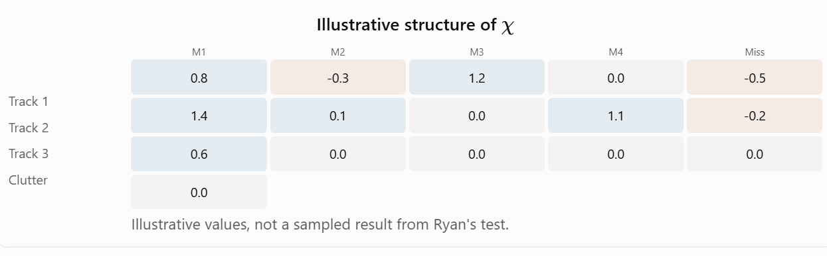
Each nonzero-score entry is a log-potential favoring or disfavoring a proposed track–measurement association. The last row represents the clutter/unassigned-measurement alternative. The last column represents the missed-detection alternative for tracks; its zero values are baseline potentials, not zero probabilities.
No entry has units of meters or meters per second.
The test is effectively asking:
Given arbitrary relative preferences between tracks and measurements, can belief propagation calculate internally consistent association probabilities?
It is not asking whether the tracker can associate two aircraft separated by 50 meters with noisy radar measurements.

Direct confirmation of The complexity claim
More importantly, I located the original 2014 NeurIPS paper, A Complete Variational Tracker.
In the abstract, and again in Section 3, the authors explicitly claim linear computational scaling with association-window length, in contrast with the exponential worst-case growth of the multi-frame MAP assignment formulation they compare against. The precise factorization in the paper is:
$$p\left(A_{1:K},X_{1:K},S_{1:K}∣Z_{1:K}\right)≈q\left(A_{1:K}\right) q\left(X_{1:K},S_{1:K}\right),$$
where $A$ represents assignments, $X$ represents target kinematic states, $S$ represents track-management states, and $K$ is the number of frames. Crucially, the VB optimization then yields
$$q\left(A_{1:K}\right)=\prod_{k=1}^{K}{q\left(A_{k}\right)}$$
while the target-state posterior retains temporal structure through separate track models.
This is an approximation to the true joint posterior, not an assertion that assignments and target states are genuinely independent. The important consequence is that the assignment calculations can be performed frame by frame without explicitly enumerating every combination of assignments across the entire window.
That is the basis for the linear-in-$K$ claim. For fixed numbers of tracks, observations per scan, model dimensions, and inference iterations, the intended architecture has work proportional to
$$O\left(K C_{scan}\right).$$
There are two significant qualifications:
- The cost $C_{scan}$ can still be substantial, particularly if single-scan assignments are enumerated exactly.
- A production MFA or MHT implementation can use gating, pruning, decomposition, and approximate search. We cannot conclude from the complexity claim alone that VB will always be faster or more accurate.
The claimed architectural advantage is real and explicitly documented. The historical MATLAB code, however, does not yet constitute a complete implementation of that advantage.
I checked the available source: both VBtracker.m and VBtracker2.m build exhaustive candidate-assignment lists for each frame. Neither calls asgMatBP.m. The belief-propagation routine is currently exercised by its standalone test.
That's an important reconstruction finding. The source contains both the exact-enumeration VB formulation and an approximate BP assignment solver, but we have not yet established their integration into the complete tracker.

How would physically realistic measurements enter the algorithm?
The bridge between the assignment test and a real radar tracker is the construction of \(\chi\). In VBtracker2.m, it builds association scores using:
Zi = getOneOfK(Z{ii}, nObs);
Xi(:, jj) = exp(logqX{jj}(:, ii));
XLZ = Xi.' * emissionLogP * Zi;
TX = [XLZ; clutterLogP * Zi];
chiN = chi0{ii} + TX;
Here:
- Xi represents posterior probabilities over discrete states for each track.
- Zi is a one-hot encoding of observed categorical measurements.
- emissionLogP contains log probabilities of observations conditioned on states.
- clutterLogP describes the observation distribution for clutter.
- chi0 supplies detection-versus-missed-detection and clutter-rate prior information.
In mathematical terms, a real track-to-measurement association score has the form
$$χ_{ij,k}=E_{q\left(x_{i,k}\right)}\left[\log{p}\left(z_{j,k}∣x_{i,k}\right)\right]+\log{\frac{P_{D}}{\left(1-P_{D}\right)λ}},$$
with the clutter alternative scored by
$$χ_{0j,k}={\log{p}}_{0}\left(z_{j,k}\right).$$
Thus the relative preference for assigning measurement j to track i, rather than clutter, includes the expected measurement log-likelihood, detection probability, expected clutter count, and clutter measurement density.

What that would look like with a Cartesian tracker
Suppose we had a track state
$$x_{k}={\left[\begin{matrix}x & y & z & v_{x} & v_{y} & v_{z}\end{matrix}\right]}^{T}$$
and a position-only measurement
$$z_{k}={\left[\begin{matrix}z_{x} & z_{y} & z_{z}\end{matrix}\right]}^{T}.$$
With Gaussian observation noise, we'd specify
$$p\left(z_{k}∣x_{k}\right)=N\left(z_{k};Hx_{k},R\right).$$
Given a Gaussian variational state distribution $q\left(x_{k}\right)=N\left(m_{k},P_{k}\right)$ the expected log-likelihood would be
$$E_{q}\left[\log{p}\left(z_{k}∣x_{k}\right)\right]=-\frac{1}{2}\left[{\left(z_{k}-Hm_{k}\right)}^{T}R^{-1}\left(z_{k}-Hm_{k}\right) +\operatorname{tr}\left(HP_{k}H^{T}R^{-1}\right) +\log\left|2πR\right|\right]$$
That's a physically meaningful association potential: it reflects the measurement residual, measurement uncertainty, and uncertainty in the state estimate. That's a physically meaningful association potential: it reflects the measurement residual, measurement uncertainty, and uncertainty in the state estimate.
$$S=HPH^{T}+R$$
VB coordinate update specifically uses the expectation of the log-likelihood. Neither of these Gaussian calculations appears in the current testAsgMatBP.m; they're what we would eventually supply to the association engine.

What about initiation, maintenance, and deletion?
Your three-stage description is exactly the operational distinction we need to recover.
And here's another interesting discovery from the paper: The explicitly designed the complete algorithm to address track initiation and deletion probabilistically, instead of relying entirely on heuristic M-of-N confirmation and coast-time rules.
He introduced active/dormant track meta-states governed by a Markov process. An active track has a higher detection probability, while a dormant track has a very low one. This gives the model a way to infer whether a hypothesized target is genuinely present, rather than requiring a fixed confirmation time.
However, our currently available MATLAB source is not yet the complete implementation of that mechanism.
Capability | 2014 paper | MATLAB code we're validating
Multiple target assignments | Yes | Yes
Missed detections and clutter | Yes | Yes
Temporal smoothing | Yes | Discrete HMM
Continuous kinematic states | Gaussian state-space model | Not in current test implementation
Active/dormant track management | Yes | Not evident in current tracker entry points
Efficient BP assignment approximation | Yes | Standalone asgMatBP.m
End-to-end BP/VB integration | Described | Not yet established
The distinction between the intended research algorithm and the surviving prototype is becoming increasingly important.

One more observation about scalability
Even a single scan can have an enormous number of feasible one-to-one assignments. For equal numbers of tracks and measurements, the number of possible partial matchings, including missed detections and clutter, is
$$N_{ass}=\sum_{r=0}^{N}{{\left({N \atop r}\right)}^{2}}r!.$$
Tracks and measurements | Feasible single-scan assignments
3 and 3 | 34
5 and 5 | 1,546
7 and 7 | 130,922
So the seven-track example is already large enough to make exact enumeration expensive. This is why asgMatBP.m matters: instead of explicitly calculating all 130,922 association hypotheses, belief propagation approximates the marginal probabilities through messages associated with the track/measurement constraints.
The factorization across time avoids compounding this per-scan combinatorial problem across the entire history. Meanwhile, the state smoother allows evidence from neighboring frames to inform each frame's assignments through repeated VB updates. That is how we can retain multi-frame information without explicitly enumerating the full joint association history.
Where I think we should go next
I would proceed in two stages. First, validate asgMatBP.m against exact enumeration, just as we planned. The current random log-potential test is appropriate for this purpose because it exercises the assignment constraints independently of any particular sensor or motion model. We should measure approximation accuracy, convergence, and sensitivity to initialization. Second, develop a physically meaningful synthetic tracking experiment. I'd begin with two or three constant-velocity Cartesian targets, realistic measurement covariance, missed detections, Poisson clutter, and crossing trajectories. Once the inference components are integrated, that experiment can measure association accuracy, track continuity, uncertainty calibration, and computational scaling as the number of previous scans increases.
The distinction I would preserve is:
- Mathematical validation: Does belief propagation solve the intended assignment approximation correctly?
- Tracking validation: Does the integrated VB formulation recover useful trajectories and identities from imperfect physical measurements?
- Scalability validation: Does measured runtime grow approximately linearly with window length when other problem dimensions remain fixed?
Those are three different claims, and our current tests address primarily the first. My conclusion is that your recollection of The central insight was remarkably accurate. The original 2014 paper explicitly confirms it. What we now need to establish is how much of that research-grade architecture survives in this MATLAB prototype and what must be integrated or extended to reproduce the complete tracker.

Where we stand in VB Tracker V&V
Component | Test | Status
Reconstructed utilities | testReconstructedUtils.m | Passed
HMM forward–backward | testFW.m Revision 3 | 2,500 passed
Markov probability conversions | testMarkov.m Revision 2 | 10,000 passed
Belief-propagation association | Original testAsgMatBP.m | 20 cases passed original assertions
Independent BP accuracy and convergence | testAsgMatBP_R2.m | Ready for MATLAB testing
Full VB tracker | VBtracker.m, VBtracker2.m | Not yet validated
The original association test revealed BP-versus-exact probability differences reaching approximately 0.0213, while transpose symmetry and row/column offset invariance held to floating-point precision.
Revision 2 — Validation results
All 108 test cases passed their programmed assertions.
This is a substantial milestone in our validation of The VB tracking code.
The most important finding is that The belief-propagation implementation converged numerically in every tested case, but its converged association probabilities are not always equal to the exact probabilities.
That's an expected possibility with loopy belief propagation, and it's precisely why we designed Revision 2 to measure accuracy and convergence separately.
Your results give us three distinct findings:
- Structural correctness: Transpose symmetry and row/column offset invariance hold near machine precision.
- Reference correctness: Independent dynamic programming agrees with exhaustive assignment enumeration to approximately $5.11×{10}^{-15}$.
- Approximation accuracy: The largest individual BP-versus-exact marginal discrepancy is 0.06671, or about 6.67 percentage points, in the deliberately ambiguous three-by-three assignment case.
That last result is worth examining carefully. A stable numerical solution is not necessarily an exact probabilistic solution.
- Additional findings from the saved MAT file
I independently inspected all 108 per-case records, not just the summary.
Median maximum marginal error
- 0.58%
90th percentile
- 2.11%
Cases above 5 points
- 2 / 108
The two largest discrepancies are:
Case | Track / measurement counts | Maximum marginal error
Three-by-three ambiguous | 3 / 3 | 0.06671
Additional-28, scale 4 | 7 / 6 | 0.05209

Both are consistent with a numerically stable approximate solution that differs from the exact association distribution. Their very small final iteration changes make incomplete convergence less likely, although the test does not prove convergence to the intended BP fixed point under all conditions.
One other reassuring observation: the worst row/column probability-mass discrepancy was $1.53×{10}^{-12}$, well within the test's ${10}^{-9}$ normalization tolerance.
Acceptance decision
I recommend accepting testAsgMatBP_R2.m as our primary association regression test, while preserving the original test and leaving the production asgMatBP.m unchanged.
I would distinguish the following two conclusions:
- Validated: The test's exact reference calculations, structural invariances, normalization properties, and observed numerical stabilization.
- Not yet established: Whether BP approximation accuracy is sufficient for a practical multi-target tracker, particularly in ambiguous association scenarios.
A 6.67-percentage-point marginal probability discrepancy is not necessarily unacceptable, but we should determine its operational consequences rather than choose an arbitrary numerical threshold.
My recommended next investigation is a controlled approximation-quality study using the two worst cases: examine sensitivity to assignment ambiguity, log-potential magnitude, iteration budget, and randomized initialization. This should help us determine whether the observed discrepancies are intrinsic to the BP approximation or could be reduced through numerical or convergence improvements.
At this point, we have successfully completed the first rigorous validation pass on the association component, just as we previously did for the HMM foundation.
We now have two interesting association problems to investigate.
Case | Tracks | Measurements | Worst BP vs. exact marginal error
Three-by-three ambiguous | 3 | 3 | 6.6712 percentage points
Additional-28-scale-4 | 7 | 6 | 5.2095 percentage points
These are maximum errors in individual association probabilities, not overall tracking error rates. Both cases also showed very small final BP iteration changes, indicating that simply allowing more iterations might not eliminate the discrepancies.

Association BP Sensitivity Study
The archive contains testAsgMatBP_Sensitivity.m. It leaves The asgMatBP.m and our accepted testAsgMatBP_R2.m unchanged.

What the study investigates
Variable | Experiment | Purpose
Association-score strength | Multiply log-potentials by 0.25–3.0 | Determine whether stronger evidence increases or decreases BP error
Assignment ambiguity | Perturb a competing 2×2 association submatrix | Examine sensitivity to closely competing assignments
Iteration count | 1, 2, 5, 10, 20, 50, 100, 200 | Separate incomplete convergence from intrinsic approximation error
Random initialization | 10 reproducible seeds | Determine whether BP converges to different solutions
For every experiment, the test recomputes exact association marginals using subset-based dynamic programming and compares them with the BP marginals.
Because The hard-coded 100 iterations into asgMatBP.m, I've included a local diagnostic copy that permits different iteration counts. The test first verifies that this copy reproduces the production routine's complete 100-iteration output with identical random initialization.
It also reconstructs the original seven-track/six-measurement case by replaying the seeded sequence of randomized association tests.
Association belief propagation: sensitivity-analysis results
All 68 sensitivity observations completed, and the numerical validation checks passed.
The most important finding is that the observed association-probability discrepancies are not simply caused by stopping The belief-propagation algorithm after 100 iterations.
In both cases, the errors persisted at 200 iterations, and all ten initialization seeds converged to the same reported accuracy. Furthermore, the diagnostic implementation reproduced The original production implementation exactly at 100 iterations.
That gives us considerably more confidence that we're observing the behavior of The intended loopy belief-propagation approximation, rather than a problem introduced during our reconstruction.
There is an important qualification: identical results from ten initializations do not establish global convergence for every possible association problem. But they are strong evidence for these two cases.

The two cases are telling us different things
I examined the CSV and saved MATLAB matrices. The seven-track/six-measurement case yields an especially useful interpretation.
The largest discrepancy occurs in the probability that measurement 6 is clutter rather than belonging to an existing track.
Measurement 6 interpretation | Exact association | The BP
Clutter/unassigned | 15.67% | 20.88%
Assigned to a track | 84.33% | 79.12%
Thus BP overestimates the clutter probability by 5.21 percentage points. The discrepancy is not merely an obscure matrix entry: it directly changes how confidently the system treats an observation as target-generated.
In the ambiguous three-by-three problem, two tracks have identical association preferences for two competing measurements, while a third track strongly favors the third measurement. The exact solution gives each competing track approximately 44.19% probability for each of the first two measurements.
This is precisely the kind of ambiguity that creates difficult track-maintenance problems.

The iteration experiment separates convergence from approximation error
Iterations | Ambiguous 3×3 error | Seven-track/six-measurement error
1 | 28.88% | 89.62%
5 | 7.81% | 15.86%
10 | 7.37% | 4.95%
20 | 6.68% | 5.04%
50 | 6.67% | 5.21%
100 | 6.67% | 5.21%
200 | 6.67% | 5.21%
The percentages are maximum absolute marginal-probability discrepancies. Early-iteration values do not necessarily represent normalized, converged association distributions.
The striking result is that 100 to 200 iterations produced essentially no improvement. Also, the seven-track case has slightly less error at 10 iterations than at convergence. That's not evidence that stopping early is better: its probability constraints were still violated by approximately 5.77 percentage points at that stage.
This confirms that convergence accuracy and approximation accuracy are fundamentally different properties.

Ambiguity is a major driver of the discrepancy
The tie-breaking experiment is perhaps the most revealing part of your results.

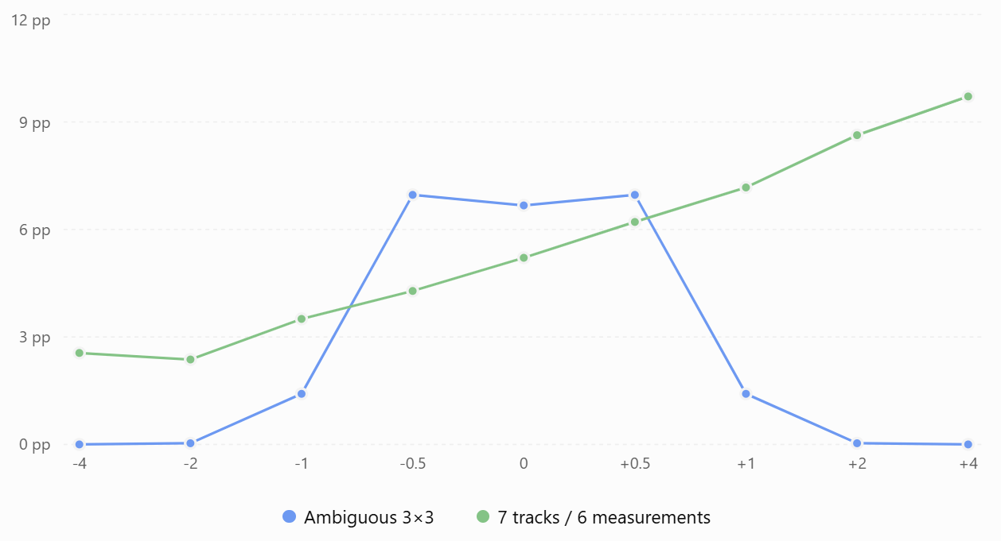
Figure 5 Maximum BP-versus-exact error as association preferences change
For the symmetric three-by-three case, making one of the competing assignments decisively preferable reduces the BP error dramatically.
The seven-track case is more complicated: biasing its selected competing assignments in one direction generally worsens the approximation, while biasing them in the other direction reduces it. This indicates that the approximation error depends on the entire network of competing associations, not simply the magnitude of one ambiguity.
All these tie-breaking experiments exhibited small final iteration changes and good probability normalization.

A new issue: 100 iterations are not always sufficient
I found something in the strength sweep that deserves attention beyond our original two cases.
Case, with potentials multiplied by 3 | Error vs. exact | Final BP change | Probability-mass discrepancy
Ambiguous 3×3 | 2.27% | 0.00594 | 0.00612
Seven-track/six-measurement | 15.63% | 0.000422 | 0.000818
These are substantially larger convergence residuals than our baseline cases. That means the fixed 100 iterations can be insufficient when the association log-potentials become more strongly differentiated. We should not yet describe those 2.27% and 15.63% discrepancies as intrinsic BP approximation errors, because the solver was not fully stabilized. A longer iteration budget might change them. This is a distinct issue from the 6.67% and 5.21% baseline errors, which persist after numerical stabilization.

My V&V assessment
Question | Finding
Does our diagnostic implementation reproduce The BP algorithm? | Yes, exact agreement at 100 iterations
Does the exact DP reference remain numerically reliable? | All executed oracle checks passed
Does BP depend materially on random initialization in these two baseline cases? | No measurable dependence across ten seeds
Are the original 5–7 percentage-point errors caused by too few iterations? | No
Can association ambiguity increase approximation error? | Yes, substantially in these cases
Can the hard-coded 100 iterations be inadequate for other inputs? | Yes, demonstrated by the high-strength tests
Is the full tracking algorithm validated? | No
I would now classify asgMatBP.m as structurally validated, with characterized approximation error and an identified convergence limitation. That's a meaningful distinction from simply declaring the code passed.

Recommended next step
I recommend one final, tightly focused BP investigation before we move into full tracker integration.
We should extend the iteration budgets to 200, 500, and 1,000 for the stronger log-potential cases, measuring when both the message changes and probability-mass constraints stabilize. That will tell us whether the fixed 100-iteration implementation requires convergence monitoring or whether these stresses reveal more difficult numerical behavior.
We should also preserve the baseline ambiguous scenarios in our future regression tests, since those cases are particularly informative about association quality.
After that, I would move beyond arbitrary Gaussian-generated log-potentials and start testing association scores derived from realistic sensor measurements and predicted track-state distributions. That will let us assess whether the approximation errors actually produce incorrect associations, identity swaps, or degraded track continuity.
My recommendation is to leave matlab production code untouched for now. The sensitivity study has already exposed a much clearer picture of its strengths and limitations; the next experiment can determine whether the iteration limit needs attention before we integrate the BP solver into the complete VB tracker.
Let’s reconsider. Rather than selecting 100, 200, or 500 iterations in advance, we should allow belief propagation to stop when it has demonstrably stabilized, subject to a maximum iteration budget.
And yes, the next logical experiment is to test that behavior with both our existing problematic association cases and association scores derived from physically meaningful track and sensor measurements.
I've prepared a new MATLAB experiment that addresses both questions.
The primary file is testAsgMatBP_AdaptivePhysical.m. It is standalone except for its dependency on The original asgMatBP.m.

Adaptive convergence
I've implemented a diagnostic version of The BP equations with the following initial stopping policy:
Parameter | Value
Minimum iterations | 8
Maximum iterations | 2,000
Maximum marginal-probability change | $${10}^{-10}$$
Maximum normalization residual | $${10}^{-8}$$
Consecutive successful iterations before stopping | 5
The algorithm evaluates the change in association probabilities after each iteration. It stops when both the probability-change and normalization criteria hold for five consecutive iterations.
This provides two advantages: easy problems can terminate before 100 iterations, while difficult problems can continue beyond 100 if required. The test also checks that the diagnostic implementation exactly reproduces The production function when configured for 100 iterations and given identical random initialization.
Importantly, a small iteration-to-iteration change indicates numerical stabilization, not necessarily agreement with the exact association probabilities.

Revisit our two problematic cases
The first experiment revisits the ambiguous 3×3 problem and the seven-track/six-measurement problem, including their log-potentials multiplied by three.
That second condition is especially relevant because our previous sensitivity results showed that the 100-iteration limit could be inadequate when assignment preferences were stronger.
We will compare fixed-100 and adaptive results against the exact association marginals computed by subset dynamic programming.

Introduce physically meaningful measurements
The second experiment simulates three moving targets with Cartesian states
$$x_{k}={\left[x, y, v_{x}, v_{y}\right]}^{T}$$
and noisy position measurements, missed detections, and spatially distributed Poisson clutter.
It tests three scenarios:
Scenario | Measurement noise (1σ) | Expected clutter per scan | Scans
Crossing trajectories | 25 m | 2 | 36
Crossing, noisier sensor | 60 m | 4 | 36
Well-separated trajectories | 25 m | 2 | 36
The association scores are derived from Gaussian measurement likelihoods, predicted state covariance, detection probability, and clutter intensity—not random randn assignment preferences.
This is an important intermediate test. The reference Kalman filters use known measurement identities for their updates, which isolates association inference from errors in track management. We are not yet testing the complete VB tracker.

What I expect us to learn
Three results will be particularly revealing.
First: The distribution of required iterations. Perhaps most cases require fewer than 30 iterations, while a small subset requires hundreds. That would support your recommendation to use an adaptive stopping policy.
Second: Whether additional iterations correct the high-strength cases that were still evolving at iteration 100. If they do, we've identified a genuine limitation of the hard-coded iteration count.
Third: Whether BP approximation errors materially alter the most probable measurement-to-track assignment in crossing-target scenarios. That will begin connecting numerical discrepancies to tracking-relevant decisions.
I also want to retain the ability to distinguish convergence failures from intrinsic approximation errors. A solver can converge perfectly and still give inaccurate marginals.
My recommendation is to keep The production asgMatBP.m unchanged until we see these results. If adaptive stopping proves reliable, we can subsequently introduce a controlled, configurable iteration policy into the production routine and preserve the original implementation as our historical reference.
Adaptive BP validation: what we learned
All 112 cases passed the numerical checks, and the adaptive solver met its stopping criteria in every case.
The intuition about convergence-based stopping was supported by the experiment. A fixed budget of 100 iterations is unnecessarily large for many association problems and insufficient for some more challenging ones.
Median iterations
- 12
Stopped before 100
- 108/112
Maximum iterations
- 479
I also examined the per-scan CSV and saved MATLAB matrices. They reveal something more interesting than the overall pass result: the largest BP approximation errors are concentrated near the crossing of target trajectories, even when the algorithm has converged. This is directly relevant to the multi-target tracking application we're eventually trying to reconstruct.
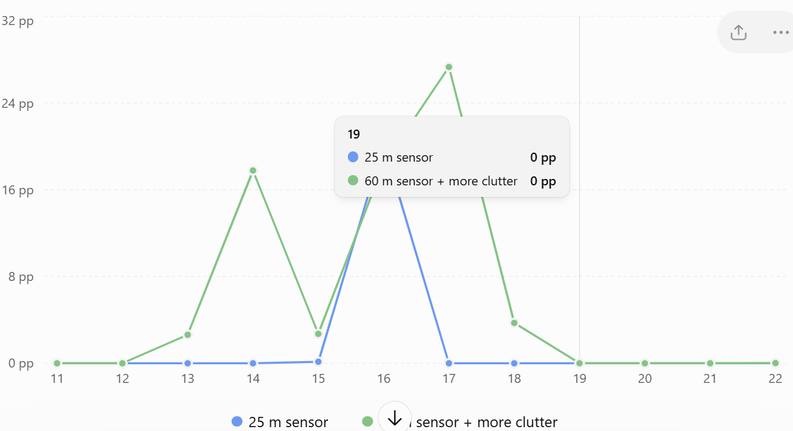
Figure 6 Maximum BP marginal-probability error by scan. Errors are absolute percentage-point discrepancies between adaptive BP and exact single-scan assignment probabilities.
The more challenging 60-meter sensor scenario exhibits a cluster of approximation errors around scans 13–18.
At scan 17, for example, we find the following probabilities for one measurement:
Candidate association | Exact | Adaptive BP
Track 1 | 65.1% | 90.1%
Track 2 | 33.4% | 6.1%
Both methods select Track 1, but BP is dramatically more confident.
This is an important tracking implication: BP may preserve the highest-probability association while substantially understating ambiguity.
That could matter when association probabilities are fed back into a track-state estimator. An overly confident incorrect association can pull a state estimate toward the wrong measurement and potentially increase the risk of an identity swap.
We haven't established that feedback effect experimentally yet, because the current experiment updates its reference Kalman filters using the known measurement identities.

Adaptive convergence is working as intended
The cases requiring more than 100 iterations were:
Case | Iterations to stopping criterion
Ambiguous 3×3, strong potentials | 479
Seven-track/six-measurement, strong potentials | 355
Crossing 25 m, scan 16 | 256
Crossing 60 m, scan 17 | 120
Across the 108 physical scan tests, 106 terminated before 100 iterations.
The measured cumulative solver time was approximately 57.3 ms for fixed-100 versus 21.3 ms for adaptive BP—a 2.7× difference in this small experiment. I would treat that as preliminary timing evidence, not yet a production performance benchmark.
One qualification: the 12-iteration median partly reflects our policy of requiring at least eight iterations and five consecutive stable iterations. It doesn't establish that 12 iterations is the mathematical minimum.

Actual association decisions
I also checked the individual measurement labels saved in the MAT file.
Physical scenario | Correct target-generated measurement choices | Correct clutter classifications
Crossing, 25 m | 97 / 99 | 60 / 60
Crossing, 60 m, more clutter | 85 / 93 | 126 / 133
Well-separated, 25 m | 103 / 103 | 80 / 80
Total | 285 / 295 | 266 / 273
These are per-measurement maximum-marginal decisions, not globally optimized assignment decisions.
Interestingly, exact inference and BP made identical top-choice decisions in all these tested scans. That includes their mistakes. Consequently, the experiment does not establish a difference in hard-assignment accuracy between the two methods.
It does establish a potentially significant difference in the confidence attached to those decisions.

One important limitation in the physical experiment
There were 1,034 track/measurement log-potential entries clipped to the lower bound of -40, out of 1,704 possible entries—approximately 61%.
For well-separated tracks, this is understandable: most track/measurement pairs should be extremely unlikely.
But this numerical floor also means many of our test problems become almost deterministic. That helps explain why BP agrees with exact inference to machine precision across so many scans.
It does not invalidate the experiment, but we should explicitly study how this floor interacts with gating, uncertainty, and association ambiguity before adopting it as a production modeling choice.

My recommended next step
I think we have enough evidence to accept adaptive convergence monitoring as the preferred direction for the BP solver, although not yet to replace The original production function.
The next experiment should concentrate on the remaining question: When BP and exact inference choose the same association, does the difference in marginal confidence matter to subsequent tracking?
I recommend a controlled multi-scan study in which the Kalman filters are updated from inferred association probabilities rather than ground-truth measurement identities. We'd compare exact association, fixed-100 BP, and adaptive BP on identical target trajectories, including crossing and closely spaced targets. We should measure state-estimation error, identity switches, association-confidence calibration, convergence, and runtime over multiple random seeds.
That would move us from validating the assignment solver in isolation toward evaluating its impact on the actual tracking problem—without yet needing to modify The complete VB implementation.
My conclusion: We've confirmed the proposed adaptive-stopping strategy is promising, and we've identified the more consequential open issue: not convergence, but the fidelity of BP's association probabilities under target ambiguity. That's the issue I'd investigate next.
There is one distinction worth sharpening: we have demonstrated that loopy belief propagation can become overconfident precisely in the ambiguous crossing-target situations where multiple-frame evidence should be especially valuable. We have not yet demonstrated that this overconfidence produces track swaps.
Consider the result from our 60-meter measurement-noise experiment at scan 17:
Association hypothesis | Exact probability | Loopy BP probability
Measurement belongs to Track 1 | 65.1% | 90.1%
Measurement belongs to Track 2 | 33.4% | 6.1%
Both algorithms favor Track 1. But they express very different levels of confidence.
The exact calculation effectively says, "Track 1 is more likely, but Track 2 remains a credible alternative."
Loopy BP says, "I'm approximately 90% confident it's Track 1."
That's a potentially consequential difference.

Why multiple-frame inference matters here
Imagine two aircraft crossing at nearly the same position. At the instant of crossing, their sensor measurements may be practically indistinguishable.
A conventional single-scan association algorithm has relatively little information to resolve the ambiguity. However, observations several frames before and after the crossing can reveal which continuation is dynamically more plausible.
This is exactly where The VB architecture becomes interesting.
His formulation can use the temporal state model to incorporate information from multiple frames when estimating target states and association probabilities. Although his variational approximation factorizes the association distribution across frames, the associations remain indirectly coupled through the smoothed target-state distributions and iterative VB updates.
Conceptually,


The potential problem with overconfident BP
Suppose the 90% association probability is fed into the VB state-estimation update.
The state estimate may then move more strongly toward the measurement associated with Track 1 than it would under the exact 65% probability.
That could influence subsequent association calculations, creating a feedback loop:
Overconfident association → biased state estimate → altered future association probabilities → possible reinforcement of the original association.
In a sufficiently difficult crossing scenario, that could make an identity swap more likely or make a mistaken association harder to reverse. But there is an important counterargument: the smoother may use future measurements to correct the state estimates, causing the next VB iteration to revise the association probabilities. That ability to revisit previous associations is part of the potential advantage of The method.
Whether the correction actually succeeds depends on the interaction between the approximate association marginals, the state smoother, and the VB iteration process.
What our current experiments do—and do not—establish
Our physical association experiment deliberately used Kalman filters updated with the known correct measurement identities. That isolated the association solver.
Consequently, we have not yet allowed an overconfident association to contaminate the track-state estimates and propagate into future scans.
That's the missing experiment.
I would now investigate three competing approaches on identical crossing trajectories:
- Exact single-frame association marginals incorporated into a multi-frame state-estimation loop.
- The fixed-100-iteration loopy BP marginals in the same loop.
- Adaptive-convergence loopy BP marginals in that loop.
We would measure position/velocity estimation error, track identity switches, association-confidence calibration, and—especially important—the ability to recover an initially ambiguous or incorrect association after subsequent measurements arrive.
The scientific question is whether multi-frame VB smoothing can overcome the approximation errors introduced by loopy BP, or whether those errors sometimes undermine the very temporal disambiguation the VB formulation is intended to provide.
That's a particularly worthwhile question because it connects The original architectural advantage directly to observable tracking performance, rather than just numerical properties of the assignment solver.

How many previous scans were involved in producing the final measurement to track association probability?
Zero previous scans were explicitly included in the association inference. Our most recent experiments used single-scan belief propagation, not The multi-frame Variational Bayesian tracking formulation.
That's an important distinction, particularly given our discussion about crossing targets and track identity swaps.
Here's exactly what we tested:
- We generated 36 consecutive scans containing three moving targets, missed detections, and clutter.
- At each scan, we calculated association log-potentials using the current measurements and predicted track states.
- We applied loopy BP and exact enumeration/DP independently to that scan's association problem.
- We compared the resulting association probabilities.
There is one subtlety: the Kalman predictions did carry information forward from previous scans, because the filters recursively updated their states using measurements with known correct identities. But those updates did not use the BP association probabilities.
Consequently:
Capability | Our latest experiment
Current-scan measurement association | Yes
Predicted states informed by earlier observations | Yes
Joint association inference across multiple scans | No
Backward smoothing using future measurements | No
Iterative refinement between BP association and state estimation | No
Testing actual track identity swaps and recovery | No
This means the 27.3-percentage-point BP discrepancy at the crossing was calculated using only the current scan's association hypotheses and the predicted track distributions, not the joint evidence from several frames.
And this gets to the heart of the question. We have not yet tested The principal multi-frame VB innovation. We have validated the underlying HMM and assignment inference machinery separately, but not their coordinated operation over an association window.
I would therefore make our next V&V priority an integrated multi-frame experiment, ideally starting with 3, 5, 10, and 20 scans, measuring both association accuracy and computational scaling as the window increases.
That would finally put the original linear-in-window-length claim—and his ability to resolve ambiguous crossing trajectories using temporal evidence—to a meaningful test.

What we're testing Next
For the first time, we're coupling measurement-to-track association with temporal HMM smoothing in a variational iteration.
The test reconstructs the core coordinate-update equations in the VBtracker2.m and calls his original softForwardBackward.m and asgMatBP.m functions.
It compares two methods on identical synthetic crossing-target measurements: exact single-scan assignment probabilities embedded in a multi-frame VB loop, and The loopy BP probabilities embedded in that same loop.
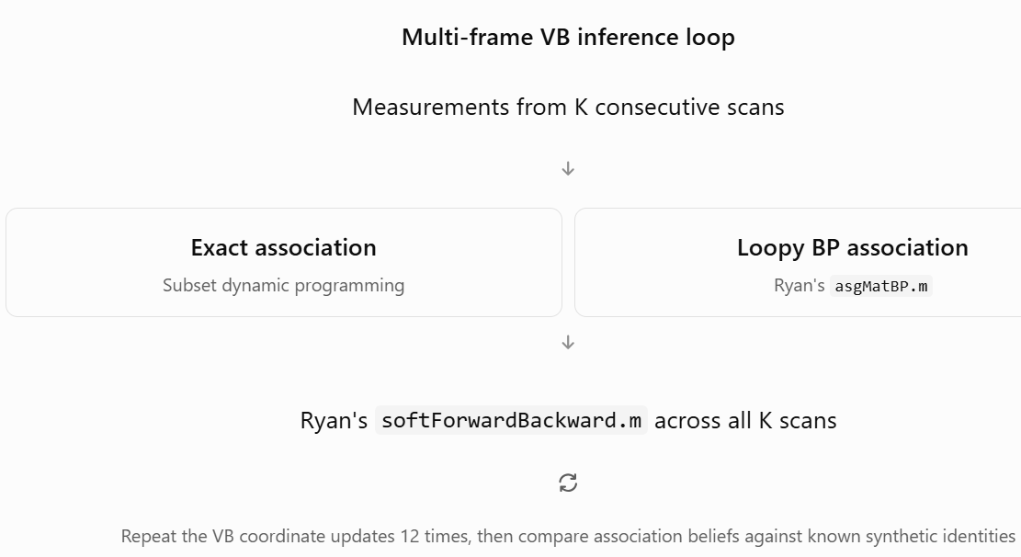
Figure 7 Compare two methods on identical synthetic crossing-target measurements

Experimental design
Parameter | Value
Targets | 2 crossing targets
Position observations | Cartesian position quantized into 30 m bins
Measurement noise | 40 m and 70 m
Probability of detection | 0.92
Average clutter | 0.8 measurements per scan
Observation sequence | 30 scans
Association window lengths | 1, 3, 5, 10, 20 scans
VB iterations | 12 fixed per window
Initial trials | 5 per scenario
The principal measurements will be the probability assigned to the correct target, highest-probability association accuracy, negative log probability of the true assignment, BP-versus-exact discrepancies, and execution time.
We'll also conduct a separate retrospective experiment: revisit the association at crossing scan 16 after receiving additional measurements through scans 18, 22, and 26. That directly tests whether future evidence helps correct earlier ambiguity.
One scope qualification: this is a focused discrete-state integration test based on The VB update equations, not yet a direct execution of his entire VBtracker2.m entry point or a continuous-state Kalman tracker. Each window also starts with an uninformative position prior, rather than carrying a mature track prior from earlier windows. Those limitations are explicitly documented.

What would constitute an important result?
I am particularly interested in whether increasing the association window from one to five or ten scans increases the probability of the correct identity near the crossing, and whether loopy BP's previous overconfidence becomes less consequential after repeated temporal smoothing.
Improvement is a hypothesis, not a guaranteed outcome. We should also watch for cases where additional frames reinforce a mistaken association.
If the experiment supports your intuition, we'll have our first direct evidence of The intended multi-frame advantage. If it doesn't, the results should help isolate whether the limitation is in the assignment approximation, state model, or VB iteration process.
This is where we begin testing the central reason The developed the architecture, rather than only its constituent algorithms.

Results
We have positive news—substantially positive, in fact. This is our first experimental evidence that The multi-frame VB architecture can use temporal context to improve measurement-to-track association dramatically.
I examined both your CSV and the saved MATLAB results, including individual association matrices. The results also reveal a problem we need to understand before declaring victory: although longer windows generally improve performance, they can sometimes produce a confidently incorrect association.
I think this is the most informative V&V experiment we've conducted so far.

The principal result: scan depth makes a substantial difference
Across both measurement-noise scenarios, we evaluated the same target detections using windows of 1, 3, 5, 10, and 20 scans.
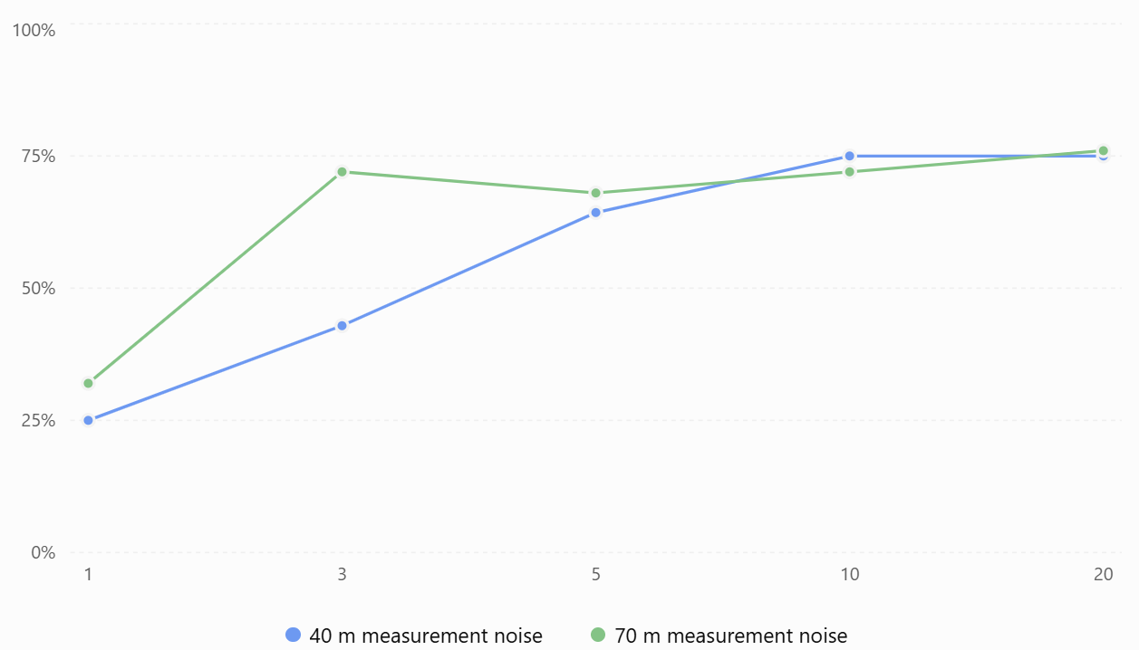
Figure 8 Correct measurement-to-track association rate using loopy BP

Here are the exact counts at the two extremes:
Scenario | Single scan (K=1) | Twenty scans (K=20)
40 m noise — Exact association | 6/28 (21.4%) | 21/28 (75.0%)
40 m noise — Loopy BP | 7/28 (25.0%) | 21/28 (75.0%)
70 m noise — Exact association | 9/25 (36.0%) | 19/25 (76.0%)
70 m noise — Loopy BP | 8/25 (32.0%) | 19/25 (76.0%)
Combined BP accuracy, K=1
28.3%
15 of 53 detections
Combined BP accuracy, K=20
75.5%
40 of 53 detections
That is a 47.2-percentage-point improvement across the combined tested detections.
It directly supports your hypothesis that historical measurement context can substantially mitigate single-scan association ambiguity.
The qualification is that each window starts with an uninformative prior, so part of the improvement reflects recovery from cold-start conditions. We cannot yet claim the same gain relative to a mature single-scan tracker carrying an established state estimate.

More importantly, multi-frame smoothing improves association confidence
The correct-association probability is often a more informative measure than whether the highest-ranked assignment happens to be correct. Consider the 40-meter scenario:
Window | Mean probability of true assignment, Exact | Loopy BP
1 scan | 0.196 | 0.189
3 scans | 0.421 | 0.415
5 scans | 0.639 | 0.631
10 scans | 0.803 | 0.803
20 scans | 0.805 | 0.805
This is especially encouraging. With one scan, the VB algorithm has little information for discriminating between targets. With 10–20 scans, the temporal state model supports much stronger probability assignments to the correct identities. Furthermore, at K=10 and K=20 in this scenario, exact per-scan assignment and loopy BP produce nearly identical results.
That suggests that, in this regime, the additional temporal information can make the approximation error associated with BP much less consequential. However, the 70-meter experiment is more difficult: its K=20 BP-versus-exact discrepancy still reaches 17.8 percentage points. Multi-frame evidence helps there too, but it does not eliminate all approximation error.

An important discovery: we actually observed a possible identity-swap mechanism
I looked at the stored association matrices for trial 1, scan 20, in the 40-meter scenario.
The different window lengths produce the following behavior:
Window | Mean probability of true assignment, Exact
K=1 | 0.468
K=3 | 0.982
K=5 | 0.005
K=10 | 0.983
K=20 | 0.980
The K=5 result is particularly interesting.
Inspecting the actual association matrix, the two target-generated measurements are assigned overwhelmingly to the opposite tracks:
- One measurement receives approximately 97.6% probability for the incorrect track.
- The other receives approximately 96.6% probability for the incorrect track.
At K=20, those same two measurements receive approximately 97.6% and 98.3% probabilities for their correct respective tracks.
This is more than a small numerical discrepancy. It is a near-complete reversal of the inferred target identities at K=5, followed by correct associations at longer windows.
And there is a crucial detail: the exact-association version exhibits essentially the same mistake at K=5.
Therefore, this particular failure cannot be attributed primarily to loopy BP. It appears to arise from the multi-frame VB inference process itself—potentially the initialization, the nonconvex variational objective, track-label symmetry, or failure of the fixed coordinate iterations to reach a preferable solution.
I would not yet call it a confirmed persistent track swap because we're examining an assignment at a particular scan, not continuity of identities over a full operational track. But we've uncovered a compelling case to investigate.
What about computational scaling?
The measured BP execution time also supports The architectural claim, at least over the window sizes tested.
Window length | 40 m cumulative BP time | 70 m cumulative BP time
1 | 0.115 s | 0.106 s
3 | 0.349 s | 0.324 s
5 | 0.546 s | 0.517 s
10 | 1.058 s | 0.992 s
20 | 2.002 s | 1.911 s
Doubling the window length from 10 to 20 increases execution time by approximately 1.89× and 1.93×, respectively.
A simple linear fit against K has an $R^{2}$ exceeding 0.999 for both scenarios.
That is consistent with approximately linear scaling in the number of scans for this particular implementation and fixed computational budget.
But two caveats matter. These times use a fixed 12 VB coordinate iterations, not a convergence-controlled optimization. And our exact comparison algorithm solves the assignments independently within each scan—it is not an exact combinatorial MFA solution across the complete window. We have not yet benchmarked The approach against a conventional high-performance MFA algorithm.

Does retrospective smoothing repair ambiguous associations?
This is where the evidence becomes mixed.
In the 40-meter scenario, the mean probability of the correct assignment at crossing scan 16 increases from 0.318 when using observations through scan 16 to approximately 0.562 when incorporating observations through scan 26.
That's promising, although the hard-assignment accuracy does not improve beyond four of nine evaluated detections.
In the noisier 70-meter scenario, the corresponding mean probability actually moves from 0.437 to 0.417, and the correct-assignment count decreases from five of nine to four of nine.
So we have demonstrated that future measurements can influence earlier associations, but we have not yet established reliable retrospective identity recovery.
In certain cases, additional data can reinforce the wrong hypothesis.

What I would change in our next experiment
I would now focus on the variational optimization process, rather than immediately introduce a larger or more complicated tracking scenario.
We have two unresolved numerical questions:
- Are the surprising identity reversals a consequence of our fixed 12 VB coordinate iterations, or are we converging to different local optima as window length changes?
- How much of the BP-versus-exact discrepancy remains after both the inner assignment solver and outer VB coordinate iterations have converged?
I recommend a next test that uses the same crossing scenarios but adds convergence monitoring for the outer VB iterations, multiple controlled initializations, and our adaptive inner BP stopping rule.
Most importantly, I would preserve the trial-1, scan-20, K=5 versus K=10 case as a deterministic diagnostic. We should investigate why adding five more frames changes the inferred identities so dramatically.
I would also extend the number of synthetic trials before making statistical performance claims; the present five trials per scenario are informative but not enough for reliable estimates of track-swap frequency.

My assessment
The central multi-frame premise has passed its first meaningful empirical test.
The results support three conclusions: multi-frame VB inference can substantially improve association accuracy, loopy BP does not necessarily undermine those improvements, and the measured computational cost is approximately linear with window length over our tested range.
However, temporal depth is not an unconditional cure. The K=5 identity reversal shows that the VB optimization itself deserves scrutiny, and the retrospective results show that future evidence does not always correct an earlier association.
I would classify our current status as multi-frame architectural feasibility demonstrated; numerical optimization and identity continuity not yet validated.
That is meaningful progress. We've moved from testing independent mathematical functions to observing the central behavior The designed the architecture to provide—and we've identified a specific, reproducible failure case that can guide the next validation experiment.

Subset Dynamic Programming: How We Used It to Calculate Exact Assignment Probabilities
Dynamic programming (DP) is a computational technique that solves a problem by breaking it into smaller, overlapping subproblems and reusing their results. Rather than enumerating every possible solution independently, DP combines solutions that share the same relevant intermediate state.
In our VB Tracker validation, we used subset dynamic programming to calculate exact marginal measurement-to-track association probabilities, providing an independent reference against which to evaluate The approximate loopy belief propagation (BP).
The assignment problem
Suppose we have two existing tracks, $T_{1},T_{2}$, and two measurements, $M_{1},M_{2}$. The association scores, expressed as relative probability weights rather than log-potentials, are:
 | Measurement 1 | Measurement 2
Track 1 | 4 | 1
Track 2 | 1 | 3
For simplicity, assign weight 1 to each clutter and missed-detection alternative.
Each track can receive at most one measurement, and each measurement can belong to at most one track.
There are seven feasible association hypotheses:
Hypothesis | Weight
Both measurements are clutter | 1
Only$T_{1}→M_{1}$ | 4
Only $T_{1}→M_{2}$ | 1
Only $T_{2}→M_{1}$ | 1
Only $T_{2}→M_{2}$ | 3
$T_{1}→M_{1}, T_{2}→M_{2}$, | 12
$T_{1}→M_{2}, T_{2}→M_{1}$ 1
The partition function, which normalizes the probability distribution, is the sum of these weights:
$$Z=1+4+1+1+3+12+1=23.$$Therefore, the exact marginal probability that Measurement 1 belongs to Track 1 is
$$P\left(T_{1}→M_{1}\right)=\frac{4+12}{23}=.69565$$
Notice that we summed over all globally valid hypotheses containing that association. Simply normalizing the first column of the score matrix would not give the correct answer because it would ignore competition for Measurement 2.
Where dynamic programming enters
For two tracks and two measurements, enumerating seven possibilities is trivial. But the number of feasible assignments grows combinatorially. DP avoids separately exploring all complete hypotheses. Our implementation processes the measurements sequentially and maintains a state describing which tracks have already been assigned. A bitmask represents that subset. For two tracks, there are only four subset states:
- 00: Neither track assigned.
- 01: Track 1 assigned.
- 10: Track 2 assigned.
- 11: Both tracks assigned.
After processing Measurement 1, the DP table contains weights of 1, 4, and 1 for the first three reachable subsets. When processing Measurement 2, it updates those accumulated weights, respecting the constraint that a track cannot be used twice. The final accumulated weights become:
Used-track subset | Accumulated weight
00 | 1
01 | 5
10 | 4
11 | 13
Total | 23
The partition function agrees exactly with enumeration. We then combine forward and backward subset calculations to recover the individual association marginals without listing all complete assignments. Mathematically, the computational complexity is approximately
$$O\left(MN2^{N}\right)$$
for N tracks and M measurements, assuming this track-subset representation.
This remains exponential in the number of tracks, but is often dramatically more efficient than enumerating all feasible assignments. It is also important that our DP uses summation of probabilities, not maximization of scores. A maximum-weight assignment algorithm would identify one best hypothesis, whereas we need the marginal probability of every possible track–measurement pairing.

How we used Dynamic Programming in experiments
In testAsgMatBP_R2.m, the function exactSubsetDP() computes these exact association marginals, while asgMatBP.m calculates The approximate BP marginals.
We verified the DP reference independently against complete enumeration in 28 selected cases; the maximum discrepancy was approximately $5.11×{10}^{-15}$.
In our subsequent sensitivity and multi-frame experiments, we continued using exact subset DP to establish what the single-scan association probabilities should be. We could then measure how closely BP approximated them.
In the latest multi-frame VB experiment, the exact association marginals were recomputed within each scan as part of an iterative VB procedure involving temporal HMM smoothing.
One critical distinction: Our DP produces exact association probabilities conditional on the log-potentials supplied for that scan. It does not solve the complete multi-frame joint association problem exactly. The overall VB procedure remains a variational approximation.
That distinction is why the exact-association and BP multi-frame versions could occasionally agree on a confidently incorrect track identity.
Bottom line: Dynamic programming gave us a computationally tractable mathematical reference for assignment probabilities. Without it, we could observe BP convergence but wouldn't know whether the converged probabilities were accurate. The DP reference is what allowed us to distinguish numerical convergence from approximation error throughout today's V&V work.
Our next priority should be validating convergence of the complete multi-frame VB coordinate-update loop, particularly the surprising identity reversal we observed in the crossing-target experiment.
We have reached an important distinction in our V&V:
Component | Current status
Forward–backward HMM inference | Validated against independent references
Markov probability transformations | Validated
Single-scan association and loopy BP | Validated structurally; approximation error characterized
Adaptive inner BP convergence | Promising; tested in controlled experiments
Multi-frame VB association | First positive results, but optimization behavior not yet validated
Complete continuous-state tracker | Not yet tested
The last experiment showed that increasing the window from one to 20 scans improved combined correct-association accuracy from 28.3% to 75.5%. But it also exposed a more revealing case: at scan 20, a five-scan window assigned both measurements to the wrong tracks with high confidence, while a ten-scan window recovered the correct identities.
Both exact per-scan association and loopy BP exhibited that reversal. Therefore, I would investigate the outer VB optimization before attributing the problem to BP or designing more elaborate tracking scenarios.

Next experiment: Outer VB convergence and identity recovery
I've prepared a focused MATLAB test that addresses this question without changing The production code.
It uses the same synthetic data generator and mathematical routines as our previous multi-frame test, but changes the experimental design in three ways:
- Outer iteration depth: Run 80 VB coordinate iterations, recording results after iterations 1, 3, 6, 12, 25, 50, and 80. We can determine whether the 12 iterations used previously were adequate.
- Convergence monitoring: Measure changes in both \(q(A)\), the association distribution, and \(q(X)\), the smoothed state distribution. Record when an adaptive stopping rule would have fired, but continue to 80 iterations to check for premature stabilization.
- Initialization sensitivity: Repeat the problematic five- and ten-scan cases with alternative initial beliefs. This helps distinguish an under-converged solution from convergence to different local optima.
The experiment uses both exact per-scan association and The original loopy BP, with 40 m and 70 m measurement-noise scenarios. It also verifies that the results at iteration 12 reproduce our earlier experiment.

What determines our subsequent direction?
If increasing outer iterations corrects the K=5 identity reversal, our next task is to develop a reliable outer VB convergence criterion, analogous to the adaptive stopping logic we explored for inner BP.
If different initializations produce different stable identities, we'll have evidence of multiple competing VB solutions, and initialization or multistart inference becomes important.
If neither explains the reversal, we should examine the model's temporal information and window initialization more closely before moving to a continuous-state formulation.
My preference is to resolve this specific, reproducible ambiguity before increasing the complexity of the tracking model. It gives us a controlled way to understand whether The multi-frame inference is delivering its intended benefit—and under what conditions it can fail.

Outer VB convergence: the results are revealing
All 36 runs completed, and all 16 checkpoints reproduced our earlier experiment.
We have now answered an important question about the puzzling identity reversal in The multi-frame VB tracker.
The five-scan failure is not simply caused by stopping after 12 VB iterations.
In the 40-meter crossing experiment at scan 20:
Window | Method | P(correct identity), iteration 12 | Iteration 80 | Final correct assignments
K=5 | Exact association | 0.00455 | 0.00379 | 0/2
K=5 | Loopy BP | 0.00354 | 0.00181 | 0/2
K=10 | Exact association | 0.98255 | 0.98255 | 2/2
K=10 | Loopy BP | 0.98261 | 0.98261 | 2/2
Furthermore, all three tested initializations converged to virtually identical answers for each window length.
This is strong evidence that five scans and ten scans lead the VB iteration to different stable association solutions. Increasing the number of iterations cannot rescue the five-scan result under the tested initialization perturbations.
It also reinforces a positive finding: the ten-scan window correctly resolves both identities, and exact association and loopy BP agree almost perfectly.
The remaining question is why the additional temporal observations produce such a profound change. That deserves closer inspection before we modify the algorithm.
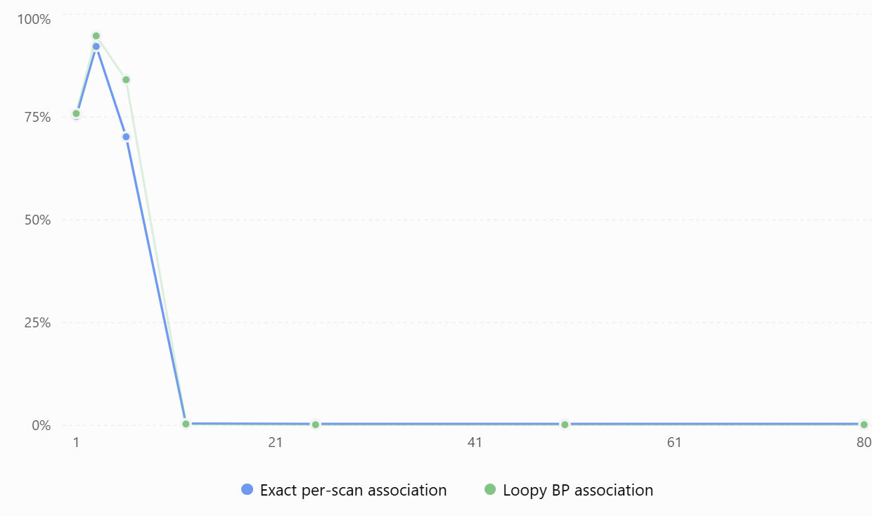
Figure 9 40 m crossing, K=5: probability assigned to the correct identity
At iteration 3, both methods appear to be approaching the correct association. By iteration 12, they've essentially exchanged the two track identities, and by iteration 32 both have stabilized.
This tells us the failure is not merely an initial bad association.
It also suggests that the VB optimization is reinforcing a different identity interpretation as its state beliefs and assignment probabilities interact.
However, we cannot yet say this solution is an inferior local optimum of The variational objective: we have not compared the actual evidence lower bound (ELBO) for the competing solutions.

The window boundary may explain the identity reversal
This is the strongest hypothesis I would investigate next.
All the experiments end at scan 20, but the windows begin at different times:
Window | Scans included | Relationship to crossing at scan 16 | Final identity result (40 m)
K=3 | 18–20 | After crossing | Correct
K=5 | 16–20 | Begins at crossing | Swapped
K=10 | 11–20 | Includes pre-crossing history | Correct
K=20 | 1–20 | Includes substantial history | Correct
The five-scan window begins at precisely the most ambiguous part of the trajectory.
The ten-scan window includes five observations preceding that point, potentially supplying the continuity evidence needed to preserve track identity.
That is exactly the behavior you hoped multi-frame inference would deliver.
There is an essential qualification, however: each experimental window starts with an uninformative prior. In a mature tracker, we would normally carry established identity and state information into the window.
In addition, if the two tracks are exchangeable under the model and initial conditions, swapping their labels may produce an equally valid probabilistic solution. We must therefore distinguish a true tracking failure from label ambiguity introduced by our experimental initialization.
I consider window initialization and identity anchoring the highest-priority issues to investigate.

A second discovery: our proposed outer convergence test is insufficient
The 70-meter, K=1 BP experiment reveals an unexpected problem.
Outer iteration | Mean probability of correct identity
3 | 0.44333
12 | 0.44333
25 | 0.44292
50 | 0.04849
80 | 0.04849
The diagnostic recorded its first stable point at iteration 11. Yet the solution subsequently changed substantially.
This illustrates a danger in using only consecutive small changes in \(q(A)\) and \(q(X)\) as the stopping criterion: a temporarily stable solution can undergo a later transition.
Also, six of the 36 runs—three initializations each of the 70-meter K=5 and K=10 BP cases—never satisfied the strict \(10^{-8}\) outer convergence criterion within 80 iterations, despite relatively stable association probabilities.
So we should not yet install our proposed outer stopping rule into production code.
The next version should examine the variational objective as well as probability changes, and distinguish genuine stationary solutions from temporary plateaus or numerical noise in the inner BP updates.

What this means for The approach
I would draw four conclusions.
The encouraging finding: Temporal context demonstrably changes association outcomes. The 40-meter K=10 and K=20 windows recover identities that the K=5 window does not.
The limitation: Additional frames do not guarantee better results. The K=3 window also succeeds, so the relationship between window length and accuracy is not monotonic.
The reassuring BP finding: Exact association and loopy BP converge to almost the same wrong solution at K=5 and the same correct solution at K=10. The identity reversal is therefore not explained primarily by the approximation error in the BP solver.
The outstanding concern: An uninformative window initialization can leave track labels inadequately anchored, particularly near a crossing. We haven't yet verified that a mature track prior prevents this behavior.

My recommended next experiment
I would conduct a controlled window-boundary and identity-initialization experiment, retaining our existing two-target crossing trajectories.
The central comparison would be between a five-scan window starting at scan 16 with an uninformative prior, and the same five-scan window initialized with track-state beliefs established before the crossing.
Both versions would receive identical observations from scans 16–20. We would repeat the comparison with exact association and loopy BP, track the outer variational objective, and inspect the association probabilities throughout optimization.
If the mature prior prevents the swap, that would be powerful evidence that our current failure is driven by missing identity history rather than a fundamental deficiency in the multi-frame VB formulation.
If the swap persists, we would have a much stronger reason to investigate the model's coordinate updates, variational objective, and ability to retain multiple association hypotheses.
After that, we should repeat the experiment over many independent trajectory realizations rather than relying on trial 1.
My assessment: We've now demonstrated that 12 outer iterations can be insufficient, that an apparently converged five-scan solution can be confidently mislabeled, and that pre-crossing temporal context is a plausible mechanism for restoring the correct identity. We have not yet established a generally reliable convergence or track-identity preservation strategy.
I would leave the source unchanged and make identity anchoring at the beginning of the association window the focus of our next MATLAB validation experiment.

I've prepared our next MATLAB validation experiment: Initial Identity Anchoring V3.
The objective is to determine whether supplying an established track-state belief at the beginning of an association window prevents the identity reversal we observed in the five-scan crossing experiment.

What changes in this experiment?
Recall our earlier results for the 40-meter crossing scenario, evaluated at scan 20 after 80 outer VB iterations:
Window | Scans included | Result
5 scans | 16–20 | Both target identities incorrect
10 scans | 11–20 | Both target identities correct
My hypothesis is that the five-scan window starts too late to establish reliable identity beliefs, especially because scan 16 coincides with the crossing.
This new experiment compares two ways of initializing the same five-scan window.
Original experiment
Uniform prior
No earlier identity belief
VB inference using scans 16–20
Anchored experiment
Learned prior
Inferred using scans 1–15
VB inference using scans 16–20
The historical prior is computed from earlier observations using our reconstructed VB updates. It does not use known measurement-to-target identities. Mathematically, for track i, the predictive distribution at the start of the window is
$$p_{i}\left(x_{16}∣Z_{1:15}\right)≈\sum_{x_{15}}{q_{i}}\left(x_{15}\right)P_{i}\left(x_{16}∣x_{15}\right).$$
We feed that predictive distribution into The original HMM forward–backward routine as the initial boundary belief.

What we'll compare
The test includes six initialization conditions:
Condition | Purpose
Uniform | Reproduce our previous baseline
25% historical prior | Weak identity anchoring
50% historical prior | Intermediate anchoring
100% historical prior | Full historical belief
Swapped historical prior | Test sensitivity to incorrect identity anchoring
Truth-aided prior | Diagnostic control using known target positions
The truth-aided prior is included only to diagnose whether an accurate boundary belief would help. It is not an operational tracking method.
For each condition, we compare exact single-scan association against loopy BP and run 80 outer VB iterations. We retain both the 40-meter and 70-meter measurement-noise scenarios, using five- and ten-scan windows.

What result would be most meaningful?
If the historical prior converts the five-scan result from incorrect to correct identities, without changing the five-scan measurements, we will have direct evidence that preserving identity information across association-window boundaries can address the observed failure.
If the result remains incorrect even with a history-derived prior, we should investigate whether a single boundary-state distribution carries enough information near a crossing or whether a longer temporal history is essential.
Either outcome will tell us something important about The architecture.
We'll keep The original functions unchanged until we've examined the evidence.

Outcome of Tests
These results are encouraging, but they also uncover a significant problem with how we're constructing historical track-state priors. I examined the MATLAB console output, all 48 runs in the summary CSV, the iteration traces, and the saved prior distributions in the MAT file.
Our principal hypothesis has passed an important preliminary test: supplying information at the beginning of a five-scan association window can prevent the identity reversal. However, the quality of that information matters enormously, and our current historical inference procedure is not always reliable.

The encouraging result: we recovered the five-scan crossing identities
Recall the original 40-meter scenario at scan 20. With a five-scan window, both exact association and loopy BP confidently assigned the two measurements to the wrong tracks.
Here's what happens when we provide historical beliefs inferred from scans 1–15.
Initial prior | Exact association at scan 20 | Loopy BP at scan 20
Uniform (original) | 0.38% | 0.18%
25% historical | 0.47% | 98.25%
50% historical | 98.25% | 98.25%
100% historical | 98.25% | 98.25%
Truth-aided control | 98.23% | 98.23%
Values are the mean marginal probability assigned to the true measurement identities after 80 VB iterations.
With a 50% historical prior, both algorithms recover the correct association of both measurements, and they maintain the correct solution through iteration 80.
Moreover, across the full five-scan window, correct associations improve from zero of nine target-generated measurements to five of nine.
That is genuine progress. We changed the prior, not the measurements or The inference functions.

But the experiment reveals a critical subtlety
The 25% historical prior is particularly interesting.
With exact per-scan association, the probability of the correct identity is initially 72.4% at iteration 12, but falls to just 0.47% by iteration 80. Exact association returns to the wrong stable solution.
Loopy BP, with the same historical prior strength, instead converges to a correct solution with approximately 98.25% confidence.
This suggests the two inference methods can enter different stable solution basins, even when the same historical prior and measurements are supplied.
It is not evidence that BP is generally preferable to exact association. The full VB objectives differ because their association updates differ, and we have not yet compared variational objective values.
It does indicate that initialization can interact nonlinearly with the subsequent VB optimization.

The swapped-prior control changes our interpretation
The most revealing control is the deliberately swapped historical prior.
In the 40-meter, five-scan case, that swapped prior also produces correct associations with approximately 98.26% probability. Initially, this seems paradoxical: why should an incorrectly labeled historical prior help preserve identity? The saved MAT file provides an important clue. At the start of scan 16, the two inferred historical priors have means of:
 | Predicted position | True position
Track 1 | +10.64 m | +11.65 m
Track 2 | +7.39 m | −8.71 m
Both track distributions are centered near the crossing. Their total variation distance is only about 0.042, meaning the two probability distributions are extremely similar. Swapping them therefore does not provide a particularly strong test of incorrect identity anchoring.
Also, the two track-specific motion models remain different: one predicts motion in the positive direction, the other in the negative direction. Swapping the initial distributions does not swap those transition models.
My interpretation is that the historical prior is helping push the VB iteration into a different solution basin, but this particular experiment does not yet prove that preserved historical identity information, as opposed to the prior's shape or strength, is responsible. That distinction is important.

The 70-meter experiment exposes a larger concern
This is the result I would investigate before proceeding further.
For the 70-meter scenario with K=10, the prior inferred from scans 1–10 predicts:
 | Historical prediction at scan 11 | True position
Track 1 | +231.97 m | −73.35 m
Track 2 | −232.66 m | +62.00 m

Those predictions are dramatically wrong—approximately 19 predicted standard deviations away from their respective true positions. The historical inference has placed the two tracks near opposite boundaries of the modeled position interval, despite the true targets being much closer to the center.
When we apply that full-strength historical prior, the result is mixed:
- At the endpoint, the mean correct-association probability improves from 81.24% to 93.50% for exact inference.
- Across the entire ten-scan window, exact association accuracy deteriorates from 13/19 to 7/19.
- Loopy BP similarly deteriorates from 14/19 to 7/19.
This demonstrates why endpoint accuracy alone is insufficient. A prior can improve the final scan while seriously damaging historical association consistency. The saved distributions also show that approximately 78% of Track 1's predictive probability sits at the +240 m boundary, while approximately 79% of Track 2's sits at −240 m.
I suspect the bounded position grid and the track-specific motion models are creating undesirable boundary-attractor behavior. That's a hypothesis worth testing, not yet a proven source-code defect.

Overall comparison
Scenario | Window | Uniform: exact / BP correct over window | Full historical prior: exact / BP
40 m | K=5 | 0/9 · 0/9 | 5/9 · 5/9
40 m | K=10 | 9/18 · 10/18 | 9/18 · 9/18
70 m | K=5 | 7/9 · 7/9 | 7/9 · 7/9
70 m | K=10 | 13/19 · 14/19 | 7/19 · 7/19
This table captures the principal lesson: identity anchoring can dramatically improve a difficult window, but an unreliable historical prior can make the overall result worse. We should not treat historical anchoring as an unconditional improvement.

What I recommend we validate next
I would not modify Ryan's tracker yet. Instead, I recommend a targeted study of how reliable the pre-window state distribution is, using a broader set of simulated crossing trajectories and several carefully controlled initializations.
Specifically, I want to separate three effects:
- Prior accuracy: Does the pre-window VB inference estimate the correct target positions and identity-specific motion histories? We should detect grid-boundary concentration and estimate how frequently the prior becomes confidently wrong.
- Prior strength: When a historical prior is trustworthy, how strongly should we use it? Our current 25%, 50%, and 100% mixing experiment suggests solution-basin transitions that deserve systematic measurement.
- Boundary effects: Does expanding or removing the artificial ±240-meter grid boundary eliminate the pathological historical predictions seen in the 70-meter experiment?
We should also calculate an appropriate variational objective or ELBO diagnostic during the outer iterations, so that we can distinguish numerical stabilization from the quality of the solution being optimized.
One further caution: the 70-meter BP runs frequently reported stable=0, so they did not satisfy our strict outer convergence criterion within 80 iterations. We should not describe all of those results as fully converged.

V&V disposition
V3 passed all programmed mathematical assertions and reproduced the previous baseline.
But I would mark the identity-anchoring hypothesis as partially supported, not fully validated.
We now have direct evidence that a historical boundary belief can rescue the five-scan identity reversal. We also have evidence that a poor historical belief can degrade multi-frame inference.
My next experiment would focus on historical prior reliability and boundary sensitivity, before attempting to incorporate anchoring into a production tracking implementation.
This is an important finding about the architecture: the quality of the historical state estimate may be as consequential as the depth of the association window itself.

The Bayesian analogy is more than an analogy
Ryan's VB algorithm starts with a Bayesian generative model. The approximation enters through the variational factorization and optimization of its posterior.
Schematically, the update for the target-state distribution is
$$q\left(X\right)∝p\left(X_{1}\right)\prod_{k=2}^{K}{p}\left(X_{k}∣X_{k-1}\right)\exp\left[E_{q\left(A\right)}\left[\log{p}\left(Z∣X,A\right)\right]\right].$$
This contains exactly the ingredients you're describing:
- Prior belief about the target state.
- Dynamical transition probabilities.
- Measurement likelihoods weighted by the association probabilities.
A strong but incorrect prior can dominate when the measurements provide insufficient contradictory evidence, especially near a target crossing.
The difference from conventional MAP tracking is that Ryan maintains distributions over states and associations rather than selecting only one maximum-probability hypothesis. His iterative coordinate updates allow the association and state beliefs to influence one another.
But that doesn't eliminate the familiar Bayesian tradeoff between prior information and measurement evidence.

What actually concerns me about our results
Consider the 70-meter experiment, where our inferred prior predicted the two tracks at approximately
$$\left(+232,-233\right) \text{meters}$$
when their true positions were approximately
$$\left(-73,+62\right) \text{meters}.$$This is not a surprising posterior response to an incorrect prior. The surprising part is that our preceding multi-frame inference produced those predictions at all.
That discrepancy raises questions about the reliability of our experimental implementation:
- Is the discrete state-transition model propagating target motion appropriately?
- Is our bounded position grid creating artificial concentrations near its boundaries?
- Are track identities becoming exchanged or misrepresented during the historical inference?
- Is our simplified categorical-state harness faithfully representing the dynamical assumptions in Ryan's intended tracking model?
These are implementation and model-validation questions, not discoveries about Bayesian inference.
And I would add one further concern: in the 40-meter experiment, even the deliberately swapped historical prior improved the five-scan result. Since those two historical state distributions were nearly identical, that control didn't actually provide a strong test of identity preservation.

What I think this changes in our V&V strategy
I would slightly redirect our next investigation.
Rather than spending additional effort showing that stronger or weaker priors influence assignment probabilities—which we already know from first principles—I would focus on the validity of the historical predictive distributions themselves.
We should take a known synthetic trajectory, examine how the HMM propagates each track's state probability distribution through time, and compare its predictions with both ground truth and an independent propagation calculation.
Only after establishing that those historical predictions are physically and mathematically sensible should we use them to evaluate whether identity anchoring improves multi-frame association.
Otherwise, we risk diagnosing shortcomings in Ryan's VB algorithm that are actually artifacts of the simplified test harness we've constructed.
So I agree with your criticism. The Bayesian behavior is entirely expected. The unexplained degradation of our historical state estimates is what warrants investigation.
And that distinction matters enormously: our objective is to validate Ryan's original mathematical architecture, not to confuse errors in our reconstruction or experimental assumptions with limitations of his algorithm.

Looking at First Principles for Answers
Before designing another experiment, I would return to the approximation Ryan makes to the joint posterior, the assumptions in the target motion model, and the consequences when two tracks become difficult to distinguish.
My leading suspicion is not that we're missing some obscure numerical issue. It's that the combination of posterior factorization, temporal dynamics, and target-label ambiguity may explain much of what we've observed.
And your reference to naïve Bayes is useful, with one important qualification: adding more evidence does not necessarily make a factorized approximation more accurate. It makes the inference more informative when the model captures the relevant dependencies correctly. If the approximation discards an important dependency, additional evidence can sometimes make the resulting incorrect belief more confident. That distinction goes directly to the architecture.

Where one makes the fundamental approximation
In the 2014 paper, A Complete Variational Tracker, the primary variational approximation is
$$p\left(A_{1:K},X_{1:K},S_{1:K}∣Z_{1:K}\right)≈q\left(A_{1:K}\right)q\left(X_{1:K},S_{1:K}\right).$$
Here, $A$ represents measurement assignments,$X$ target states, and $S$ track-management states. The resulting variational updates induce an additional factorization across scan assignments, while the state trajectories retain their temporal structure.
This is a carefully chosen computational compromise. It does not assert that measurements or states are naturally independent. It restricts the family of posterior distributions Ryan is willing to represent.

When does it work well?
When there is one clearly favored association hypothesis, the distinction between the full joint posterior and its factorized approximation can be small.
For example, if two targets are well separated and their measurement likelihoods barely overlap, knowing the assignment tells us relatively little additional information about the state beyond what the posterior already strongly suggests.

When does it break down?
Consider two crossing targets and two plausible hypotheses:
- Hypothesis 1: Track A continues left-to-right; Track B continues right-to-left.
- Hypothesis 2: Their identities are exchanged.
Each hypothesis may have a coherent state trajectory and a corresponding association history.
But the association and trajectory hypotheses are strongly correlated. The full posterior can retain both alternatives:
$$p\left(A,X∣Z\right)≈w_{1}p\left(X∣A_{1},Z\right)δ_{A_{1}}\left(A\right)+w_{2}p\left(X∣A_{2},Z\right)δ_{A_{2}}\left(A\right).$$
A product approximation $q\left(A\right)q\left(X\right)$ cannot generally preserve the fact that trajectory 1 belongs specifically with association hypothesis 1, and likewise for hypothesis 2. It may concentrate on one solution or blur information across competing solutions. Either can be problematic near a crossing.
There's a rigorous connection here: in the true posterior, the dependence between A and X can be measured by conditional mutual information,
$$I\left(A;X∣Z\right).$$
Large dependence indicates that the independence approximation is discarding important structure. This is not identical to the optimized variational KL error, but it identifies the dependency we're concerned about. My first candidate explanation for our identity reversals is therefore the loss of association–state dependence, not a numerical defect in BP.

More evidence helps—provided the model can represent what it reveals
The spam-filter analogy is useful. In naïve Bayes, conditional independence is assumed among features. When that assumption is approximately true, accumulating independent evidence can make classification increasingly reliable.
But if features are strongly correlated, naïve Bayes can count the same underlying evidence multiple times and become overconfident. The approximation has a related vulnerability, although the dependency being discarded is different.
For multi-target tracking, additional scans can strengthen the distinction between competing trajectories. But they do not automatically restore the joint association–trajectory dependencies omitted by the variational family.
This helps explain why our ten-scan window could resolve an ambiguity that the five-scan window could not, while additional temporal information sometimes reinforced the wrong identity.
We shouldn't interpret every nonmonotonic result as a defect. There is no theorem requiring the association accuracy of an approximate variational solution to improve monotonically with window length.

The state-transition model may be just as important
This is the second issue I would examine. The target-state update uses association probabilities to weight the measurement likelihoods. In the Gaussian formulation, this leads to a Kalman smoother driven by association-weighted pseudo-measurements, with effective observation covariance related to the expected detection probability. That creates the intuitive feedback:
$$q\left(A\right) ⟶ q\left(X\right) ⟶ q\left(A\right) ⟶⋯$$
If a trajectory prediction is wrong but the transition model is overly confident, measurements may be pulled toward an incorrect association interpretation. Once the assignment becomes highly concentrated, subsequent updates can reinforce that interpretation.
The important question is whether the transition model assigns physically credible probability to the target's actual motion, particularly through the crossing.
I reexamined the MATLAB source, and one implementation detail deserves attention. The softForwardBackward.m contains:
X0 = 1;
P0 = zeros(nStates, 1);
P0(X0) = 1;
So the routine initializes its state through a designated starting state and a transition matrix. It does not independently accept an arbitrary initial probability vector. Our anchoring test worked around that interface, but it means the first transition can play a disproportionately important role in how a window begins. That is particularly relevant when a window starts at a crossing.
I would also scrutinize the position-grid boundaries and transition probabilities in our test harness. The extreme historical predictions near ±240 meters are more suggestive of a motion-model or boundary problem than of a subtle failure of variational inference.

There's another architectural distinction worth emphasizing
Ryan actually makes two major approximations, not just one.
Approximation | Computational benefit | Potential weakness
Variational posterior factorization | Avoids enumerating coupled assignment histories across time | Cannot fully represent correlated association and trajectory hypotheses
Bethe entropy / loopy BP | Efficient approximate single-scan assignment marginals | Can distort marginal confidence even when numerical messages converge
The second approximation is discussed explicitly in Section 4 of the VB NIPS 2014 paper. Our earlier results demonstrated that loopy BP can disagree substantially with exact single-scan association probabilities. But the five-scan identity reversal occurred even when we replaced BP with exact per-scan assignment inference.
That is a crucial clue. It suggests we should look first at the variational factorization, motion model, or initialization—not immediately at BP.

The biggest caveat: our test harness is not yet the complete model
This may be the simplest and most consequential point.
The published formulation uses continuous kinematic state estimation with a Gaussian state-space model and Kalman smoothing, along with a separate HMM for active/dormant track-management states.
Our recent experiments use a discrete position grid and HMM smoothing as a proxy for kinematic inference. They reproduce the relevant coordinate-update structure, but not the entire published model.
Furthermore, VBtracker2.m in the surviving MATLAB repository itself uses categorical observations and discrete-state HMMs. It does not implement all the continuous-state and track-management mechanisms described in the paper.
Therefore, we are currently validating a meaningful mathematical prototype, but we should be cautious about generalizing its failure cases to the full architecture one intended.
That is an important difference between finding a fundamental weakness in the VB formulation and finding that our simplified physical model is inadequate.

Where I would go from here
I would narrow our next investigation to two fundamental questions, rather than construct another broad sensitivity study.
First: On a very small two-target, three-to-five-scan problem, can we explicitly calculate the true joint association–state posterior and compare it with the VB factorization? That would directly show whether the independence approximation is discarding critical competing hypotheses. It is a more fundamental test than simply comparing BP with exact single-scan assignment.
Second: Before interpreting further identity reversals, verify the transition model and grid behavior on a known single-target trajectory—with no clutter and no association ambiguity. If a tracker cannot propagate that trajectory plausibly, we have no reason to expect its association inference to behave well.
Those two checks separate the mathematics of the approximation from the physics of the state model.

My current working hypothesis
I suspect Ryan's approximation will perform very well when motion history makes the target identities distinguishable and the state model is accurate enough to exploit that history.
Its most difficult regime will be one in which multiple association histories remain genuinely plausible, particularly at crossings and during missed detections. In those situations, the missing association–state correlation could be exactly the information a full multi-hypothesis representation would retain.
That is the price Ryan pays for scalability.
Whether it is an acceptable price depends on how frequently those ambiguous situations occur, how well temporal smoothing resolves them, and how much decision quality we lose compared with a more expensive joint hypothesis representation.
Which brings us back to George Box:
All models are wrong, but some are useful.
The important question isn't whether the approximation is mathematically exact. We know it isn't. The question is whether it preserves the dependencies that matter most for maintaining target identities, while discarding enough combinatorial complexity to make the algorithm practical. I think that is the fundamental question we should test next.

Where did the conditioning on measurements go?
We start with the full Bayesian posterior:
$$p\left(A_{1:K},X_{1:K},S_{1:K}∣Z_{1:K}\right)$$
And approximates it as
$$p\left(A_{1:K},X_{1:K},S_{1:K}∣Z_{1:K}\right)=q\left(A_{1:K}\right)q\left(X_{1:K},S_{1:K}\right)$$
At first glance, as you observed, the measurements $Z_{1:K}$ have disappeared from the right-hand side.
But the two \(q\) distributions are still functions of the observed measurements. The conditioning is implicit because variational inference treats the observed dataset as fixed while optimizing the distributions.
We could write the approximation more explicitly as
$$q\left(A_{1:K};Z_{1:K}\right)q\left(X_{1:K},S_{1:K};Z_{1:K}\right)$$
The semicolon emphasizes that the observations determine the optimized variational distributions; they are not additional random variables being modeled by q. In fact, each coordinate update uses the observations through the original joint probability model. Schematically,
$${\log{q}}^{*}\left(A\right)=E_{q\left(X,S\right)}\left[\log{p}\left(A,X,S,Z\right)\right]+\text{constant}$$
and similarly for $q^{*}\left(X,S\right)$.
So we have not discarded the measurement evidence. Both distributions are estimated using it, potentially including all observations in the smoothing window—not merely those preceding the current scan.

What have we actually lost?
The original posterior can be written exactly using the probability chain rule:
$$p\left(A,X,S∣Z\right)=p\left(A∣X,S,Z\right) p\left(X,S∣Z\right).$$
Notice that the association distribution depends on the target-state trajectory. He replaces that structure with
$$q\left(A;Z\right) q\left(X,S;Z\right).$$
This introduces the approximate conditional-independence assumption
$$A⊥\left(S,X\right)|Z under q$$
That is the fundamental information loss.
The approximation cannot fully retain the posterior correlation between a particular association history and the particular state trajectory that makes that association history plausible.

Why this matters at a target crossing
Suppose two tracks cross, and the measurement history supports two hypotheses equally well.
- Hypothesis 1: Assignment history $A_{1}$ goes with trajectory interpretation${ X}_{1}$.
- Hypothesis 2: Assignment history $A_{2}$ goes with trajectory interpretation $X_{2}$.
The true joint posterior might be:
 | State interpretation ${ X}_{1}$ | State interpretation $X_{2}$
Assignment$A_{1}$ | 0.50 | 0
Assignment $A_{2}$ | 0 | 0.50
The joint distribution has perfect dependence between association and state interpretation.
Its marginal distributions are each (0.5,0.5). If we simply multiply those marginals, we obtain:
 | $${ X}_{1}$$ | $$X_{2}$$
$$A_{1}$$ | 0.25 | 0.25
$$A_{2}$$ | 0.25 | 0.25

The factorized distribution now assigns 50% of its probability mass to two combinations that were impossible in the original posterior.
That table illustrates the information a product representation cannot retain. Ryan's actual variational optimization does not necessarily choose the product of the true marginals. Because it minimizes $KL\left(q‖p\right)$, it may instead concentrate on one coherent hypothesis, potentially becoming overconfident and neglecting the alternative. Either way, the full dependency is lost.

Why more frames might rescue the approximation
Here's where your earlier intuition becomes important. Suppose we add five preceding scans. Now the trajectories may become distinguishable through their motion histories. The posterior might change from a 50/50 mixture to something like:
$$P\left(A_{1},X_{1}∣Z\right)=0.99, P\left(A_{2},X_{2}∣Z\right)=0.01.$$
The association and state variables remain statistically dependent, but nearly all the probability is concentrated around one coherent interpretation.
A factorized approximation can represent that highly concentrated solution much more accurately than it could represent the original 50/50 multimodal posterior. This is the mathematical reason additional temporal evidence can make the approximation more useful.
Importantly, it is not because the independence assumption automatically becomes better as we increase the number of scans. It is because the additional observations may reduce the ambiguity that makes the omitted dependency consequential. If the trajectories remain indistinguishable, additional scans need not help.

My interpretation of architectural tradeoff
We are essentially making this wager:
We will sacrifice the ability to represent all correlations between association histories and target trajectories in exchange for a dramatically more tractable inference problem. I expect the temporal motion model and accumulating measurements to concentrate the posterior sufficiently that the discarded dependencies will usually not compromise tracking decisions.
That's a defensible mathematical tradeoff, especially when maintaining the complete joint association-history distribution becomes computationally prohibitive. It also explains why our experiments have shown both behaviors: five scans occasionally support a confidently wrong identity interpretation, while ten or twenty scans often recover the correct interpretation.
There is still a question of whether those particular failures arise from factorization, motion modeling, or our simplified test implementation. So the key answer is this: we haven't thrown away the conditioning on observations. He has thrown away the ability to represent posterior dependence between assignment and trajectory hypotheses, given those observations. And that is precisely the dependence I would want to quantify in our next small, fully enumerable joint-posterior experiment.
I've prepared our next MATLAB experiment. This one gets directly at the fundamental question we were discussing: what information does Ryan's variational factorization discard, and when does that loss matter for target association?

What we're testing
For two targets, we construct a small generative tracking model and calculate the complete joint posterior:
$$p\left(A_{1:K},X_{1:K}∣Z_{1:K}\right).$$
We then calculate the fundamental variational approximation
$$q\left(A_{1:K}\right)q\left(X_{1:K}\right).$$
Unlike our earlier experiments, this test enumerates both the possible target-state trajectories and the complete association histories.
Parameter | Test configuration
Targets | 2
Discrete position states per target | 3
Measurements per scan | 2
Window depths | 1, 3, 5 scans
Motion models | Symmetric and directional
Measurement-noise levels | 2
VB initialization conditions | 3
Maximum mean-field iterations | 60
At five scans, the complete joint posterior contains 1,889,568 configurations, small enough to enumerate explicitly.

The principal mathematical diagnostic
We'll calculate the conditional mutual information:
$$p\left(A_{1:K};X_{1:K}∣Z_{1:K}\right)$$
This measures how much statistical dependence exists between association histories and state trajectories after conditioning on all available measurements.
We'll also measure dependence among assignments at different scans, and compare the exact posterior association probabilities with the factorized VB solution.
The critical comparison will be between a model where target identities are fundamentally exchangeable and one where directional motion supplies information about identity continuity.
This is a controlled discrete-state mathematical experiment—not yet a test of the complete continuous-state tracker. It deliberately excludes clutter, missed detections, and loopy BP so that any discrepancy can be attributed to the posterior factorization rather than those additional approximations. I independently checked the exact-enumeration mathematics against a separate forward-recursion calculation in Python, obtaining agreement near machine precision. The MATLAB implementation itself has not yet been executed, so it remains a test candidate.
What I'm particularly interested in is whether the exact posterior retains multiple coherent association–trajectory interpretations while the variational approximation concentrates on just one.
That would provide direct mathematical evidence of the information he sacrifices to obtain computational scalability—and would help us assess whether the sacrifice is significant in the tracking situations we care about.

This is an important result: we have now measured the cost of the variational factorization
All 12 exact-posterior experiments and 36 variational optimization runs passed their numerical checks.
I examined the uploaded summary CSV, initialization records, and saved MATLAB posterior distributions. This experiment answers something more fundamental than our earlier tests: when we replace the coupled association–trajectory posterior with a product of distributions, how much dependence does that approximation discard? The answer is that it can discard substantial information, especially when the model cannot distinguish target identities.

The difference between symmetric and directional motion is striking
The central measure is the conditional mutual information $I\left(A;X∣Z\right)$. A value of zero means the exact posterior already factorizes between association and state trajectories. A positive value means the product approximation necessarily loses some of their dependence.
Mutual information is measured in bits. Since the joint variable grows with K, comparisons across window lengths describe total dependence over the window, not dependence per scan.
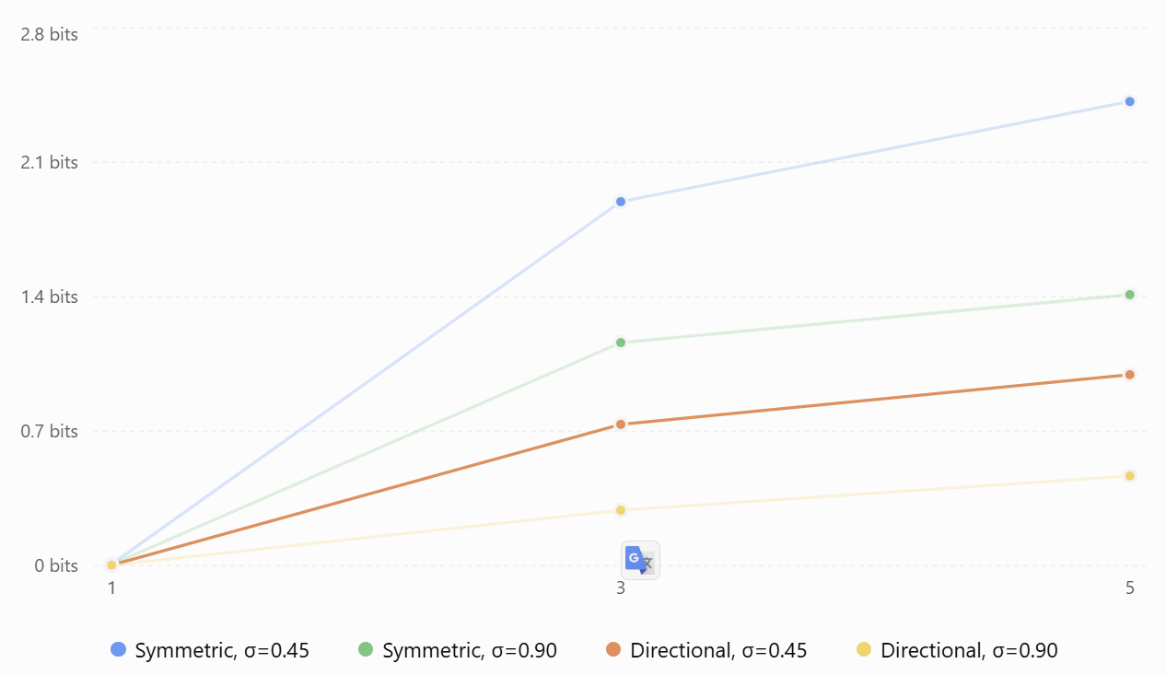
Figure 10 Association–trajectory dependence in the exact posterior
At five scans, with observation noise $σ=0.45$:
- Symmetric motion model: 2.417 bits of association–state dependence.
- Directional motion model: 0.995 bits.
This is exactly the distinction we were hoping to expose. When the targets have identical motion models, competing trajectory and identity hypotheses remain highly correlated. Directional motion provides information that distinguishes them and reduces that dependence.

The 50-percentage-point marginal discrepancy is significant—but not quite what it might appear
Under the symmetric model, the exact posterior gives each target identity a 50% marginal probability at every scan. That is appropriate: exchanging the labels of otherwise identical targets yields an equally plausible explanation of the data.
But the variational approximation sometimes gives an association almost 100% probability. For the symmetric, $σ=0.45$; five-scan case:
Quantity | Result
Exact center-scan P(true) | 0.500
Mean-field center-scan P(true) | 0.439
Maximum marginal discrepancy across scans | 0.500
Best reverse KL divergence | 1.322 nats
The 50-point discrepancy occurs at a scan elsewhere in the window, not at its center.
This is false confidence relative to the exact posterior, rather than proof of an actual track swap. With perfectly exchangeable track labels, there is no information in the model that uniquely identifies which labeled trajectory is correct.
And this is the mechanism we were discussing earlier: the true posterior can preserve multiple correlated assignment–trajectory hypotheses, while reverse-KL mean-field inference can concentrate on one interpretation.

There is a second loss: correlations among association decisions across scans
Our test also calculates the total correlation among scan assignments, $TC\left(A\right)$. For the symmetric, $σ=0.45$ model:
Window | Assignment total correlation
1 scan | 0 bits
3 scans | 0.076 bits
5 scans | 1.344 bits
In the exact posterior, assignment decisions at different scans become correlated through the shared target trajectories, even though the generative model evaluates observations scan by scan.
Ryan's factorized association update does not retain all those correlations explicitly.
Thus, the problem is not merely an uncertain association at one particular scan. It is the inability to represent the full dependence among a sequence of associations and its corresponding trajectory interpretation.
One technical distinction: mutual information and total correlation measure different dependencies and can overlap. We should not add their values together as if they represent separate, independent information losses.

An especially important discovery: different initializations can produce very different stable solutions
The initialization results deserve attention. Consider the five-scan directional-motion model at $σ=0.45$.
Initialization | Final KL(q‖p) | Maximum marginal discrepancy
Uniform | 0.295 nats | 0.215
Truth-favored diagnostic | 0.295 nats | 0.215
Swapped-favored diagnostic | 10.256 nats | 0.997
All three runs become numerically stationary, with final changes near machine precision.
Yet the swapped-favored initialization converges to a dramatically worse variational solution.
That establishes a critical point: numerical convergence of the VB coordinate updates does not establish that we have found a good approximation to the posterior. And it makes the initialization issue we encountered in the earlier crossing-target tests much more understandable. We now have a mathematical example of the same kind of behavior, although this experiment does not prove that factorization caused the specific identity reversal in our earlier harness.

Why the noisier model sometimes looks better
You might notice that the directional model with $σ=0.90$, produces lower mutual information and smaller marginal errors than the model with $σ=0.45$. At five scans:
Table 6 Mutual Information at Different Noise Levels
Measure | σ = 0.45 | σ = 0.90
Mutual information | 0.995 bits | 0.467 bits
Best K L(q‖p) | 0.295 nats | 0.203 nats
Maximum association marginal discrepancy | 21.47 points | 4.70 points

This does not mean a noisier sensor is better for tracking. It means the exact posterior is less sharply structured in this particular experiment, making it easier for a product distribution to approximate. A more informative measurement model can reveal stronger statistical dependencies that mean-field inference struggles to represent. That's a subtle but important distinction between posterior approximation quality and tracking performance.

What have we established about Ryan's central assumption?
I would summarize it this way:
Ryan's approximation is especially attractive when temporal dynamics and measurement evidence produce a relatively concentrated, coherent association–trajectory interpretation.
It is most vulnerable when the posterior contains several mutually incompatible but plausible interpretations.
Our exact enumeration has now demonstrated both regimes.
The experiment also shows why simply adding more scans does not guarantee the independence approximation becomes better. More scans can either resolve ambiguity or reveal stronger temporal dependence that the variational family cannot fully retain.

My recommendation for the next test
I would conduct one controlled symmetry-breaking experiment, still using exact joint posterior enumeration.
Rather than changing multiple aspects of the tracker, we would gradually transition the model from perfectly symmetric target dynamics to increasingly distinct directional motion models, holding the measurements and window length fixed.
We would measure how the exact identity uncertainty, mutual information, mean-field marginal error, and variational KL change as the target identities become more physically distinguishable. We'd also compare initialization outcomes and ELBO values. The key question would be:
How much temporal motion information is required before the factorization becomes an accurate and reliable approximation of the joint association posterior?
That would help connect the theoretical weakness we've identified to Ryan's intended benefit: using motion across multiple frames to make the approximation operationally useful.
My assessment: We have now directly established that the discarded dependence can be substantial, that mean-field inference can become confidently inconsistent with an ambiguous exact posterior, and that its optimizer can settle into poor stationary solutions. We have also seen that informative target dynamics can markedly reduce those effects.
This is a strong result for understanding both the promise and limitations of the approach. It remains a controlled discrete-HMM experiment, not a validation of his full tracker—but it gives us a much firmer mathematical foundation for the next stage.

What have we established about Ryan's central assumption?
I would summarize it this way:
Ryan's approximation is especially attractive when temporal dynamics and measurement evidence produce a relatively concentrated, coherent association–trajectory interpretation.
It is most vulnerable when the posterior contains several mutually incompatible but plausible interpretations.
Our exact enumeration has now demonstrated both regimes.
The experiment also shows why simply adding more scans does not guarantee the independence approximation becomes better. More scans can either resolve ambiguity or reveal stronger temporal dependence that the variational family cannot fully retain.

My recommendation for the next test
I would conduct one controlled symmetry-breaking experiment, still using exact joint posterior enumeration.
Rather than changing multiple aspects of the tracker, we would gradually transition the model from perfectly symmetric target dynamics to increasingly distinct directional motion models, holding the measurements and window length fixed.
We would measure how the exact identity uncertainty, mutual information, mean-field marginal error, and variational KL change as the target identities become more physically distinguishable. We'd also compare initialization outcomes and ELBO values.
The key question would be:
How much temporal motion information is required before the factorization becomes an accurate and reliable approximation of the joint association posterior?
That would help connect the theoretical weakness we've identified to the intended benefit: using motion across multiple frames to make the approximation operationally useful.
My assessment: We have now directly established that the discarded dependence can be substantial, that mean-field inference can become confidently inconsistent with an ambiguous exact posterior, and that its optimizer can settle into poor stationary solutions. We have also seen that informative target dynamics can markedly reduce those effects.
This is a strong result for understanding both the promise and limitations of the approach. It remains a controlled discrete-HMM experiment, not a validation of the full tracker—but it gives us a much firmer mathematical foundation for the next stage.
I've prepared the next MATLAB validation experiment: Symmetry Breaking V1. This continues directly from our last result, where we established that the variational factorization can lose substantial association–trajectory dependence. Our next question is:
As the targets' motion becomes more distinguishable, does Ryan's variational approximation become more accurate and less sensitive to initialization?
We retain the same observations, initial state distributions, and measurement-noise assumptions. Only the two targets' state-transition matrices change.
We introduce a parameter $λ$:
$$T_{i}\left(λ\right)=\left(1-λ\right)T_{sym}+λT_{i,directional}$$
At $λ=0$ the targets have identical motion models and their identities are exchangeable. At $λ=1,$their directional motion models are maximally differentiated within this experiment. We test seven values of $λ$, from 0 to 1, using three- and five-scan windows at two measurement-noise levels.
The test will calculate the complete joint posterior and compare it against the mean-field approximation, measuring:
- Exact identity-association probabilities.
- Mutual information $I\left(A;X∣Z\right)$
- Correlation among assignments across scans.
- KL divergence between the variational approximation and the exact posterior.
- Maximum marginal-probability discrepancies.
- Sensitivity to three different VB initializations.
There will be 28 exact joint-posterior experiments and 84 mean-field optimization runs.

What I'm particularly interested in
If increasing motion-model distinguishability makes the exact posterior concentrate on the correct association history while reducing the mean-field approximation error, we'll have a more precise understanding of when the factorization is a good computational tradeoff.
Equally important, we may discover that the information loss is nonmonotonic, or that different VB initializations still produce inferior stable solutions even when the dynamics favor one identity.
Either finding will help us move beyond the simplistic assumption that more scans always produce better inference. This should be a particularly useful experiment for understanding the mathematical operating envelope of the architecture before returning to the complete tracker.

Test Results
This is a particularly informative result. The experiment confirms that distinguishing target motion reduces the statistical dependence discarded by Ryan's variational factorization—but it also reveals that the mean-field approximation can remain dramatically overconfident even as the exact Bayesian posterior improves.
I reviewed the 28-case summary, all 84 initialization runs, and the saved MATLAB evidence. All numerical checks passed, including agreement with the independent exact-inference calculation to $4.72×{10}^{-16}$.

The central hypothesis is supported
As we increase λ from 0 (identical motion models) to 1 (maximally differentiated motion models), the exact posterior generally becomes more decisive about target identity.
For the five-scan experiments:
Quantity | Symmetric, λ=0 | Directional, λ=1
Exact P(true), σ=0.45 | 50.0% | 69.8%
Exact P(true), σ=0.90 | 50.0% | 53.0%
Mutual information, σ=0.45 | 2.417 bits | 1.682 bits
Mutual information, σ=0.90 | 1.411 bits | 1.318 bits
For the lower-noise case, distinguishable motion reduces association–trajectory mutual information by approximately 30%. That's encouraging. It supports the idea that an effective dynamical model can make the dependence omitted by this factorization less consequential. However, the improvement is much smaller in the higher-noise experiment.

The variational approximation does not follow the exact posterior smoothly
This is the most interesting result in the new data. Consider the $σ=0.45$, five-scan experiment. At $λ=0.05$, the exact posterior assigns only 51.0% mean probability to the true identity. The best tested mean-field solution assigns 90.2%. That is a very large discrepancy for a tiny change in the motion models. The likely explanation is the mode-selecting behavior of reverse-KL variational inference. A small symmetry-breaking influence causes the approximation to concentrate on one coherent interpretation before the exact posterior provides nearly that level of confidence. In effect, the mean-field approximation is resolving uncertainty much more aggressively than the exact posterior.

The higher-noise case reveals the opposite problem
At \(\sigma=0.90\), \(K=5\), and \(\lambda=1\):
Quantity | Result
Exact mean P(true) | 52.98%
Best-KL mean-field P(true) | 37.03%
Truth-favored initialization P(true) | 71.35%
Best-KL solution | 0.7814 nats
Truth-favored solution | 0.9567 nats

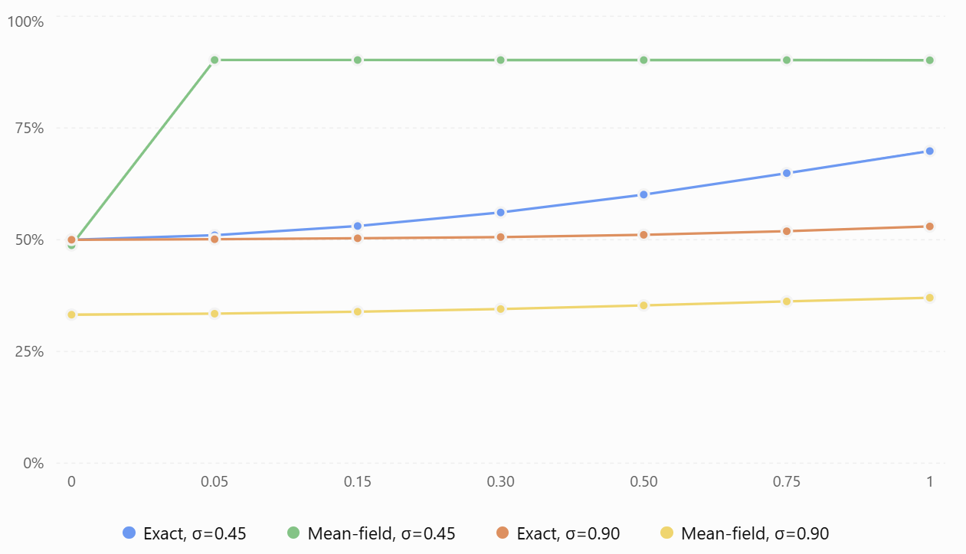
Figure 11 Five-scan window: probability assigned to the true identity. Probability values are averaged across the five scan assignments. Mean-field values are from the lowest-KL solution among three initializations, not necessarily the globally optimal variational solution.
This is remarkable for a different reason. Of the solutions we tested, the one with the better variational objective assigns less probability to the actual identity than the alternative solution.
That is not a contradiction. The variational objective measures how well the complete approximation represents the modeled posterior under reverse KL. It does not directly optimize agreement with the known target labels in our synthetic experiment. The posterior itself only weakly prefers the true identity in this case. Nevertheless, it demonstrates that a numerically converged, lower-KL variational solution need not yield the most accurate target-label decisions. That is operationally relevant.

Increased distinguishability can also increase optimization sensitivity
The differences between initializations deserve attention. $σ=0.45,$ $K=5$.
λ | Spread in final KL across initializations
0 | 0.670 nats
0.15 | 0.526 nats
0.50 | 1.878 nats
0.75 | 3.065 nats
1.00 | 4.686 nats
As the target dynamics become more distinguishable, the correct and incorrect trajectory interpretations become increasingly unequal under the model.
That can make initialization matter more, not less: an optimizer trapped near the disfavored trajectory interpretation can settle into a substantially inferior stationary solution.
This is consistent with our earlier observation that a wrong identity interpretation can become self-reinforcing during the coordinate updates.
It does not prove the optimizer is globally deficient; we have tested only three initializations. But the variation is too large to dismiss as numerical rounding.

What do these results tell us about core factorization?
I would now separate three effects that our experiments have exposed.
Effect | Evidence | Interpretation
Statistical approximation | Mutual information remains positive | Association and state trajectories retain dependencies that a product approximation cannot represent
Posterior mode selection | Mean-field probabilities can become nearly deterministic when exact probabilities remain ambiguous | Reverse-KL inference can discard plausible competing interpretations
Optimization sensitivity | Final KL varies substantially with initialization | The coordinate-update algorithm can settle into very different stationary solutions
These are related, but they are not interchangeable.
A fourth observation is that the total correlation among assignments across scans does not always decrease with motion-model distinguishability. At $σ=0.90,$ $K=5$, it actually increases from 0.678 to 0.746 bits. So the reduction in association–state mutual information does not imply all temporal dependence is disappearing.

What I recommend next
At this point, I would stop extending the small synthetic symmetry-breaking studies.
They have served their purpose. We've demonstrated the central mathematical tradeoff, characterized its dependence on motion-model distinguishability, and exposed mode selection and initialization sensitivity.
Our next priority should be to return to Ryan's surviving MATLAB tracker implementation and validate its actual coordinate updates and variational lower bound (ELBO).
Specifically, I would inspect VBtracker2.m and its associated bound function, then construct a small deterministic test that records the objective after each coordinate update. With exact per-scan assignment updates, we should be able to examine whether the expected coordinate-ascent behavior holds under the relevant model assumptions.
For the BP variant, we'd need to distinguish the exact variational objective from any Bethe-approximated objective; monotonicity of the exact ELBO is not automatically guaranteed by approximate BP updates.
I would also preserve one of our difficult five-scan cases as a regression benchmark.
The reason for changing direction is practical: we now understand what the variational approximation can lose. It's time to verify that Ryan's actual implementation optimizes the mathematical objective he intended, rather than continuing to explore consequences of factorization in a separate toy model.
My overall assessment is encouraging for the architecture, but qualified. Distinguishable motion does help; temporal evidence matters; and the approximation can be computationally attractive. However, preserving association uncertainty and avoiding poor stationary solutions remain consequential challenges. The next stage should connect these mathematical insights directly to Ryan's original source code.
The benefit is not that Variational Bayesian inference necessarily produces more accurate measurement associations than multiple-frame assignment (MFA). It is that VB offers a computationally tractable way to use much longer measurement histories when estimating target states and association probabilities, without explicitly maintaining the combinatorial collection of complete association histories.
That's a meaningful architectural distinction.
The question is whether the approximation sacrifices too much of the information needed to preserve target identities in the difficult cases. Our experiments suggest the answer is sometimes yes—but certainly not always.
I think the architecture deserves further development, although there are particular situations where I'd want to preserve more association uncertainty than Ryan's original factorization permits.

The architectural benefits go beyond linear scaling
I see four interrelated benefits worth preserving.
Benefit | Why it matters
Longer association windows | Allows earlier ambiguous associations to be reconsidered as subsequent scans arrive
Approximately linear work in window length | Makes long-window inference potentially practical, avoiding explicit joint association-history enumeration
Soft association probabilities | Carries uncertainty into track-state updates instead of immediately committing to one hard assignment
Model-based track management | Treats target activity, missed detections, and track existence probabilistically rather than relying entirely on confirmation/deletion heuristics
The last point deserves emphasis. Ryan wasn't simply offering a faster version of MFA. The complete published formulation was intended to combine association, state estimation, and active/dormant track management in one probabilistic framework. The important computational relationship is approximately
$$C_{VB}∼K I_{VB}\left(C_{smooth}+C_{associate}\right)$$
where K is window length and $I_{VB}$ is the number of outer iterations.
If the per-scan problem size and iteration counts remain bounded, computation is approximately $O\left(K\right)$.
That is a serious advantage. But it isn't free: the association cost still depends on track density, clutter, and BP convergence, while the outer VB iteration count can depend on ambiguity and initialization.
Our earlier MATLAB timing experiment was consistent with linear scaling from 1 to 20 scans under a fixed 12-iteration budget. It was not yet a production-grade scalability benchmark.

What our V&V has actually demonstrated
I would distinguish the evidence supporting Ryan's architecture from the evidence identifying its limitations.
Question | What we've established
Does more temporal context improve association? | Often substantially, in our crossing experiments
Does computation grow approximately linearly with scan depth? | Yes, under the fixed-iteration conditions tested
Does the VB factorization preserve the full Bayesian posterior? | No; we've measured the discarded dependencies explicitly
Can VB become overconfident? | Yes, particularly when competing trajectory interpretations remain plausible
Can VB converge to an inferior stationary solution? | Yes, in our controlled discrete examples
Are these defects fatal to the architecture? | Not established
Has the complete published tracker been reproduced and benchmarked? | Not yet
The distinction I consider most important is between a model that sometimes makes an incorrect association and a model that systematically loses the benefits of temporal information.
We've observed the former. We have not established the latter.
Indeed, our early multi-frame tests showed combined hard-association accuracy improving from 28.3% at one scan to 75.5% at 20 scans. Those numbers come from a small, cold-start synthetic experiment, so I wouldn't use them as a performance claim. But they demonstrate the mechanism.
The subsequent exact-posterior experiments exposed where the factorization can lose information, not that it necessarily loses the decision-relevant information in typical conditions.
A subtle point: when two targets are genuinely indistinguishable under the available observations and dynamics, the correct Bayesian answer is uncertain. Neither MFA nor VB can manufacture information that isn't there. VB's particular weakness is that it can sometimes present an unjustifiably confident answer instead of preserving that uncertainty.
That is an important limitation, but it is not equivalent to saying the method is ineffective.

4. Is the comparison with MFA still favorable?
Here I would temper one aspect of the original argument.
The exact joint multi-frame assignment problem is combinatorial and generally NP-hard. But modern MFA/MHT implementations do not simply enumerate every possible measurement history. They use gating, pruning, sparse graph structures, Lagrangian relaxation, and bounded hypothesis sets.
For example, MathWorks' current tracking documentation discusses multidimensional assignment using Lagrangian relaxation and multiple-hypothesis tracking using hypothesis pruning. A 2024 sliding-window tracker also demonstrates how graph sparsity and bounded hypothesis sets can make multi-frame tracking practical in real time. So I would not frame the competitive argument as:
VB is linear; MFA is exponential; therefore VB wins.
I would frame it as:
For a given computational and latency budget, how much useful association history can VB incorporate, and how accurately does it preserve track identities, compared with an optimized MFA implementation?
That's the actual architectural competition.
VB may enable longer windows at lower computational expense. MFA may represent competing association histories more faithfully. Which wins depends on target density, clutter, motion ambiguity, and the required decision latency.

The hybrid idea may be more valuable than you think
I understand why you're calling a hybrid approach a half-measure. You probably don't want two completely separate tracking algorithms with arbitrary logic deciding when to invoke each one. That could become operationally complicated and difficult to validate. But there's a more elegant possibility that remains fundamentally a VB tracker. Rather than using a single factorized posterior,
$$q\left(A,X\right)=q\left(A\right)q\left(X\right),$$
consider a bounded mixture of coherent variational hypotheses:
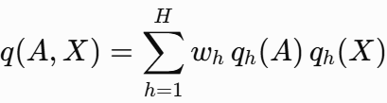
Each component retains the tractable VB structure, but the mixture can preserve several competing association–trajectory interpretations.
For example, during a crossing:
- Component 1 represents both tracks continuing through the crossing.
- Component 2 represents the competing identity-exchange hypothesis.
Within each component, we can still use efficient smoothing and association updates. The mixture preserves some correlation between assignment and trajectory hypotheses that a single product cannot.
For a fixed, small number H of components, the cost could remain approximately linear in window length:
$$C_{mixture}∼O\left(HK C_{VB per scan}\right).$$
This is a structural complexity argument, not a demonstrated performance bound for an implemented mixture tracker. Managing and weighting the components would introduce additional challenges.
But the concept is attractive because it targets the specific deficiency our exact-posterior experiments identified.
Instead of abandoning VB for MFA whenever ambiguity appears, we could retain a small collection of competing VB hypotheses only where the posterior warrants it.
That is not necessarily a half-measure. It could be a principled extension of the original architecture, provided we can identify meaningful alternative modes and weight them appropriately.
I would not implement it yet. I would first establish how well the original complete formulation performs.

Where I stand on the investment
I would continue pursuing Ryan's algorithm, for three reasons.
First, the theoretical scalability advantage is substantial and explicitly supported by the induced factorization in his paper. It is not a superficial heuristic.
Second, the original published evaluations reported meaningful tracking and association advantages over their contemporary comparison methods. The architecture has already shown empirical promise beyond our current toy experiments.
Third, our V&V has uncovered weaknesses that are understandable in terms of variational inference: lost posterior dependence, mode selection, sensitivity to initialization, and BP approximation quality. We haven't found evidence that the fundamental mathematics is internally inconsistent.
What concerns me more is that we still haven't reconstructed and tested the complete continuous-state, model-based tracker that Ryan actually described in 2014. We've invested considerable effort validating its component algorithms and studying its variational approximation, but those aren't the same as establishing its engineering performance.
I would now make our next major milestone a credible end-to-end tracker with Gaussian kinematics, association inference, multi-frame smoothing, clutter, missed detections, and eventually track-management meta-states. Then compare it against a competent, optimized MFA baseline on identical scenarios, varying window depth and target density.
That comparison should evaluate tracking quality, identity continuity, uncertainty calibration, processing latency, and runtime—not just marginal assignment accuracy.

My conclusion
I still believe the original big idea is sound and valuable: long temporal context without explicit combinatorial hypothesis-history growth.
The mean-field approximation imposes a genuine cost, but we don't yet know whether that cost is large enough in realistic tracking situations to offset the computational advantage.
If we eventually discover that preserving a few correlated association–trajectory hypotheses is necessary, I would favor enhancing the VB representation rather than immediately replacing it with an unrelated MFA subsystem.
And one final observation: the objective was not to outperform exact Bayesian tracking. It was to make a richer probabilistic tracker computationally practical. That's the standard by which I think we should evaluate it.
I would continue the V&V effort with confidence in the research direction, but without assuming the final architectural choice has already been made.

What do you mean by window length, outer iterations and per-scan?
These are three distinct dimensions of Ryan's VB tracking algorithm, and understanding their relationship is important to understanding both its computational cost and its advantage over conventional multi-frame assignment (MFA).

1. Window length (\(K\))
Window length is the number of consecutive measurement scans considered together during an inference operation. Suppose a radar updates once per second and we want to determine measurement-to-track assignments at scan 20.
Window length | Scans considered | Temporal history
K = 1 | 20 | Current scan only
K = 3 | 18–20 | Current + 2 previous
K = 5 | 16–20 | Current + 4 previous
K = 10 | 11–20 | Current + 9 previous
K = 20 | 1–20 | Current + 19 previous
The advantage we are pursuing is the ability to use a longer window to resolve ambiguous associations by leveraging target motion before and during a crossing.
In the experiments we conducted today, increasing K from 1 to 20 substantially improved association accuracy in several scenarios.

Per-scan association
Per-scan association is the calculation of measurement-to-track assignment probabilities for one particular scan.
Suppose at scan 20 we have three tracks and four radar measurements. The association algorithm calculates probabilities such as:
$$P\left(A_{20,j}=i\right)$$
where$A_{20,j}$ represents the track assigned to measurement j at scan 20, with an additional possibility for clutter. Module asgMatBP.m approximates these probabilities using belief propagation while enforcing the competition constraints among tracks and measurements. The key distinction is that although assignment probabilities are calculated one scan at a time, they can depend on information from the entire window through the temporally smoothed track-state distributions. That is central to the VB architecture.

Outer iterations $I_{VB}$
Outer iterations are repeated cycles of updating the association probabilities and target-state distributions until they become mutually consistent. One complete outer iteration consists conceptually of:
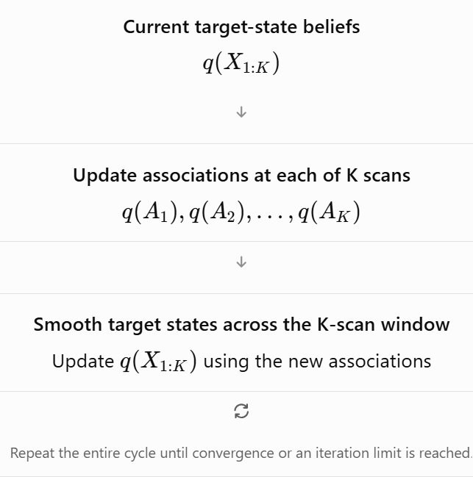
Figure 12 One complete outer iteration. Repeat the entire cycle until convergence or an iteration limit is reached.
For example, in our initial multi-frame experiment we used 12 outer iterations. Later, we extended this to 80 outer iterations to examine convergence and identity reversals.
More outer iterations do not mean more measurements or a longer history. They simply mean repeatedly refining the posterior approximation using the same measurement window.

How the three concepts interact
Consider a ten-scan window with 12 outer iterations.
Each outer iteration:
- Calculates association probabilities independently for each of the 10 scans, conditional on the current smoothed state beliefs.
- Updates the target-state distributions using temporal smoothing across all 10 scans.
Thus, the full operation performs approximately 120 per-scan association updates and 12 ten-scan smoothing passes.
There's also a fourth parameter worth distinguishing: inner BP iterations. Ryan's original asgMatBP.m runs 100 message-passing iterations within each individual per-scan association calculation. Those are not VB outer iterations.
For fixed problem size and iteration counts, a useful approximate cost expression is
$$C_{VB}∝K I_{VB}\left(C_{association}+C_{state}\right).$$
This helps explain the linear-in-window-length argument: if all other computational costs stay bounded, doubling the number of scans approximately doubles the work.
But if difficult problems demand more outer iterations or more BP iterations, actual runtime may grow faster.

The key distinction
The particularly important idea is that Ryan does not solve one gigantic combinatorial association problem involving all K scans simultaneously.
Instead, he solves tractable single-scan association subproblems, then uses temporal state smoothing to communicate information across scans, repeating those operations.
That is how he seeks to capture much of the benefit of multiple-frame association without explicitly enumerating all possible measurement-assignment histories.
And it's the main reason I still find his architecture compelling: the window provides temporal information; the per-scan solver handles assignment competition; and the outer VB iterations allow those two sources of information to inform each other. The key summary regarding the VB technique can be said as follows:
Solve tractable single-scan association subproblems, then use temporal state smoothing to communicate information across scans, repeating those operations
The statement captures what I consider the central insight of a Variational Bayesian (VB) tracker. It is also the source of both its computational advantage and its most important approximation.
Ryan separates the association problem into two interacting operations:
- Spatial assignment: At each scan, determine which measurements are most likely associated with which tracks, enforcing the one-to-one assignment constraints.
- Temporal inference: Across the entire measurement window, estimate each target's most plausible trajectory, using its motion model and the uncertain measurement assignments.
It alternates between these operations, letting the estimated trajectories improve the assignments and the revised assignments improve the trajectories.
The subtlety is that the individual assignment calculations do not directly solve a multi-frame association problem. The temporal information enters through the smoothed target-state distributions.
That's what makes the architecture interesting. Let's work through the actual mathematics and then a crossing example.
- 1. Two different ways of coupling the tracking problem
Consider two targets observed over five radar scans. Each scan contains two measurements.
A conventional joint multi-frame assignment method asks: Which complete sequence of assignments across these five scans best explains the measurements and target dynamics? It reasons about association histories such as
$$\left(A_{1},A_{2},A_{3},A_{4},A_{5}\right).$$
Even with only two possible assignments per scan, there are potentially $2^{5}=32$assignment histories. With more targets, clutter, and missed detections, the combinatorial problem grows rapidly. We instead introduce the approximation
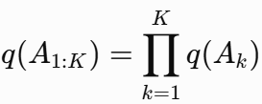
where $q\left(A_{k}\right)$ is a probability distribution over valid assignments at scan k. But it does something very different with the target states:
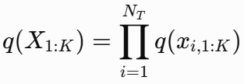
Here, each
$$q\left(x_{i,1:K}\right)$$
is a distribution over the entire trajectory of target i.
This is the essential asymmetry:
- Assignment distributions are factorized across time.
- Target-state distributions remain dynamically coupled across time.
Therefore, it gives up explicit joint association histories but retains temporally coupled state trajectories. This is the induced factorization at the heart of the method.

First operation: solve the association problem at one scan
Let's examine scan k. Suppose we have two tracks, $T_{1},T_{2}, and two measurements, z_{1},z_{2}$. The two basic complete-assignment hypotheses are:
$$\begin{aligned}H_{1}&:T_{1}→z_{1}, T_{2}→z_{2}, \\ H_{2}&:T_{1}→z_{2}, T_{2}→z_{1.}\end{aligned}$$
Initially, assume the targets are well separated. Their predicted states make $H_{1}$ much more likely than $H_{2}$. At a crossing, both assignments might be nearly equally plausible. This algorithm evaluates the assignment possibilities using the current estimated state distribution for each track. For a Gaussian observation model,
$$z_{j,k}=Hx_{i,k}+v_{j,k}, v_{j,k}∼N\left(0,R\right),$$
the association score for assigning measurement j to track i contains
$$l_{ij,k}=E_{q\left(x_{i,k}\right)}\left[\log{N}\left(z_{j,k};Hx_{i,k},R\right)\right].$$
This is an expected log-likelihood, not merely the likelihood evaluated at a predicted point estimate. If
$$q\left(x_{i,k}\right)=N\left(m_{i,k},P_{i,k}\right),$$
then, apart from terms independent of the assignment,
Two things influence the score:
- Predicted measurement residual: How well does the track's estimated state explain this measurement?
- State uncertainty: How uncertain is the track-state distribution under the measurement model?
The assignment calculation also incorporates detection and clutter probabilities, including information from the track-management meta-state model.
- Enforcing assignment competition
We represent each scan's association distribution as
$$q\left(A_{k}\right)∝1\left\{A_{k}\text{ valid}\right\}\exp\left(\sum_{i,j}{A_{ij,k}}w_{ij,k}\right),$$
Where $w_{ij,k}$ combines the expected measurement log-likelihood and relevant assignment-prior terms.
The indicator function enforces the assignment constraints: a measurement cannot belong to two tracks, and a track cannot generate two measurements in the same scan.
The conjugate assignment prior (CAP) gives precisely this structure. The computational challenge is calculating its marginals efficiently, for which the it introduces a Bethe approximation and loopy belief propagation. The result is a matrix of marginal assignment probabilities,
$γ_{ij,k}=E_{q\left(A_{k}\right)}\left[A_{ij,k}\right]$.
For example:
Table 7 Illustrative case with both tracks detected and no clutter.
 | Measurement 1 | Measurement 2
Track 1 | 0.55 | 0.45
Track 2 | 0.45 | 0.55
Notice that these are soft probabilities, not hard assignments. And importantly, although the probabilities are fractional, the underlying distribution $q\left(A_{k}\right)$ is defined over valid one-to-one assignments. Ryan is not simply treating each track-to-measurement probability as an independent Bernoulli variable.
At this point, however, the assignment solver has used information only from the state beliefs supplied to it. It has not explicitly considered competing five-scan assignment histories. That is where the next operation becomes essential.

Second operation: use the soft assignments to estimate each entire trajectory
Here is the most elegant part of the formulation. Ordinarily, a Kalman filter receives a measurement $z_{k}$ with measurement covariance R. But suppose a track has several possible associated measurements, each with a probability. we derive an equivalent pseudo-measurement using those probabilities.
Define the expected detection indicator
$$d_{i,k}=\sum_{j=1}^{N_{Z}\left(k\right)}{γ_{ij,k}}.$$
For $d_{i,k}>0,$define
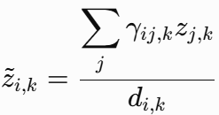
And
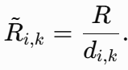
These are equations where the derivation shows that the variational state update has the form of a linear Gaussian smoothing problem.

Why is that powerful?
Consider a track with two candidate measurements:
$$z_{1}=98\text{ m}, z_{2}=102\text{ m},$$
with association probabilities
$$γ_{1}=0.7, γ_{2}=0.3.$$
Assume the track was detected, so $d=1$. Then,
$$\tilde{z}=\left(0.7\right)\left(98\right)+\left(0.3\right)\left(102\right)=99.2\text{ m}.$$
The Kalman smoother can use 99.2 m as an effective observation for that track. Now suppose the same track has only a 30% probability of being detected:
$$d=0.3.$$
The effective measurement covariance becomes
$$\tilde{R}=\frac{R}{0.3}≈3.33R.$$
Thus, the information supplied by this scan is weakened. If d=0, there is no associated measurement contribution for that track at that scan. This is a remarkable practical simplification: uncertain data association becomes a weighted observation process that can be handled by ordinary state-space smoothing machinery.
There is one important limitation: the pseudo-measurement is a variational device, not a claim that the true measurement distribution is Gaussian with that mean. When candidate measurements are widely separated, their weighted average can lie between two physically plausible alternatives. That is one mechanism by which mean-field tracking can merge or distort competing trajectory hypotheses.

Third operation: smoothing carries information backward and forward through time
Now we have an effective observation sequence for each track:
$${\tilde{z}}_{i,1},{\tilde{z}}_{i,2},…,{\tilde{z}}_{i,K}.$$
We assume a dynamical model, such as
$$x_{i,k}=Fx_{i,k-1}+w_{i,k}, w_{i,k}∼N\left(0,Q\right).$$
The state update is therefore
$$q\left(x_{i,1:K}\right)∝p\left(x_{i,1:K}\right)\prod_{k=1}^{K}{N}\left({\tilde{z}}_{i,k};Hx_{i,k},{\tilde{R}}_{i,k}\right).$$
Notice that the motion model $p\left(x_{i,1:K}\right)$ still couples all time steps. That is the mathematical reason temporal information has not disappeared. A Kalman smoother can solve this complete trajectory-estimation problem efficiently.
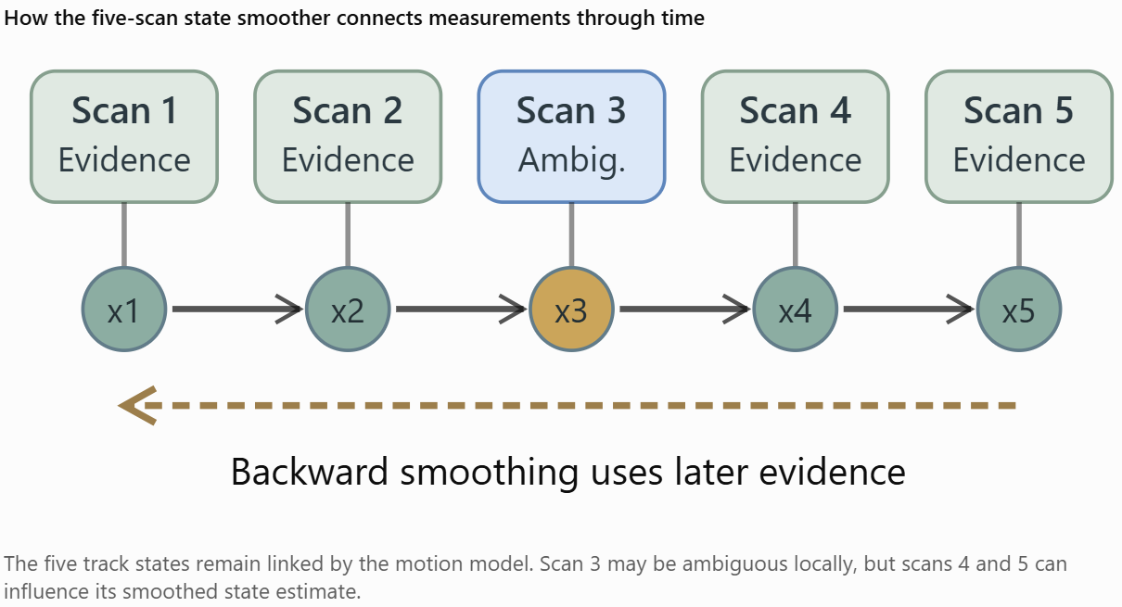
Figure 13 A five-scan state smoother representation
In an RTS Kalman smoother, one backward step takes the form
Here:
- ${\hat{x}}_{k|k}$ is the forward-filtered state estimate at scan \(k\).
- ${\hat{x}}_{k|K}$ is the smoothed estimate using all \(K\) scans.
- $C_{k}$ is the smoothing gain.
- The correction involves information from the next smoothed state.
Repeated backward recursion propagates later measurement evidence into earlier state estimates. Crucially, the smoother itself does not revisit or change the assignment probabilities. It updates the state distributions conditional on the current soft association weights. To change the assignments, we must return to the first operation.

Fourth operation: the revised trajectory changes the earlier assignments
This closes the loop and is the source of the multi-frame benefit. Imagine two targets crossing during scans 1–5.
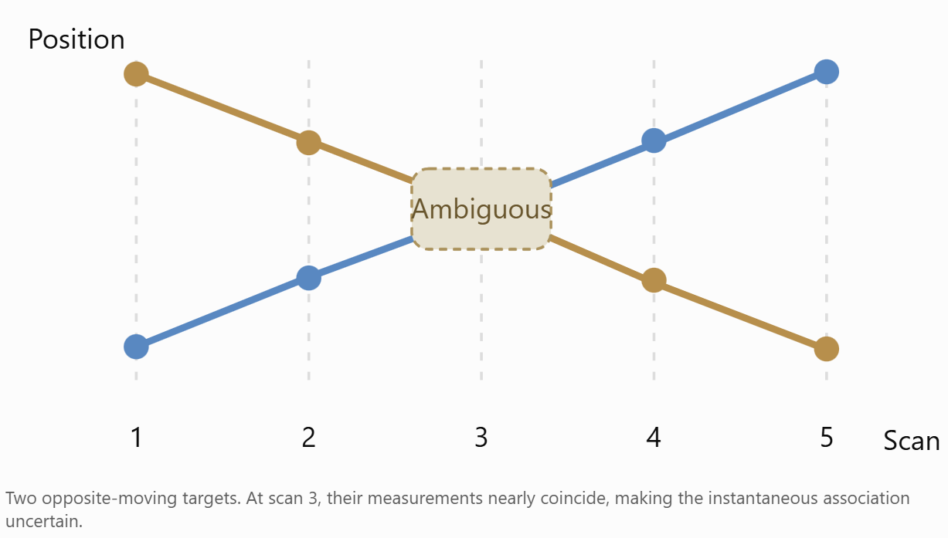
Figure 14 An illustrative crossing
Initially, the scan-3 association probabilities might be
$$q\left(A_{3}\right): P\left(H_{1}\right)=0.50, P\left(H_{2}\right)=0.50.$$
But the other scans provide information about direction and continuity.
The state smoother considers the motion before and after the crossing. This may produce a revised state estimate showing that Track 1 was moving consistently rightward and Track 2 leftward.
Now we recompute the association probabilities at scan 3 using those revised state beliefs.
For illustration, we might obtain
$$q^{\text{new}}\left(A_{3}\right): P\left(H_{1}\right)=0.85, P\left(H_{2}\right)=0.15.$$
Those numbers are hypothetical, but the mechanism is real. We then use the updated scan-3 association probabilities to reconstruct the pseudo-measurements, smooth the entire trajectory again, and repeat.
In compact notation:
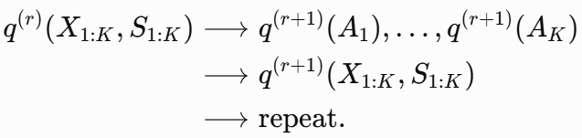
The meta-states \(S\) are included because Ryan's complete formulation also updates track activity/dormancy probabilities using an HMM forward–backward recursion.
This alternating computation is variational coordinate optimization.
The assignment at scan 3 can therefore incorporate evidence from scans 4 and 5—not because the scan-3 assignment algorithm explicitly evaluates future assignments, but because its input state distribution has been smoothed using future measurements.
That's the key distinction.
And we need one qualification: future observations do not guarantee the correct identity will emerge. If the motion histories are genuinely indistinguishable, or the VB updates settle into a poor interpretation, those probabilities may remain ambiguous or become incorrectly concentrated.

What happens across one complete outer iteration?
Here is the actual computational flow.

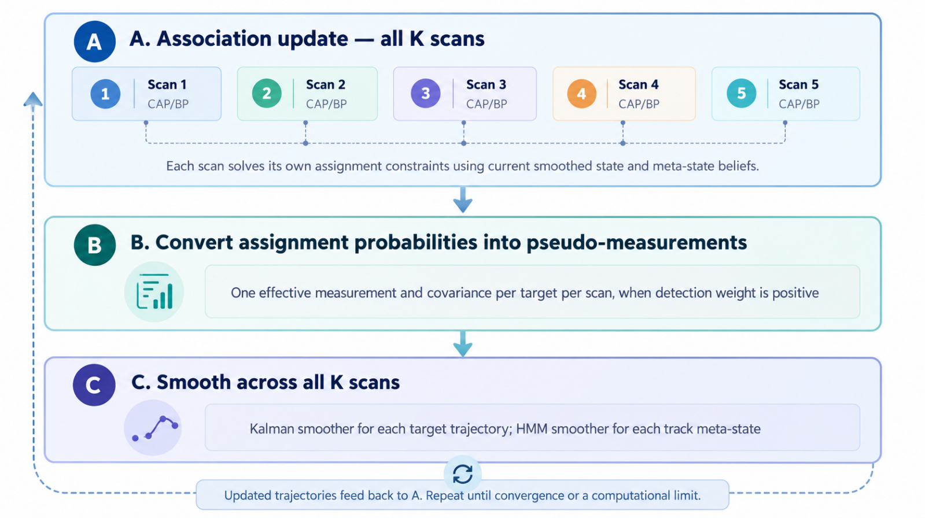
Figure 15 Actual computation flow
That entire process is one VB outer iteration.
In our earlier experiments, for a ten-scan window and 12 outer iterations, we performed approximately 120 per-scan association calculations and 12 full-window smoothing passes.
All the measurements in the ten-scan window are used repeatedly. We aren't adding observations during the iterations; we're improving the internal consistency of the inferred assignments and trajectories.

What makes this fundamentally different from MFA?
This is where I want to return to original motivation for the method. Suppose an ambiguous crossing admits two coherent complete association histories:
$$H_{1}=\left(A,A,A\right), H_{2}=\left(B,B,B\right),$$
each with posterior probability 0.5. A joint multi-frame representation can retain
$$P\left(H_{1}∣Z\right)=P\left(H_{2}∣Z\right)=0.5.$$
It knows that all three association decisions are correlated. If we instead take the per-scan marginals, each scan has probability 0.5 of choosing A or B. Their product assigns probability to all eight possible sequences, including six mixed sequences such as $\left(A,B,A\right)$ that were absent from our stipulated joint posterior.
In that illustrative case, the product of the exact marginals would place 75% of its mass on incoherent combinations. The optimized variational distributions need not equal the exact marginals; they might instead collapse onto one of the two coherent histories. But the factorized family cannot accurately preserve the original two-mode correlation. That is the statistical information sacrificed.
So the distinction is:
MFA-style joint history representation | VB architecture
Explicitly represents associations across multiple scans as coupled hypotheses | Represents scan assignments separately under the variational approximation
Preserves selected alternative association histories | Represents one factorized posterior approximation, typically via soft assignment marginals
Motion consistency affects the plausibility of entire histories | Motion consistency affects assignment probabilities through smoothed state beliefs
Multiple competing hypotheses may be retained explicitly | Competing global modes may be lost or collapsed
Hypothesis growth requires pruning or more sophisticated optimization | Work scales approximately linearly in window length under bounded per-scan cost and iteration counts
Notice the distinction between retaining temporal information and retaining temporal association correlations. It retains the former through the motion model and smoother. He sacrifices much of the latter through the variational factorization. That is the entire tradeoff.

Why I think this matters for our REACTOR tracking objectives
In a dense multi-target environment, many scans can be individually ambiguous even when the complete target trajectories are relatively easy to distinguish.
Imagine two aircraft following stable, opposite-direction trajectories. They approach, their measurements overlap, and they separate.
Their instantaneous positions at the crossing are poor indicators of identity, but their multi-scan kinematics contain valuable information about which aircraft is which.
The architecture seeks to extract that information without explicitly solving a large joint combinatorial problem.
That is precisely the type of situation where I expect it to have value.
By contrast, if two targets have nearly identical kinematics over the full window, then there may be insufficient information to distinguish them. The smoother cannot create nonexistent information, and the factorized approximation may obscure the remaining ambiguity.
One additional point matters to me: the state-space smoother is a linear-time operation in window length for fixed state dimension, and the association calculations factorize over time. With bounded iteration counts and a scalable per-scan solver, this is what makes the computational argument work. It does not mean the algorithm is linear in the number of targets or measurements, nor that convergence iterations are always bounded by a small constant.

The deepest insight
I would characterize the architecture as a deliberate exchange:
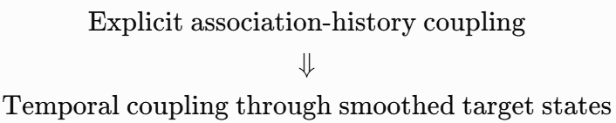
Figure 16 Essence of VB trade-off
It doesn't eliminate the multi-frame nature of tracking. It changes where the temporal coupling lives.
Instead of carrying a combinatorial set of assignment histories through time, the algorithm carries temporally coupled probabilistic state estimates. Those state estimates repeatedly inform the individual assignment problems. There is one caveat I want to make explicit: a smoothed Gaussian trajectory is not a lossless encoding of all possible assignment histories. This is an approximation, not a mathematical equivalence to full multi-frame association. But it is a principled approximation that can preserve much of the useful temporal evidence at much lower computational cost.
This is why I find the approach compelling. Its central innovation is not belief propagation, nor even variational inference in isolation. It is using continuous-time-history state inference as the mechanism for coordinating otherwise separate measurement-assignment problems across scans.
The question our V&V must ultimately answer is how often that mechanism delivers the correct association decisions—and how much critical identity information is lost when the history contains genuinely competing trajectory interpretations.
I think we're ready for that transition. We've learned quite a lot about Ryan Turner's VB formulation, but the next meaningful question is no longer whether its individual equations work. It's whether a complete VB tracking loop can maintain target identity and produce accurate state estimates in realistic multi-target situations, at a computational cost that makes longer association windows practical.
I would build that evaluation around a six-state Cartesian constant-velocity model, synthetic tracks with known ground truth, missed detections, clutter, and controlled target spacing relative to measurement uncertainty.
There is one important point to resolve first.

Why the same F and R for every target can still improve association
Your intuition is understandable, but different tracks do not need different transition matrices for temporal smoothing to distinguish them.
For a three-dimensional constant-velocity model, let
$$x_{i,k}={\left[\begin{matrix}p_{x,i} & p_{y,i} & p_{z,i} & v_{x,i} & v_{y,i} & v_{z,i}\end{matrix}\right]}^{T}.$$
Every track can use the same transition matrix:
$$F=\left[\begin{matrix}I_{3} & ΔtI_{3} \\ 0 & I_{3}\end{matrix}\right].$$
And every measurement can use
$$z_{j,k}=Hx_{i,k}+v_{j,k}, H=\left[\begin{matrix}I_{3} & 0\end{matrix}\right], v_{j,k}∼N\left(0,R\right).$$
The distinction between tracks is contained in their state distributions, not necessarily their system matrices.
Consider two targets at the same position at a crossing:
$${\hat{x}}_{1,k}=\left[\begin{matrix}0 \\ 0 \\ 0 \\ +25 \\ 0 \\ 0\end{matrix}\right], {\hat{x}}_{2,k}=\left[\begin{matrix}0 \\ 0 \\ 0 \\ -25 \\ 0 \\ 0\end{matrix}\right].$$
Both use identical $F$, Q, H and R. But one second later,
$$F{\hat{x}}_{1,k}⇒p_{x}=+25\text{ m}, F{\hat{x}}_{2,k}⇒p_{x}=-25\text{ m}.$$
Their positions were identical at the crossing, but their velocity estimates distinguish their subsequent trajectories.
More importantly, smoothing uses measurements before and after the crossing to refine those velocity estimates. That information then feeds back into the association probabilities at the ambiguous scan.
So the fundamental requirement is not different F matrices. It is sufficiently informative kinematic state estimates and covariance distributions.
There is a caveat: if the tracks have identical initial state distributions and identical dynamical and measurement models, their labels are exchangeable. No amount of smoothing can distinguish their identities without some symmetry-breaking information.
This is why I would strongly prefer a six-state position-and-velocity model over a three-state position-only model for our next experiment.

What we should reuse from our earlier experiments
I examined the two larger MATLAB test programs, and they are complementary rather than competing implementations of VB.
Earlier experiment | What it established | What we should retain
testAsgMatBP_AdaptivePhysical | Physical Cartesian measurement scenarios; original fixed-100-iteration BP versus adaptive BP; exact single-scan reference | Measurement generation, clutter, missed detections, and association-solver validation
testVB_MultiframeWindow_V1 | Actual iterative association–state feedback over multiple scans, comparing exact association with Ryan's BP | Multi-scan variational updates and window-length comparisons
The critical limitation was that the Cartesian experiment used truth-labeled Kalman updates, while the multi-frame experiment used one-dimensional discrete position states.
I've combined their relevant mathematical approaches into a new continuous-state system benchmark.

The new benchmark: a six-state VB tracker
This is a new system-level test candidate, not yet executed in MATLAB. It uses Ryan's original asgMatBP.m unchanged and reconstructs the continuous-state VB association and Kalman/RTS smoothing updates.
The first configuration is deliberately manageable.
Parameter | Initial test
State vector | 6D Cartesian position and velocity
Targets | 4 and 8
Scan count | 30
Window lengths \(K\) | 1, 5, 10
Measurement noise \(\sigma_z\) | 25 m per coordinate
Nominal closest target spacing | \(1.5\sigma_z\), \(4\sigma_z\)
Detection probability | 0.92
Clutter | Poisson, mean \(N/4\) per scan
Scenarios | Crossing and parallel trajectories
VB outer iterations | 8
Association solvers | Original BP; exact per-scan subset DP for 4 tracks
The generator uses the same $F,Q,H,R$ for every track. Crucially, it does not use ground-truth measurements to update the tracks after initialization.

Why your spacing parameter is useful
Your idea of controlling the distance between targets as a multiple of measurement noise is exactly how I would structure this evaluation.
Define
$$α=\frac{d_{min}}{σ_{z}}.$$
With $R=σ_{z}^{2}I_{3}$ $α$ is also the nominal Mahalanobis separation of two target positions at closest approach. At $α=1.5$, the two targets are quite difficult to distinguish spatially. At $α=4$, their instantaneous measurements should generally be more separable.
By holding $α$ fixed, we can scale the physical environment without changing its nominal measurement-resolution difficulty.

The system-level measurements that matter
I would judge VB using more than assignment accuracy.
Metric | What it tells us
Correct association fraction | Whether measurements retain the correct track identities
Mean probability of correct association | Whether VB's uncertainty estimates are sensible
Position and velocity RMSE | Whether improved association translates into better state estimation
Position NEES | Whether covariance estimates are consistent with observed errors
Clutter false-positive rate | Whether clutter is being incorrectly assigned to established tracks
Runtime and BP convergence | Whether long windows remain computationally practical
Reporting latency | What additional delay is incurred by processing longer windows
There's an important implementation choice in V1: it processes nonoverlapping blocks of K scans. This prevents measurement evidence from being counted twice when carrying estimates between blocks, but it's not yet a continuously sliding fixed-lag smoother. That will be an important subsequent engineering distinction.
The test generates a console log, summary CSV, per-scan CSV, and MAT file containing the synthetic scenarios and inferred state/association histories. If it encounters an error, it saves a failure MAT file for diagnosis.
Once we've verified this first execution, I'd expand toward 12–24 targets, more Monte Carlo trials, maneuvering targets, and a wider range of normalized separations.

My larger architectural recommendation
I would keep the six-state CV tracker as the primary baseline, rather than immediately introducing IMM, MFA, or more complicated motion models.
In fact, our earlier one-dimensional experiment encoded opposing target directions through different transition models. This new test is more demanding: all tracks share the same F, and the algorithm must distinguish them from their estimated states and velocity histories.
That is a better test of the actual value proposition of the VB approach.
What I want to find is an operating envelope such as:
For N simultaneous tracks, measurement separation $α$, detection probability${ P}_{D}$, and clutter density $ρ_{c}$, how much does increasing the VB lookback window improve correct association and state estimation, and what additional computation and latency does it require? That is a question we can answer empirically and quantitatively.
My recommendation is to establish that operating envelope before considering any hybrid with MFA. If VB produces worthwhile improvements across a broad range of realistic conditions, then we have a meaningful technology. If it struggles, we'll have a much clearer understanding of where and why, and whether the limitation belongs to the variational approximation, the association solver, or the tracking system itself.

Initial assessment: our first Cartesian VB system test is promising, but it has exposed an important weakness
The MATLAB test completed successfully: eight synthetic scenarios, 36 tracker comparisons, and 1,080 per-scan diagnostic records.
My initial conclusion is that longer VB windows are improving state estimation substantially, but they are not consistently improving measurement association. That distinction is especially important because our original motivation was better association through longer lookback—not simply better Kalman smoothing.
For example:
Scenario | K=1 association | K=5 association | K=10 association
4 targets, crossing, 1.5σ, exact | 95.5% | 97.3% | 97.3%
4 targets, crossing, 1.5σ, BP | 95.5% | 95.5% | 97.3%
4 targets, parallel, 1.5σ, exact | 83.6% | 56.4% | 86.4%
4 targets, parallel, 1.5σ, BP | 64.5% | 58.2% | 60.9%
8 targets, parallel, 1.5σ, BP | 53.8% | 68.3% | 51.6%
The parallel, closely spaced targets are clearly our most challenging cases. They also provide a valuable counterexample to the assumption that more scans necessarily produce better associations.
There's another distinction in the results: a five- or ten-scan smoother can reduce state RMSE even when association accuracy stays unchanged. We need to determine how much of the improvement comes from ordinary temporal smoothing and how much comes from VB's iterative reassignment.

The saved trajectories reveal something more specific: persistent identity swaps
I also inspected the actual state trajectories in the MAT file and compared them against ground truth using an independent, evaluation-only optimal matching at each scan. This separates two very different failure modes: estimating a physically poor trajectory versus estimating a good trajectory under the wrong target label.
For the difficult four-target parallel scenario at \(1.5\sigma\):
Method | Window | Original position RMSE | Position RMSE after evaluation-only relabeling
Exact | K=1 | 22.93 m | 22.93 m
BP | K=1 | 38.64 m | 22.76 m
Exact | K=5 | 72.37 m | 20.41 m
BP | K=5 | 39.38 m | 21.29 m
Exact | K=10 | 15.88 m | 15.88 m
BP | K=10 | 38.84 m | 19.32 m
This is a very useful discovery. In the exact K=5 result, Tracks 3 and 4 exchange identities and remain reversed. The estimated trajectories are nevertheless quite close to the physical target trajectories. Relabeling them for diagnostic purposes reduces the apparent RMSE from 72.37 m to 20.41 m.
For BP, the persistent problem largely involves Tracks 1 and 2.
The eight-target parallel case tells a similar story: at K=10, its labeled position RMSE is 60.87 m, but its evaluation-only relabeled RMSE is just 17.11 m.
So this is not primarily a failure to estimate where the targets are. It is a failure to preserve which target is which. That distinction matters a great deal for Combat ID, track continuity, and any downstream decision logic. Relabeling is only a diagnostic; we cannot use ground truth to repair identities in an operational tracker.

A crucial fairness check: smoothing versus real-time filtering
I examined another comparison that changes how we should interpret the position RMSE results.
The K=10 block provides retrospective state estimates for its earlier scans, using measurements that arrive later. The first scan in a block is reported with nine scans of future information; the last scan is reported without any future information.
To isolate this effect, I compared the methods only at scans 10, 20, and 30—points where the K=10 estimate has no lookahead.
For the four-target, \(1.5\sigma\) crossing scenario using exact association:
Method | Mean position RMSE at scans 10, 20, 30
K=1 | 19.44 m
K=5 | 19.46 m
K=10 | 19.48 m
These are averages of the three per-scan position RMSE values.
Notice the contrast: the full-horizon RMSE improves from 20.79 m at K=1 to 13.94 m at K=10, yet the no-lookahead comparison is virtually unchanged.
That means much of the apparent state-estimation benefit in this particular scenario comes from retrospective smoothing, not from better endpoint estimation.
That is a legitimate benefit if we can tolerate reporting latency or use the improved history for retrospective association correction. But we should not present it as a demonstrated real-time accuracy improvement.

What concerns me in the present implementation
There are three technical issues worth addressing before a large Monte Carlo campaign.
First, BP is not consistently converged. In the eight-target, closely spaced parallel case, the maximum reported BP update difference reaches 0.0549, and marginal normalization residuals reach approximately 0.011 in one configuration. We shouldn't treat those outputs as high-precision probability estimates. Ryan's fixed 100-iteration BP implementation warrants adaptive convergence monitoring.
Second, the covariance consistency is problematic in the identity-swap cases. Position NEES reaches 57.17 in the eight-target K=10 parallel scenario, compared with an expected mean near 3 for a calibrated three-dimensional position estimate. This is consistent with the tracker maintaining a relatively tight state distribution around an incorrectly labeled trajectory.
Third, the current association-accuracy metric uses the largest marginal probability independently for each measurement. That is useful as a marginal classification diagnostic, but those individual choices are not guaranteed to form a valid one-to-one assignment. We should add a constrained hard-assignment score alongside the existing metric.
I also noticed thousands of clipped association log-scores. Many likely correspond to physically implausible track–measurement pairs, so clipping isn't automatically an error. Nevertheless, we should verify sensitivity to the clipping limits before treating the results as definitive.

My recommendation for V2
I would not increase the scenario complexity yet. The present benchmark has already uncovered a meaningful failure mode, and we should understand it before scaling to dozens of targets.
The next version should retain the current synthetic data and add the following:
- Explicit identity-continuity diagnostics: Detect persistent track-label exchanges, report their onset scans, and calculate both labeled and evaluation-only relabeled RMSE.
- Exact association for eight tracks: Our subset-DP routine already supports this size. Changing cfg.exactMaxTracks from 5 to 8 would allow exact-versus-BP comparisons across every existing scenario, albeit with additional computation.
- VB and BP convergence traces: Record association changes, state changes, and objective values where available, rather than relying exclusively on eight fixed outer iterations.
- Fair endpoint comparisons: Separate zero-lookahead endpoint performance from retrospective smoothing performance and report latency explicitly.
- Independent reference trackers: Add an oracle-association Kalman/RTS smoother as an upper reference for state-estimation accuracy, followed by a conventional probabilistic association baseline.
Once those checks are in place, I would expand to at least 20–50 independent trials per configuration, with uncertainty intervals around aggregate metrics.
One caveat: the current $α=d_{min}/σ_{z}$ is a nominal scenario-construction parameter. Independent process noise changes actual separations during the simulation. We should record realized pairwise Mahalanobis distances so association difficulty can be analyzed against what the tracker actually encountered.

What these results mean for Ryan's original idea
I find the outcome useful rather than discouraging.
The system successfully runs multi-frame VB iterations with six-dimensional states, common$F,Q,H,R$, realistic noisy observations, clutter, and missed detections. In well-separated scenarios, BP and exact association frequently agree closely. In ambiguous scenarios, the tracker can estimate the geometry of the targets well while losing their labels.
That last observation is especially relevant to Ryan's architecture. A good smoothed trajectory is not sufficient if the algorithm fails to preserve its association with the correct target identity.
Our preliminary system benchmark has therefore identified the precise question we need to answer next:
Can the longer VB window prevent persistent identity exchanges, rather than merely improve the geometric quality of smoothed trajectories after an exchange has occurred?
At present, the answer is mixed. K=10 exact association successfully prevents the persistent swap seen at K=5 in our difficult four-target example, but BP does not. And at eight targets, longer windows can improve or degrade identity continuity depending on the scenario.
My V&V disposition is that CVSystem V1 is a successful integration test, but not yet a validation of the claimed long-window association advantage.
I would build V2 around the identity-continuity and fair-latency diagnostics above. We're now testing the issue that will ultimately determine whether this architecture is useful for operational multi-target tracking.

Results From V2

What V2 evaluates
We're retaining the same six-state constant-velocity model, synthetic scenarios, measurement noise, and initial track conditions as V1. This allows a direct comparison.
Evaluation | V1 | V2
Four- and eight-target scenarios | Yes | Yes
Window lengths K = 1, 5, 10 | Yes | Yes
Exact per-scan association | 4 targets | 4 and 8 targets
Ryan's original BP | Yes | Yes
Oracle-association Kalman/RTS reference | No | Yes
Constrained one-to-one hard assignments | No | Yes
Persistent identity-exchange diagnostics | No | Yes
BP versus exact marginals on identical inputs | No | Yes
Outer VB convergence traces | Limited | Every iteration
Equal-latency endpoint comparisons | No | Yes
The oracle reference uses true measurement identities for its association decisions but does not use true target states for Kalman updates. It gives us a useful benchmark for separating association errors from state-estimation errors.

The question I particularly want answered
In V1, the difficult eight-target parallel scenario at $1.5σ$ had association accuracy of just 51.6% with K=10. Was that primarily caused by BP approximation error, a persistent track-identity exchange, or an unfavorable solution of the outer VB iterations?
V2 is designed to distinguish those possibilities. If your V1 summary CSV remains in that directory, V2 will also attempt to reproduce the 36 corresponding V1 results automatically.
The expected run includes 72 tracker comparisons across eight scenarios, three window lengths, and three association methods.
The inherited V1 mathematical routines are unchanged, and the new combinatorial matching routines passed independent checks. V2 itself has not yet been executed in MATLAB, so it remains a validation candidate.
One final point: I'm deliberately keeping the scenario complexity unchanged. Before increasing to 20 or 50 tracks, I want us to establish whether the architecture's longer lookback is actually preserving identities more effectively, and whether the answer depends on exact association versus BP.
That is the central engineering question we need to resolve before declaring the VB approach a compelling alternative to MFA.

CVSystem V2 — principal findings
V2 passed its programmed checks, but it has not yet established a reliable long-window association advantage. More importantly, we can now distinguish several causes of poor performance.
The most valuable new result is that persistent identity exchanges occur even with exact per-scan association, so BP approximation error cannot be the sole explanation.

The difficult eight-target parallel case
All targets use the same constant-velocity dynamics and measurement covariance. Their nominal spacing is $1.5 σ$.
Window | Exact association | BP association | BP position RMSE
K=1 | 49.8% | 53.8% | 61.9 m
K=5 | 51.6% | 68.3% | 40.1 m
K=10 | 52.5% | 51.6% | 60.9 m
The exact solver barely improves with window length. BP improves considerably at five scans, then deteriorates at ten. The identity diagnostics explain much of this behavior. In the K=10 result, both exact and BP exhibit 94 persistent wrong-label track-scans. These represent accumulated track-level mismatches, not 94 distinct radar scans.
Yet the K=10 BP position RMSE falls from 60.9 m to just 17.1 m when we relabel estimated trajectories against ground truth for evaluation. This means the algorithm is estimating physical trajectories reasonably well but assigning several of them to incorrect target identities. That is much more consequential for operational tracking than a few isolated assignment errors.

Exact association has helped isolate the problem
V2 now computes exact single-scan assignment marginals for all eight tracks. This matters because we can rule out BP approximation error as the explanation for every identity failure.
Consider the four-target parallel scenario at $1.5 σ$:
K | Exact: correct association | Exact: persistent wrong-label track-scans | BP: persistent wrong-label track-scans
1 | 83.6% | 0 | 24
5 | 56.4% | 40 | 30
10 | 86.4% | 0 | 36
At K=5, exact per-scan assignment produces a persistent exchange between Tracks 3 and 4 beginning at scan 11. K=10 avoids that particular exchange. BP instead develops an exchange between Tracks 1 and 2. This demonstrates that the choice of window can change which stable association interpretation the system adopts.
But exact per-scan association is not exact multi-frame Bayesian inference. It still participates in Ryan's factorized VB loop. Therefore, these failures do not establish that a full joint MFA solution would behave the same way.

BP approximation error is independently significant
The new maxBPvsExact diagnostic is especially valuable because it compares BP and exact association marginals using the same input score matrix, not different trajectories produced by two tracking runs.
In difficult cases, the largest discrepancies are substantial:
Scenario | Maximum BP versus exact marginal difference
4-target crossing, 1.5σ | 0.389
4-target parallel, 1.5σ | 0.361
8-target crossing, 1.5σ | 0.351
8-target parallel, 1.5σ | 0.398
These are maximum individual probability differences, measured over all scans and VB iterations; they are not average errors. Importantly, some sizeable discrepancies remain even when the BP message updates are numerically almost stationary.
That tells us that increasing BP iterations alone may not eliminate the difference. It could reflect the Bethe approximation itself, although we should still check the consistency of the association model and its implementation before drawing that conclusion.
By comparison, in the four-target, $4σ$ parallel scenario, the maximum difference is below 0.004 across the tested window lengths. BP appears much more reliable in well-separated association problems than in our highly ambiguous ones.

The outer VB algorithm also has unfinished convergence
The eight-target, $1.5 σ$ parallel K=10 BP case is especially revealing. In the final ten-scan block, scans 21–30, its last association refresh changes a marginal probability by as much as
\[ \boxed{\Delta q(A)=0.3521.} \]
That's a large change after eight outer iterations. Its BP message-update residual also reaches approximately 0.0549 during that block. These represent two different convergence issues:
- The inner BP solver sometimes has not settled.
- The outer VB coordinate updates have not necessarily reached a stationary solution after eight sweeps.
Consequently, I would not characterize that run as a converged variational solution. We should test additional outer iterations before attributing all its poor performance to the factorization.

There's a surprisingly simple issue with our scenario generator
This connects directly to your earlier point that we should look for simple explanations before pursuing increasingly complicated ones. Our present generator primarily tests two extremes:
- Crossing trajectories: They are ambiguous near the crossing but relatively easy to distinguish before and afterward.
For eight targets at nominal \(1.5\sigma_z\), the realized minimum pairwise separation is below \(2\sigma_z\) on only 10% of scans. Even K=1 achieves 98.7% exact-association accuracy. There is very little headroom for longer windows to demonstrate improvement.
- Parallel trajectories: Targets travel with nearly identical velocities and remain close together.
In the eight-target \(1.5\sigma_z\) scenario, the realized minimum separation is below \(2\sigma_z\) on 100% of scans, with mean minimum separation only \(1.02\sigma_z\).
Because their relative motion supplies little distinguishing information, additional observations may not strongly resolve identity ambiguity. In other words, we've been testing scenarios that are either too easy or persistently ambiguous. Neither is ideal for demonstrating the primary advantage of longer VB lookback.
The most revealing test would be intermediate: targets that remain close for several scans but have sufficiently different velocity vectors that their motion histories eventually distinguish them. That is where temporal smoothing should have a real opportunity to improve association.

The other V2 diagnostics
The constrained one-to-one matching test returned the same association accuracy as the original independent marginal argmax in all 72 runs. No invalid independent argmax scans were reported.
So infeasible hard-assignment decisions were not causing our observed errors.
The oracle Kalman/RTS reference also provides useful confirmation. In the eight-target, $1.5 σ$ parallel case at K=10:
Measure | Exact VB | BP VB | Truth-association reference
Labeled position RMSE | 60.2 m | 60.9 m | 14.8 m
Evaluation-only relabeled RMSE | 16.9 m | 17.1 m | 14.8 m
Mean position NEES | 55.9 | 57.2 | 3.3
The Gaussian motion and measurement model can estimate these trajectories well when given correct association information. The principal failure is identity continuity. The reference is privileged, of course, so its association performance isn't achievable by definition in every operational case.
Finally, V2's nonoverlapping K=10 blocks have an average retrospective reporting lag of 4.5 scans. The larger window's lower whole-trajectory RMSE must therefore still be distinguished from zero-lookahead accuracy. Our equal-endpoint comparisons show that this distinction matters.

What I recommend for V3
I would make V3 a focused investigation with two parts rather than immediately generating a much larger Monte Carlo campaign.
First, retain the exact same difficult parallel scenarios but test 8, 20, and 50 outer VB iterations, along with adaptive BP convergence. That will establish which failures survive after adequate numerical optimization. We should monitor association changes, state changes, and an appropriate variational objective where feasible.
Second, introduce a new family of prolonged but resolvable ambiguities, using target pairs with controlled closest approach, encounter duration, and relative velocity. That will test the specific situation for which longer lookback is supposed to help.
I'd parameterize encounter difficulty using both
$$α=\frac{d_{min}}{σ_{z}}$$
and
$$β=\frac{\left\|Δv\right\|Δt}{σ_{z}}.$$Here $α$ measures spatial separation in measurement-noise units, while \(\beta\) measures how rapidly the targets' relative positions change per scan in those same units.
Holding $α$ fixed while varying $β$ should be particularly informative: it separates instantaneous measurement ambiguity from the amount of distinguishing motion information available to the smoother. Once we find the regimes where VB succeeds and fails, we can run the larger Monte Carlo campaign and compare against a proper multi-frame assignment baseline.

V&V disposition
CVSystem V2 has successfully validated the experimental infrastructure and exposed several real tracking behaviors. It has not yet proven that longer VB windows consistently improve association.
My main conclusion is that the next experiment should be designed around how much distinguishing temporal information is available, not merely how many scans the window contains.
That is the most direct test of the central idea—and probably the simplest way to determine how valuable this architecture really is.

V3 System Test V&V
I’ll make this a focused final VB test: first determine whether more outer iterations and better-converged BP resolve the difficult identity swaps, then test a controlled encounter where relative velocity provides useful multi-scan information. I’ll keep the setup manageable so we can interpret the result and then move on to your next problem.
One simplification is useful here: rather than changing the tracker and the scenarios simultaneously, V3 will replay the two difficult parallel cases exactly, then add two “resolvable encounter” variants. Those variants keep the same nominal closest separation but give the targets different relative velocities.
I’m keeping the original 100-iteration BP as one baseline and putting the adaptive BP implementation beside it, without altering the source. The test will also retain exact per-scan association, so we can identify which failures persist even when BP is removed.
The benchmark is assembled. It will compare 8 versus 30 VB outer iterations, original versus adaptive BP, and exact per-scan assignment on the same measurements. It also includes a labeled-association Kalman reference and checks that the two new encounter geometries have the intended separation and relative velocity.

What we're testing
This experiment addresses two questions left unresolved by V2:
- Convergence: Do persistent identity exchanges disappear when we increase VB outer iterations from 8 to 30 and allow adaptive belief propagation up to 300 iterations?
- Temporal information: Does longer lookback become more useful when closely spaced targets have distinguishable relative velocities, rather than moving in nearly identical parallel trajectories?
We retain the six-state Cartesian constant-velocity model, identical$F,Q,H,R$ for every track, 25-meter measurement noise, missed detections, and clutter.
Test configuration | Settings
Target count | 4 and 8
Nominal separation | \(1.5\sigma_z\)
Relative motion \(\beta\) | 0, 0.15, 0.45
Window length | 1, 5, 10 scans
Outer VB iterations | 8 and 30 (K=5,10)
Association methods | Exact, original BP, adaptive BP
Reference | Oracle-label Kalman/RTS smoother
The two original difficult parallel scenarios are reproduced using their V2 seeds. The new encounters introduce controlled relative velocity while holding nominal closest separation fixed. The test includes numerical self-checks and, when your V2 summary CSV is available, a regression comparison with the earlier results.
Please send the console output and the generated summary, convergence, identity-episode CSVs, and MAT file. Those will let us judge whether the identity errors survive better numerical convergence and whether increased temporal motion information helps.
One qualification: This is a 72-run controlled diagnostic, not a statistical performance campaign. The MATLAB implementation has not been executed here, so this is a validated-package candidate rather than an experimentally confirmed result.
I think this is a sensible stopping point for tonight's VB work. Once we review these results, we'll have a clear technical record of the system-level issues and can turn to the other problem we're eager to tackle.

V3 System Test Results of VB Tracking Architecture
All six expected V3 files are present and readable, including the 72 MB MATLAB results file. Nothing appears to be missing from your upload. The four CSV datasets have exactly the expected number of records:
File | Verified records
Summary | 72 tracker runs
Per-scan diagnostics | 2,160
Convergence traces | 7,716
Identity-exchange episodes | 182
The console also reports that V3 passed its assignment and adaptive-BP self-checks and reproduced the 12 selected V2 regression cases within $4.26×{10}^{-14}$.
The preliminary result is that additional VB iterations and adaptive BP do not eliminate the persistent identity exchanges in the difficult parallel-target cases. The new relative-motion scenarios provide a more encouraging result, particularly when the targets' velocities are sufficiently distinguishable.

What V3 tells us
Association accuracy in the eight-target scenarios
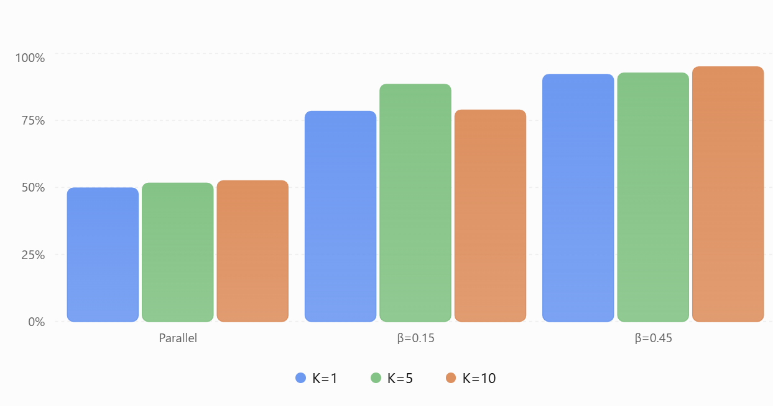
Figure 17 Association accuracy with exact per-scan assignment, eight outer sweeps; comparing K=1, K=5, K=10.
One synthetic realization per scenario. These are diagnostic results, not population-level performance estimates.
Three conclusions stand out.
First, numerical convergence isn't the primary explanation for the identity failures. Increasing from 8 to 30 outer iterations generally leaves association accuracy essentially unchanged. In the four-target parallel case, exact K=5 association remains 56.4% and retains 40 persistent wrong-label track-scans, despite the final association change falling to$3.3×{10}^{-7}$.
Second, adaptive BP provides little improvement over Ryan's original 100-iteration BP in these tests. It sometimes reaches its 300-iteration cap, especially in the difficult eight-target case, but produces nearly identical tracking outcomes. BP's marginal differences from exact assignment can still approach 0.4.
Third, relative velocity matters substantially. At $β=0.45$, the eight-target K=10 tracker reaches 95.0% association accuracy with no persistent wrong-label episodes, using either exact assignment or BP. At $β=0.15$, K=5 exact association reaches 88.5%, but K=10 deteriorates to 78.9%. This is useful evidence that temporal information can help VB preserve identities, although longer windows do not guarantee improvement.
One diagnostic worth retaining in our records: the $β=0.15$ oracle run reports a few wrong spatial-label matches despite perfect truth-assisted measurement association. That isn't necessarily contradictory, since the spatial matching metric can disagree with physical identity when estimated trajectories are close. We should preserve that distinction in future reporting.

My recommendation
I would close V3 as a successful controlled system-level evaluation, while leaving the broader operational performance question open.
We now have evidence that the reconstructed VB tracker can exploit multi-scan kinematics, that its persistent identity failures are not merely due to insufficient iterations, and that BP is only one contributor to the difficult cases.
We have not yet demonstrated superiority over an optimized MFA baseline, nor established statistical reliability across multiple trials.

